* **Question And Answers**

1. **Describe basic aspects of AWS Elastic Compute Cloud.**
2. AWS Elastic Compute Cloud provides a Web interface, so it is simple to configure web services and enables user to configure the capacity as per user requirements.
3. It allows you to control all computing resources and run applications on EC2 cloud environment.
4. EC2 will save money by paying only for computing capacity that is in actual use.
5. Amazon EC2 offers the broadest and deepest compute platform with choice of processor, storage, networking, operating system, and purchase model.
6. It provides you with complete control of your computing resources and lets you run on Amazon’s proven computing environment.

**Benefits:**

1. Scalability
2. Good Security
3. Flexibility
4. Improved Reliability
5. Economic
6. **How to create a virtual machine instances in AWS EC2**

Step 1 – Login to AWS and select your course, I am using foundation course

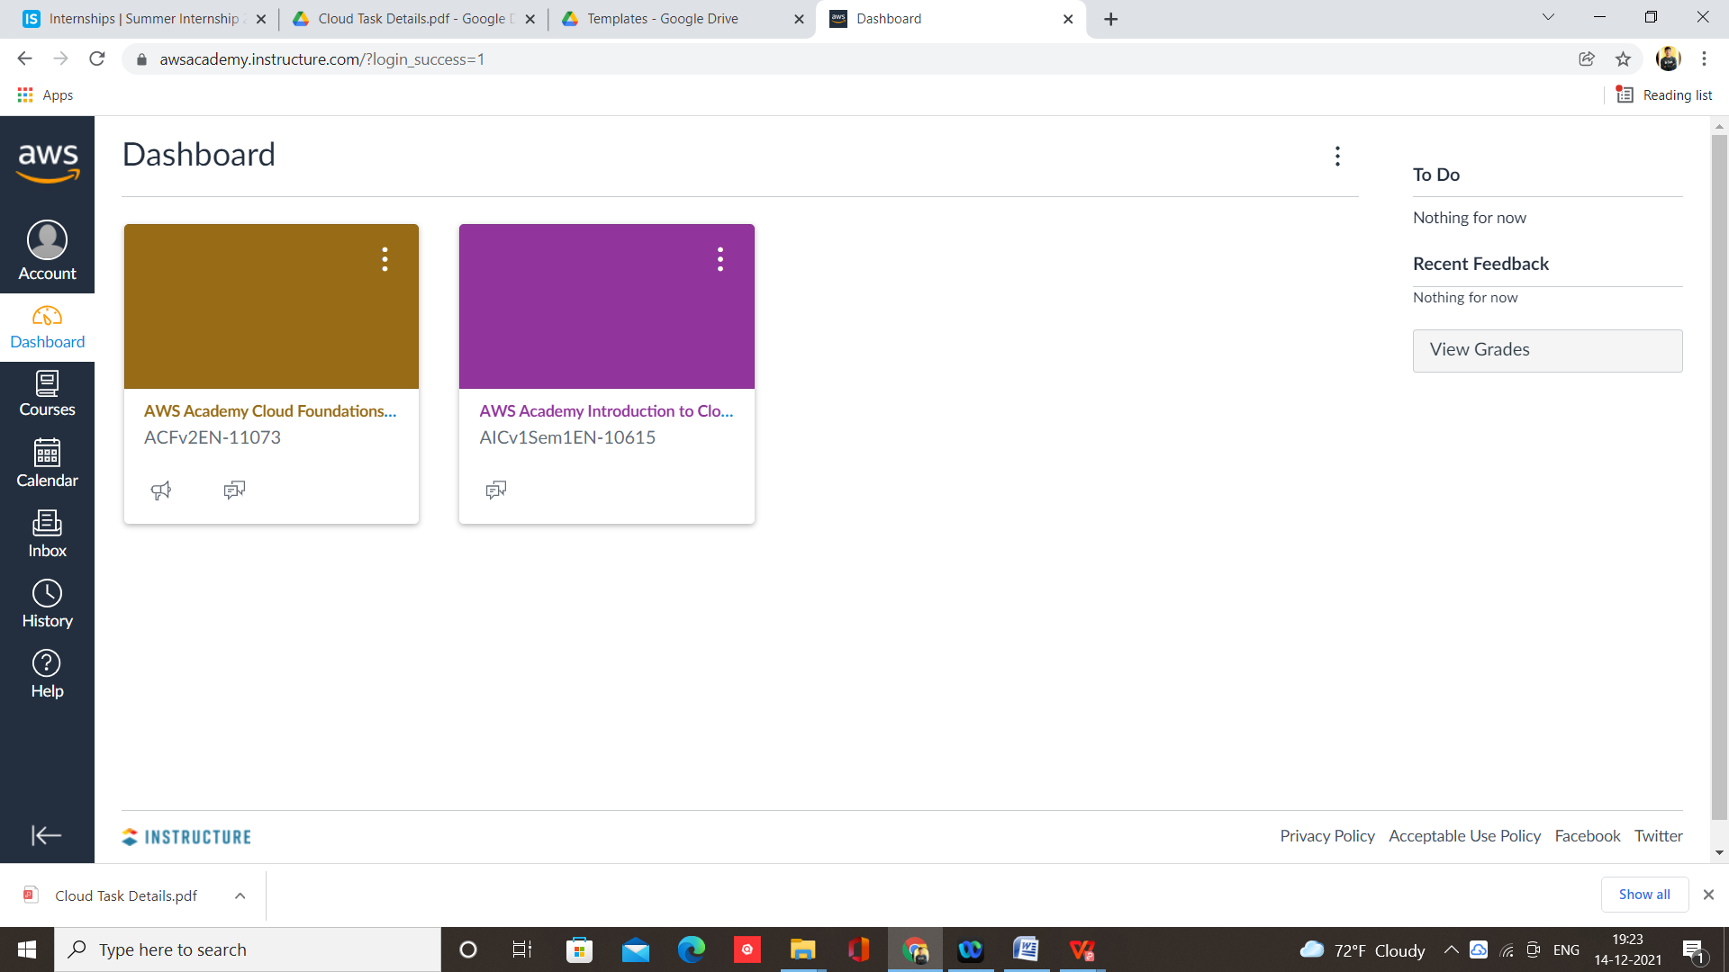

Step 2 – Select module and lab in which your instances working properly, I am selecting Module 7 Lab 4

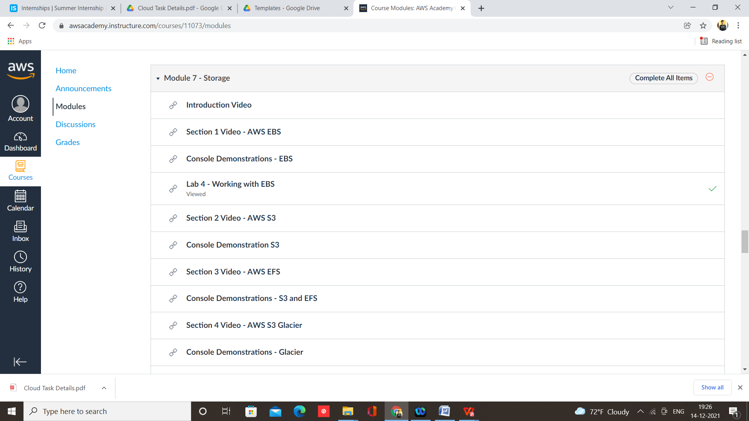

Step 3 – Start Lab and click on AWS to open console

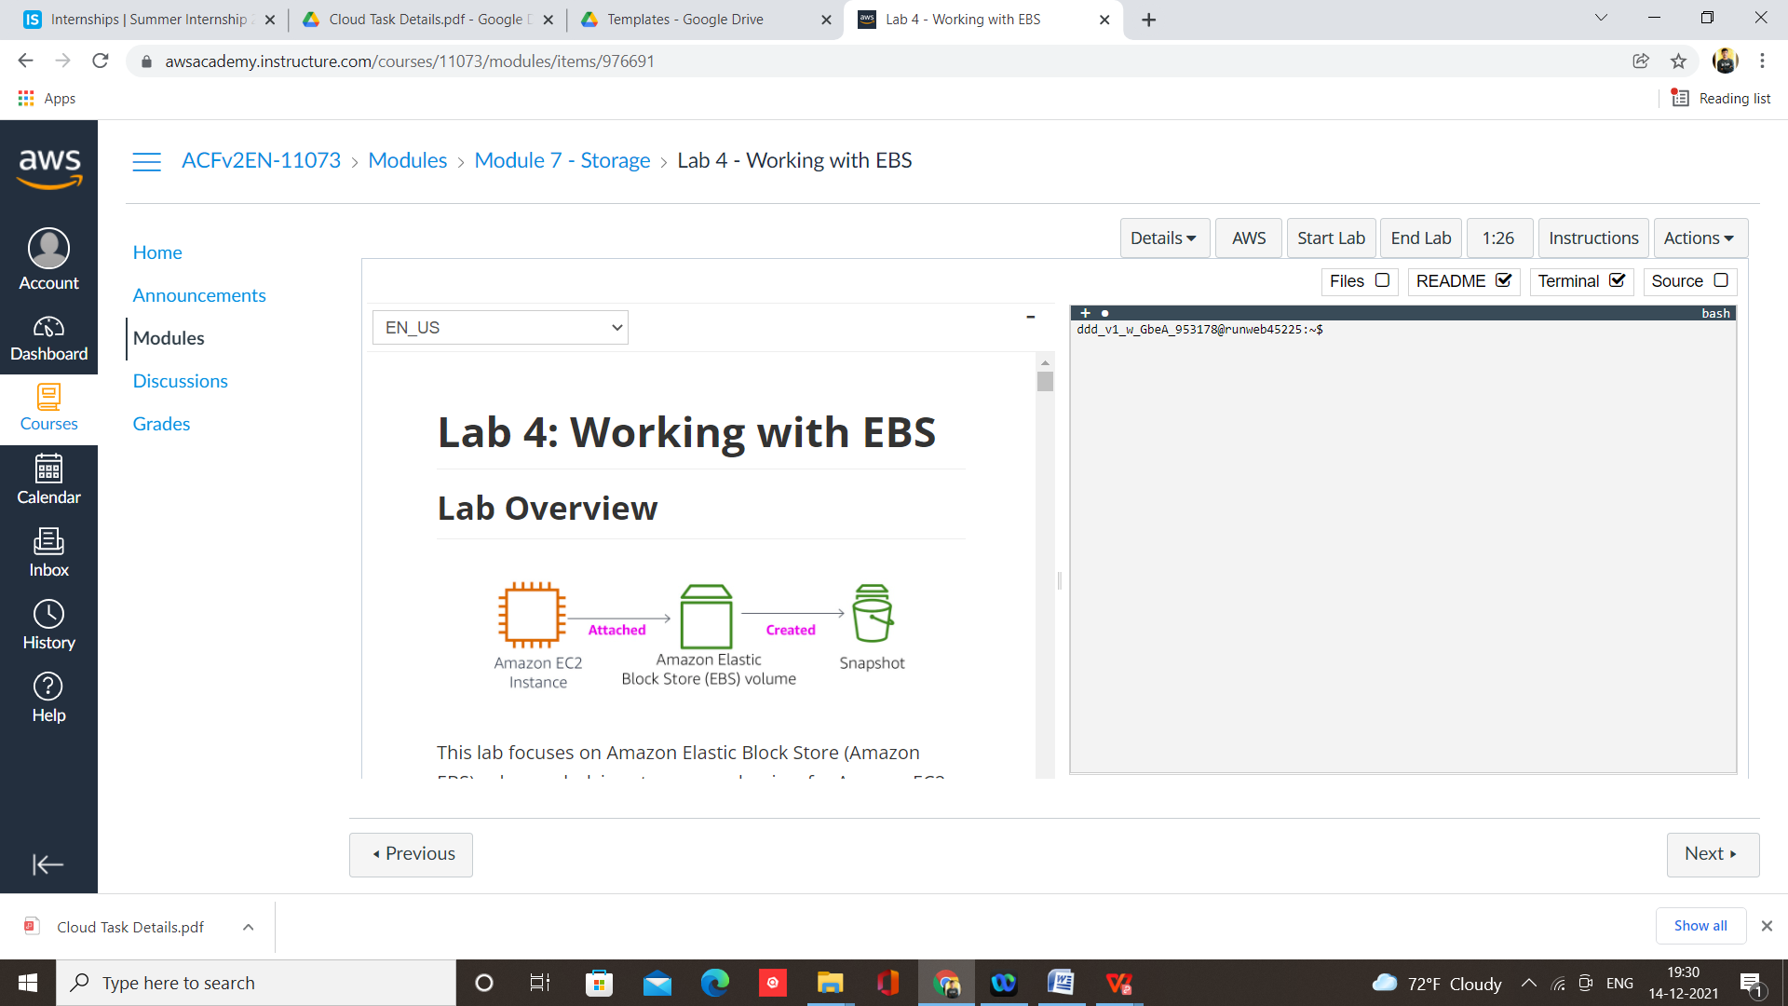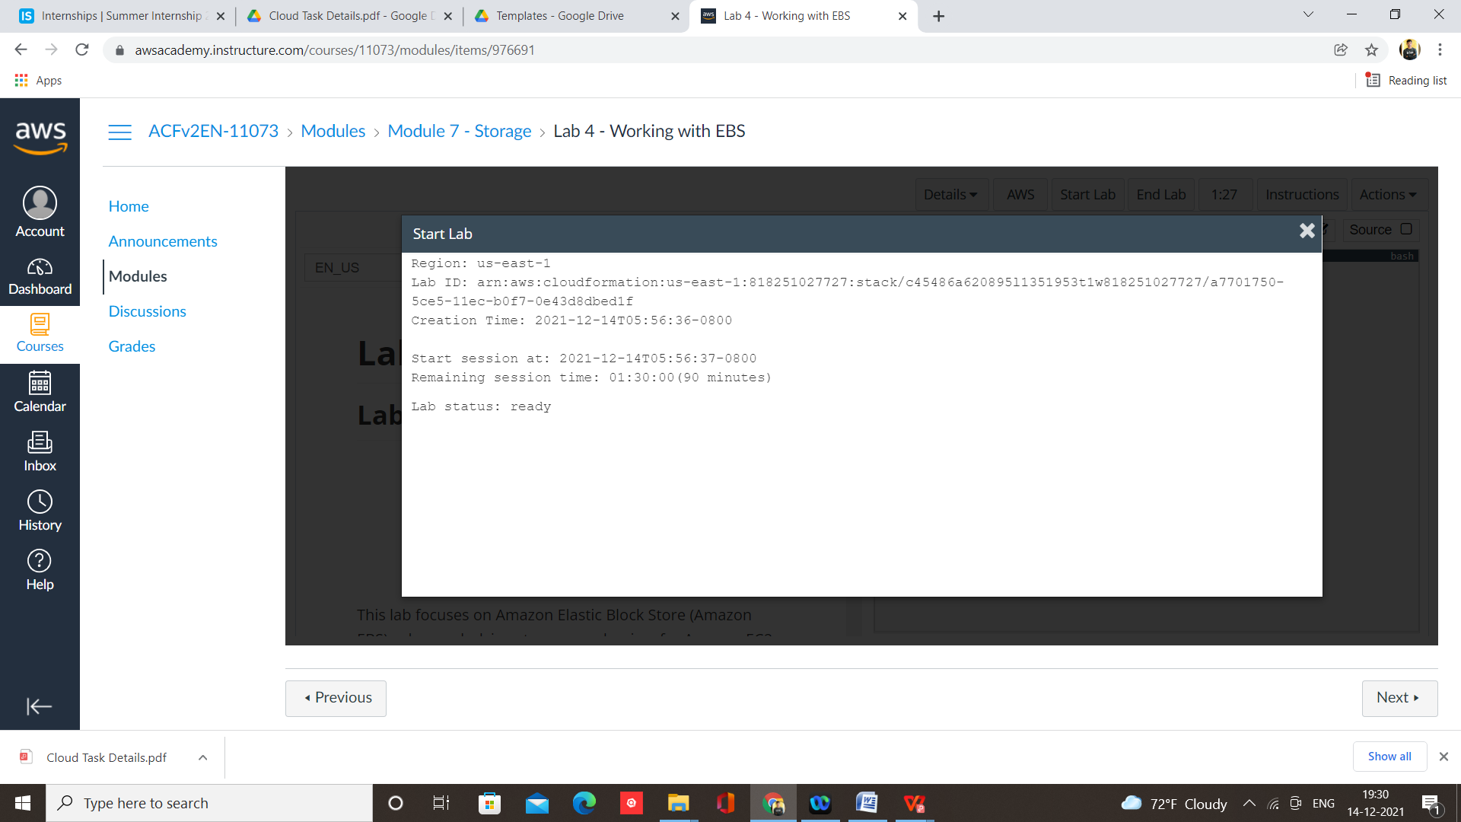

Step 4 – Select EC2 from services

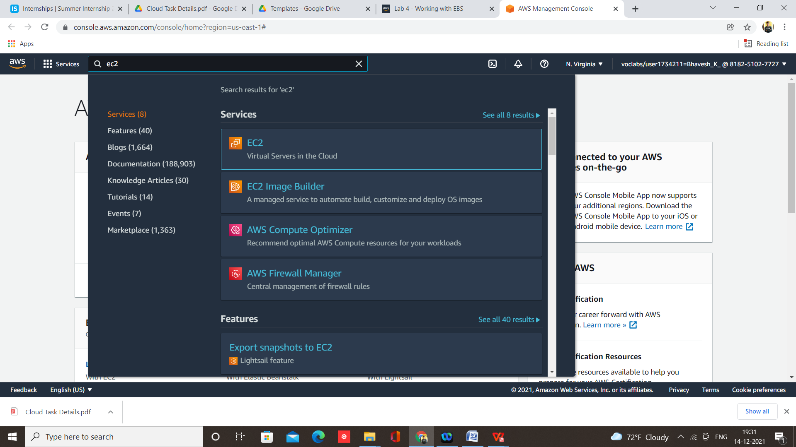

Step 5 – Click on launch instances

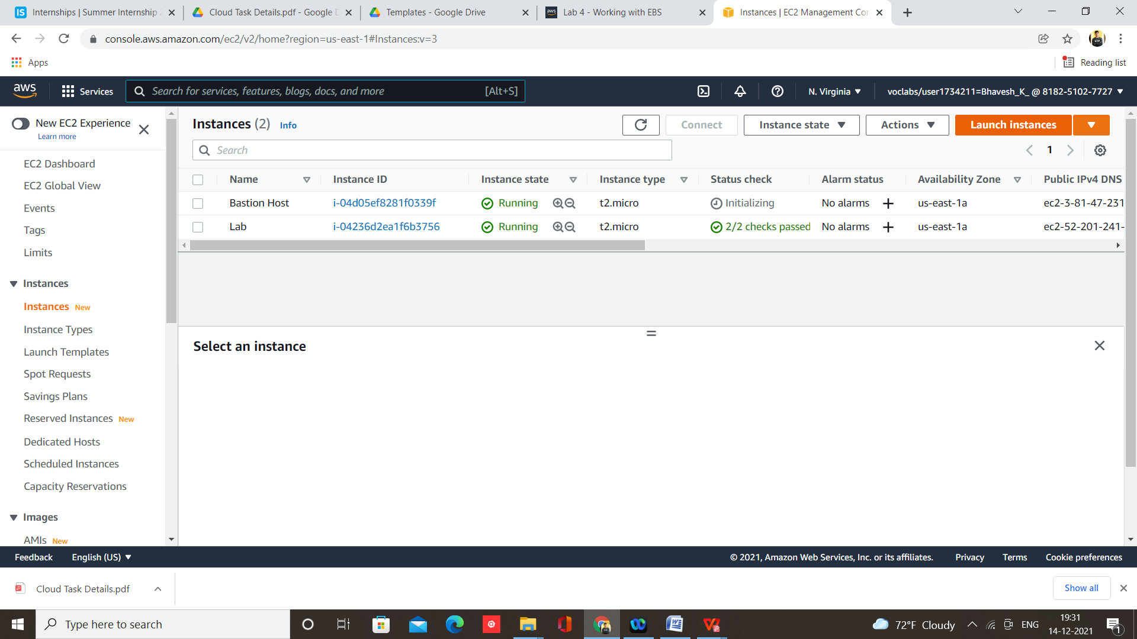

Step 6 – Select AMI, I am selecting Windows

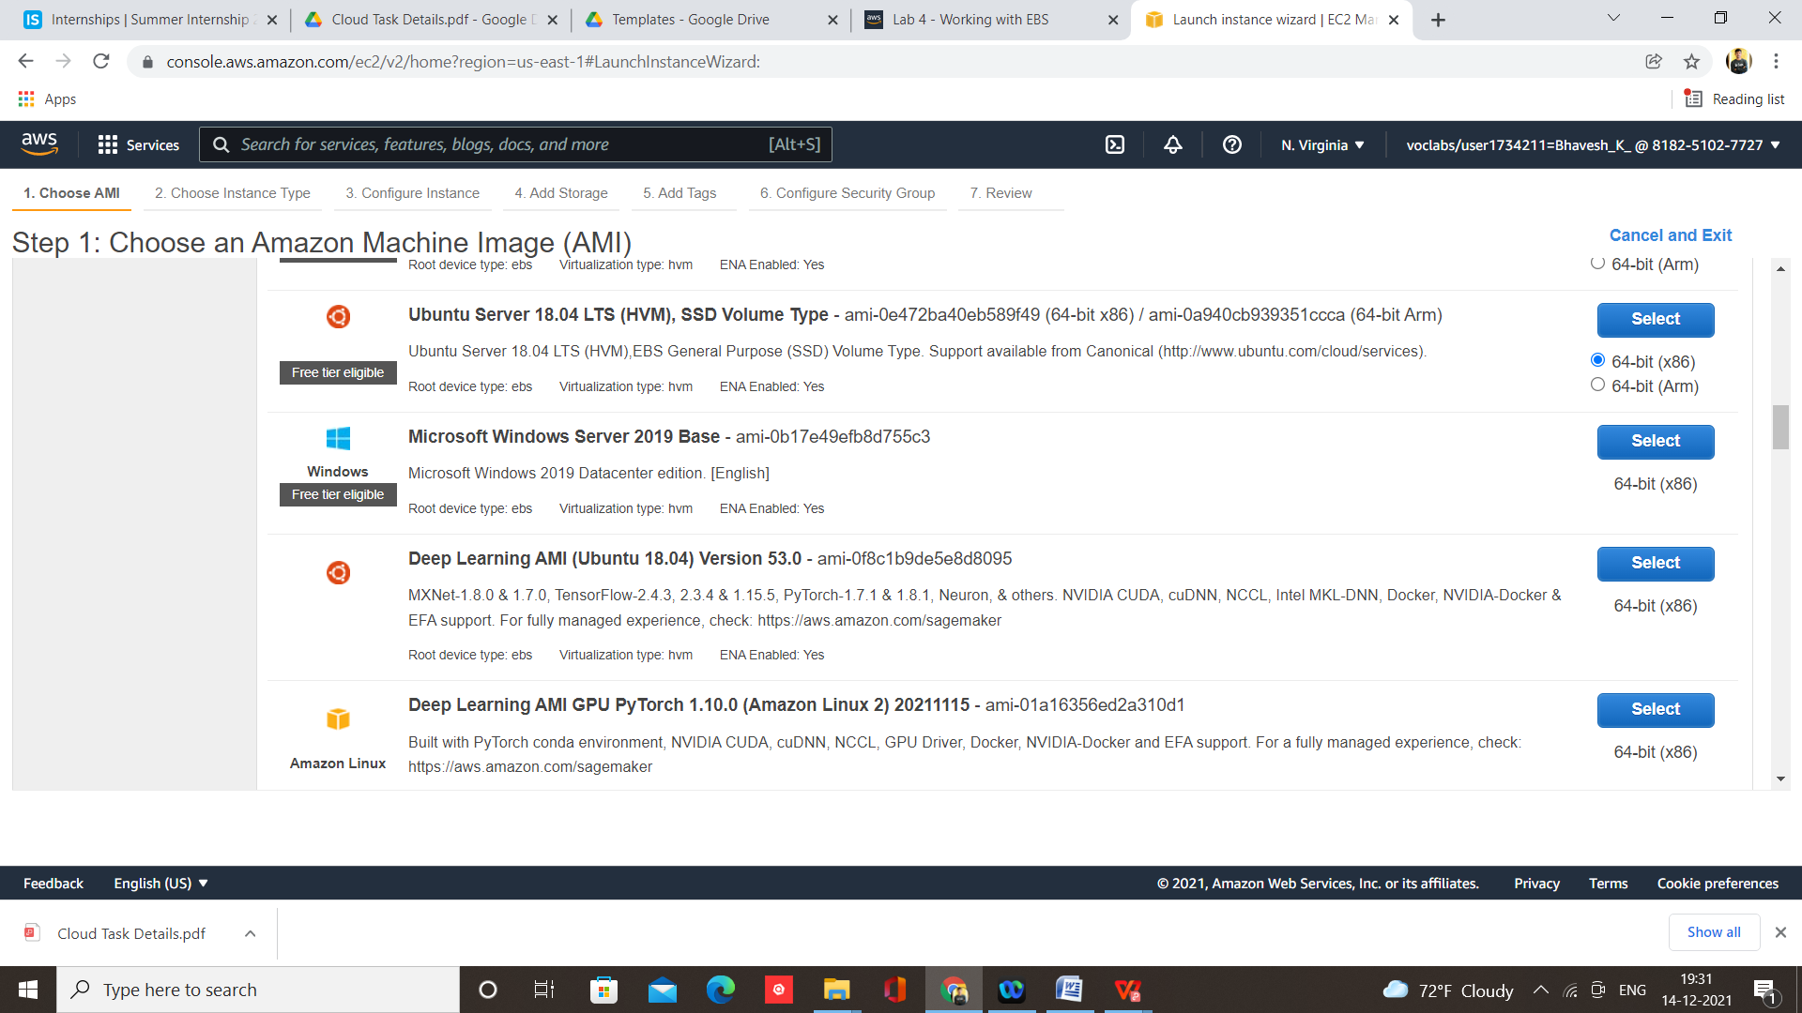

Step 7 – Configure and click on Review and Launch

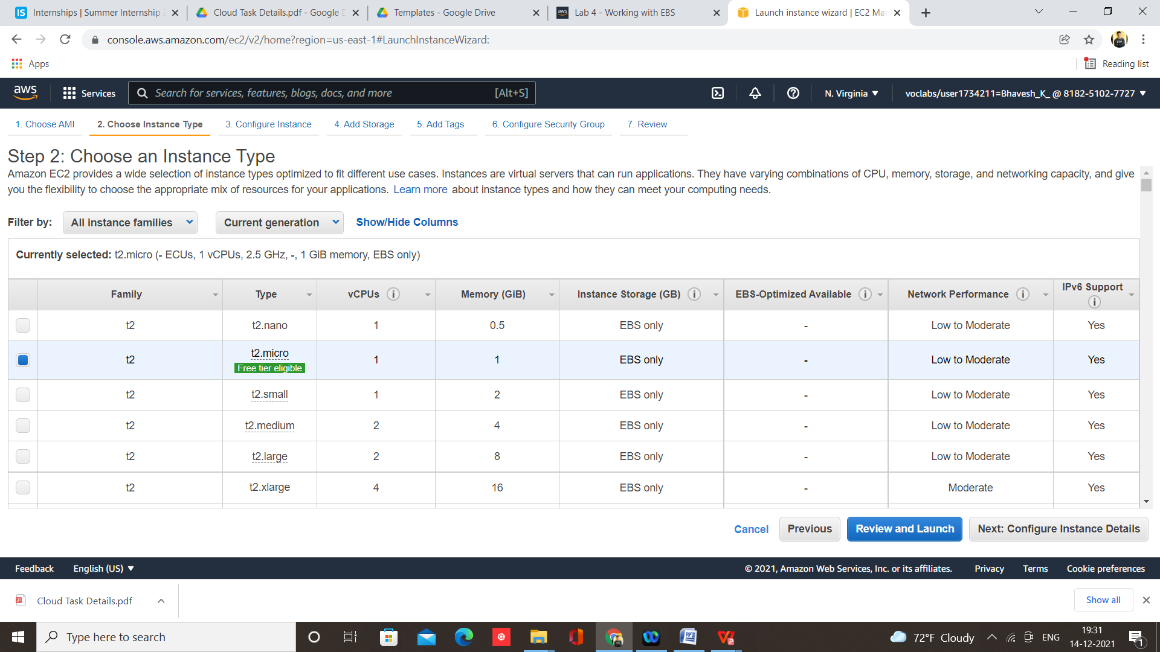

Step 8 - Click on Launch

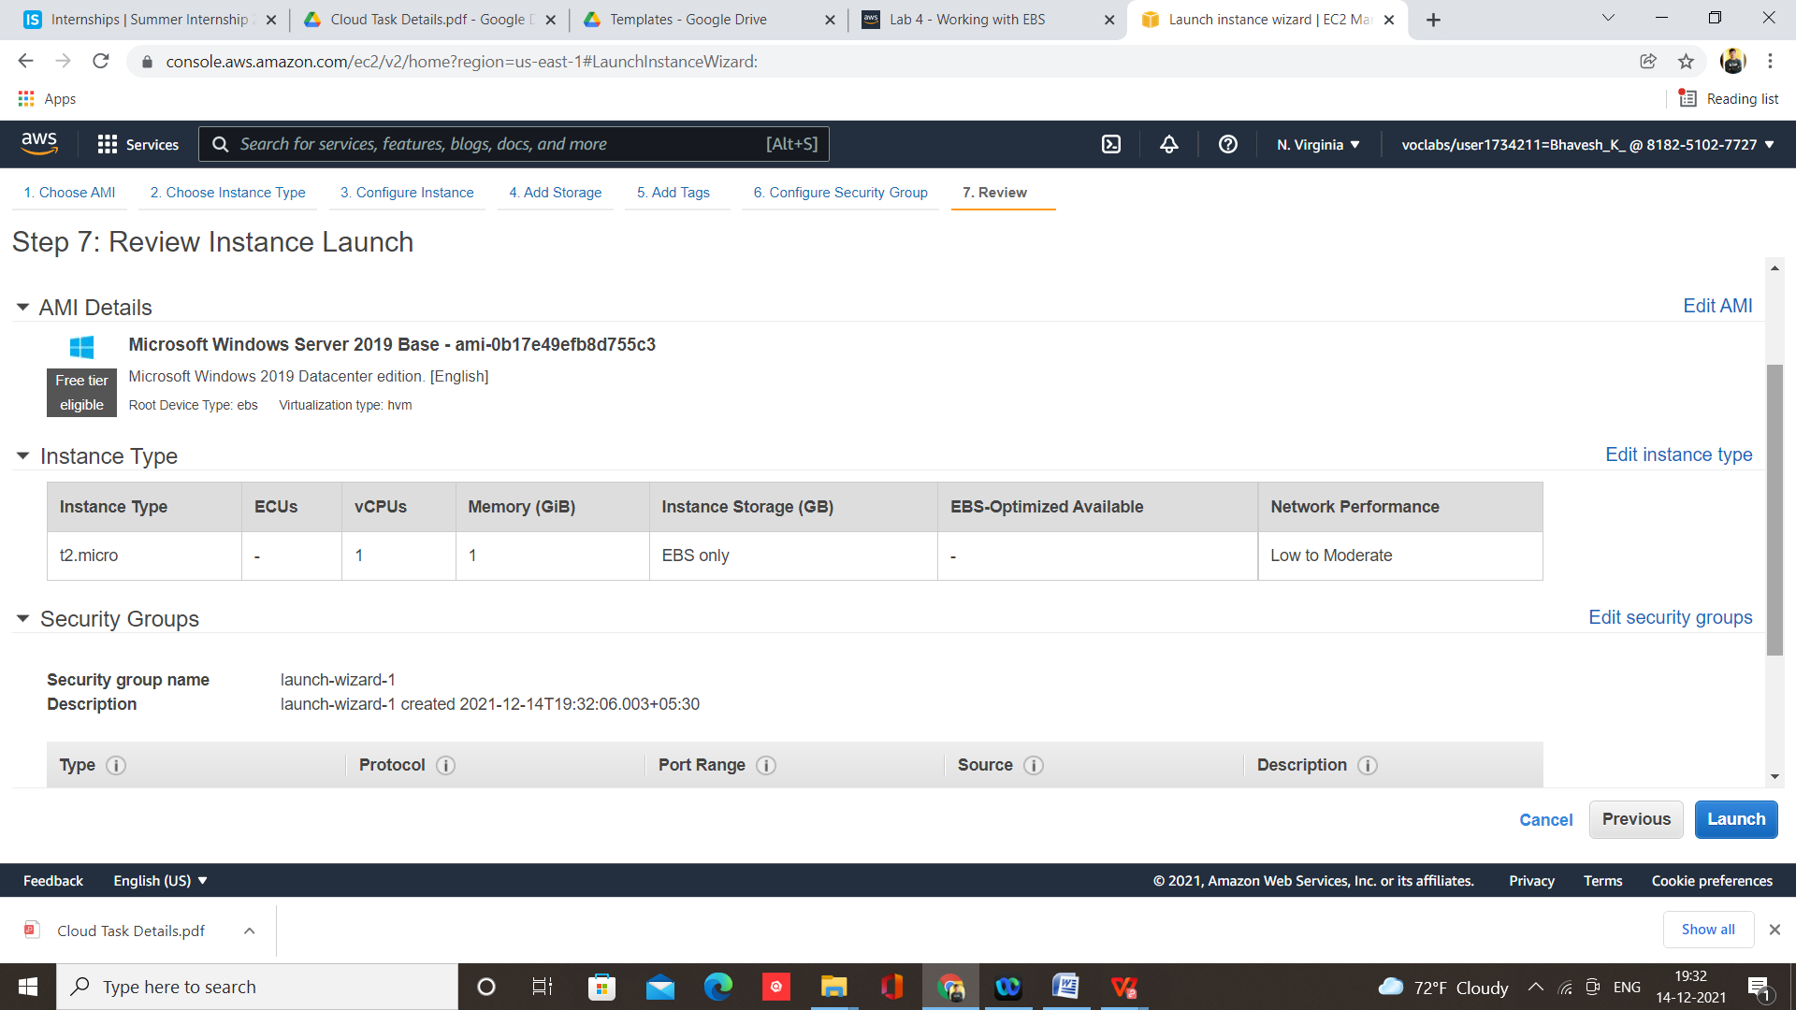

Step 8 – Now create and download key pair and click on launch instances

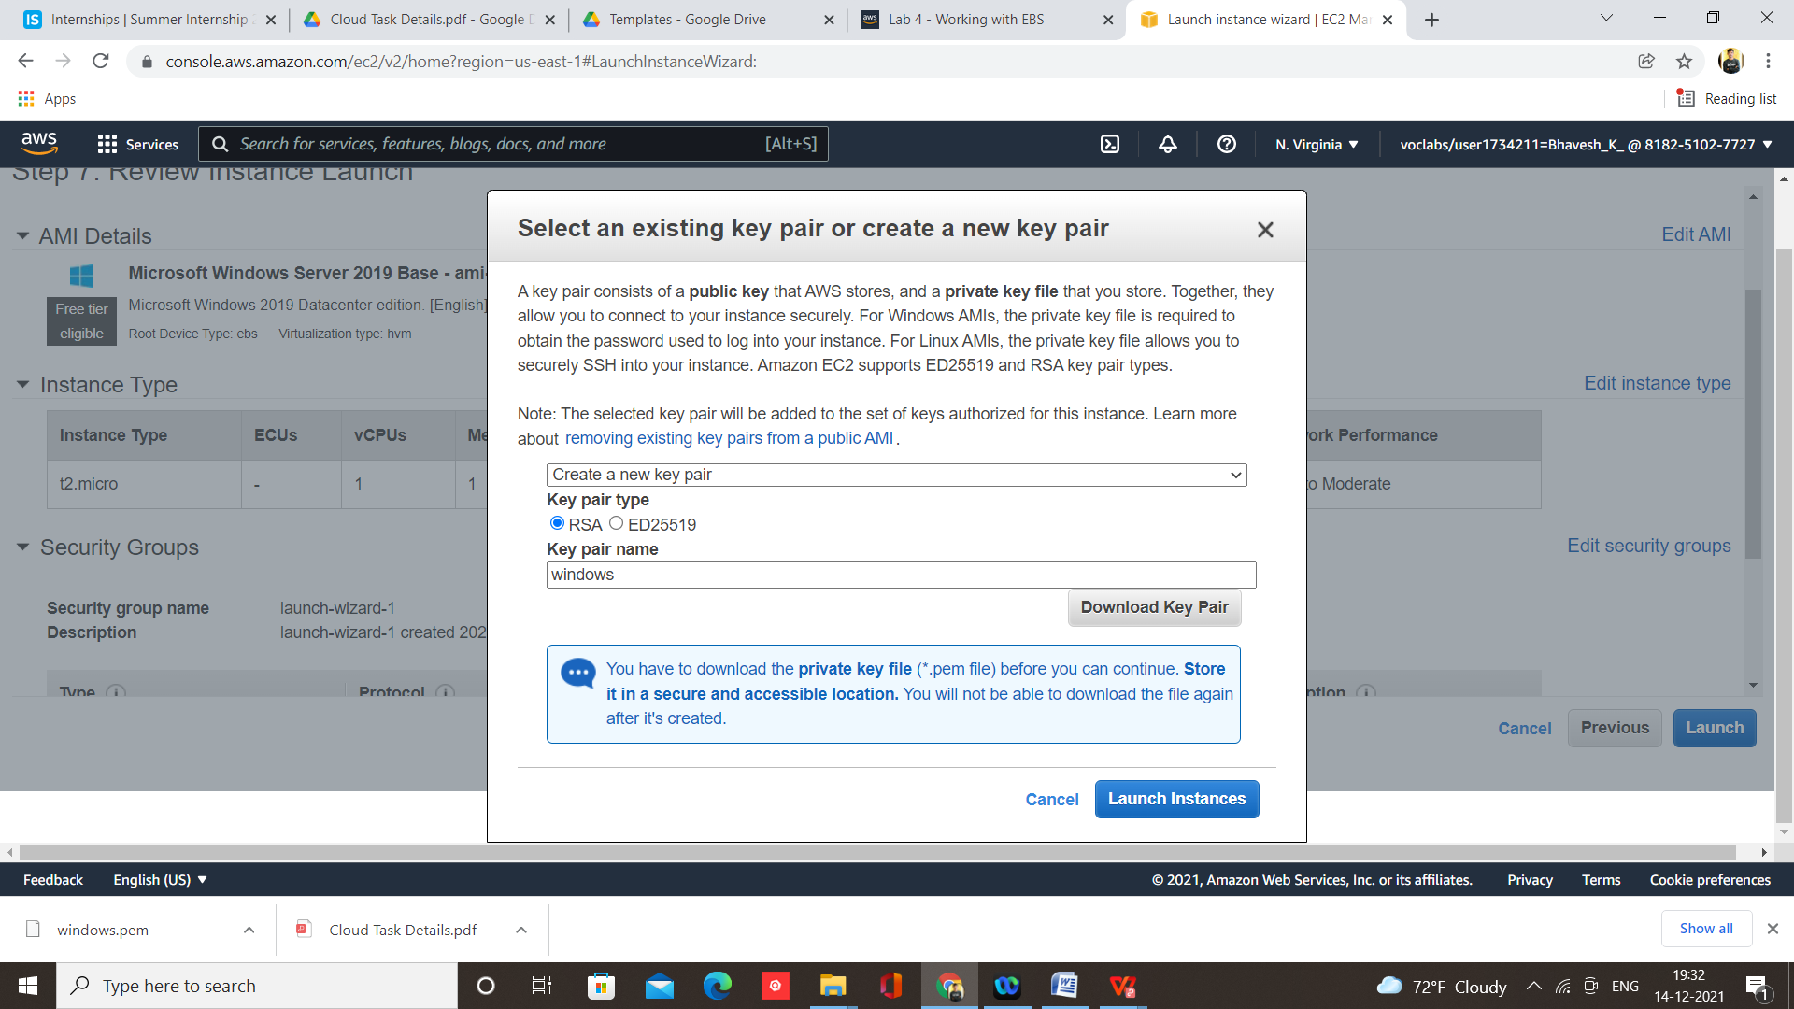

Step 9 – Click on Launch

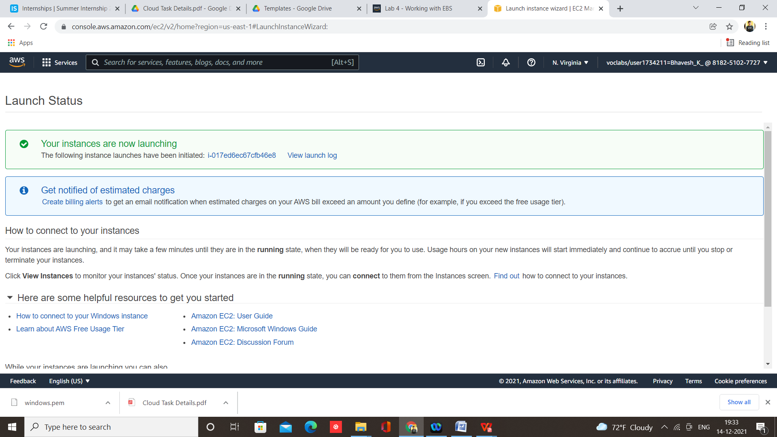

Step 10 – Select your instance and click on connect

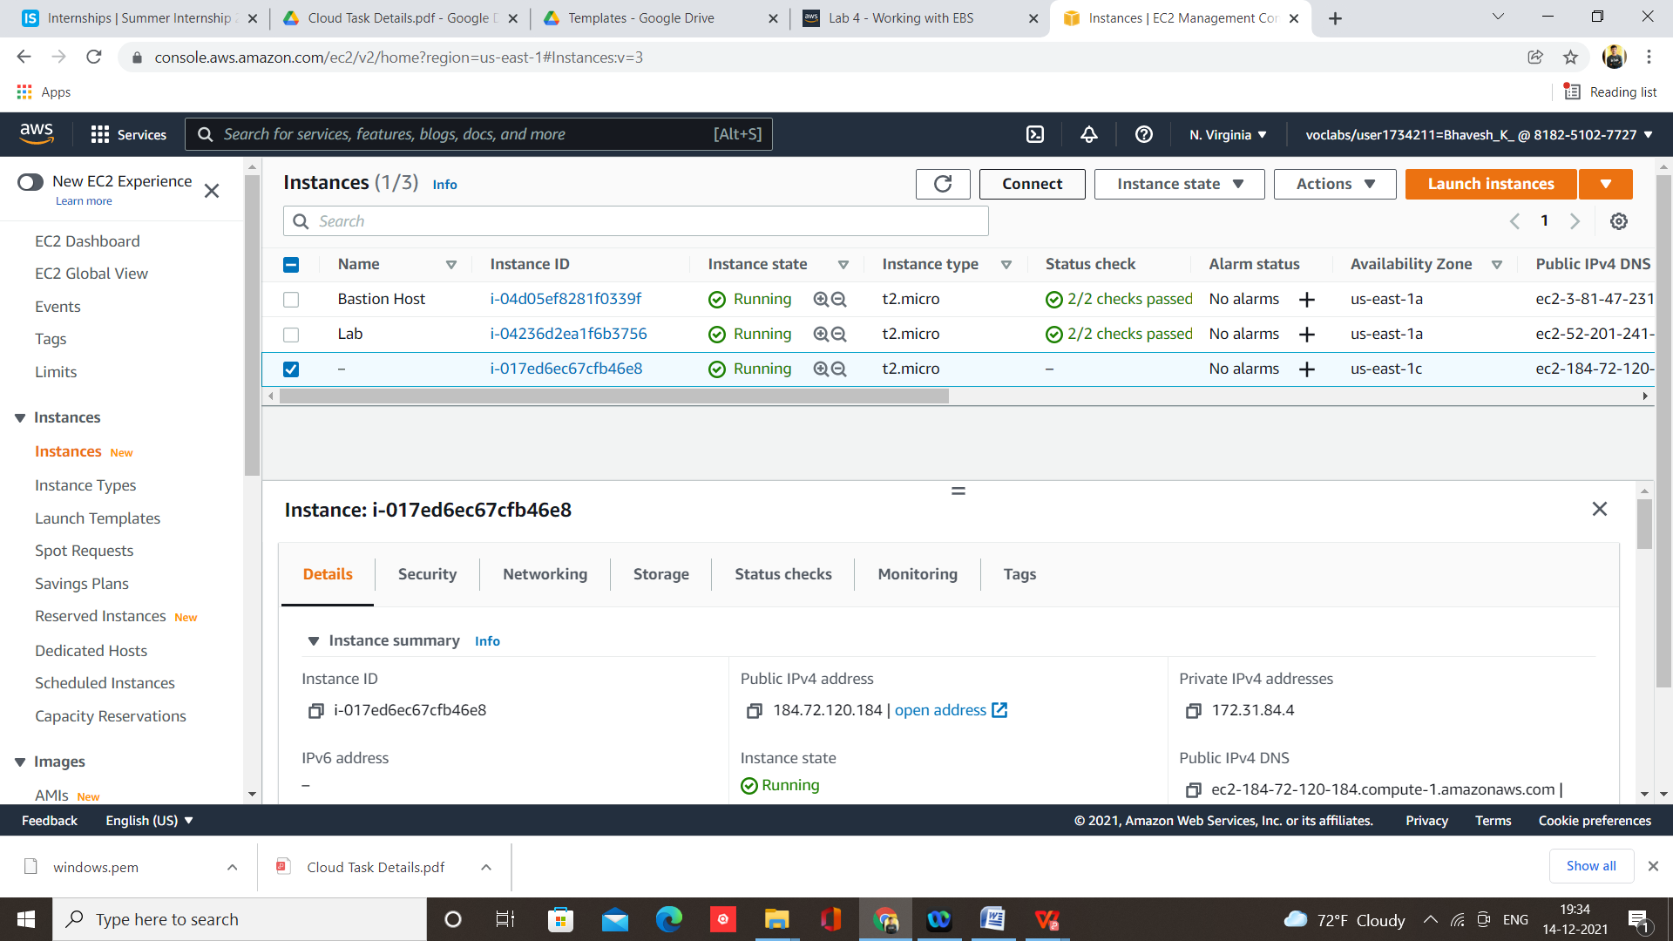

Step 11 – In RDP client, Download remote desktop file

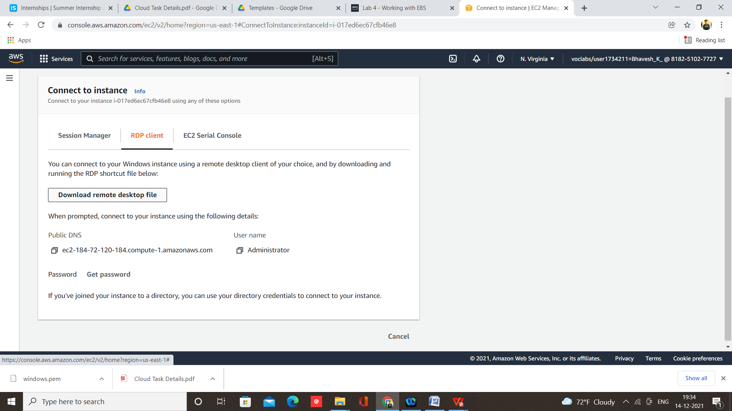

Step 12 – Double click on it and connect

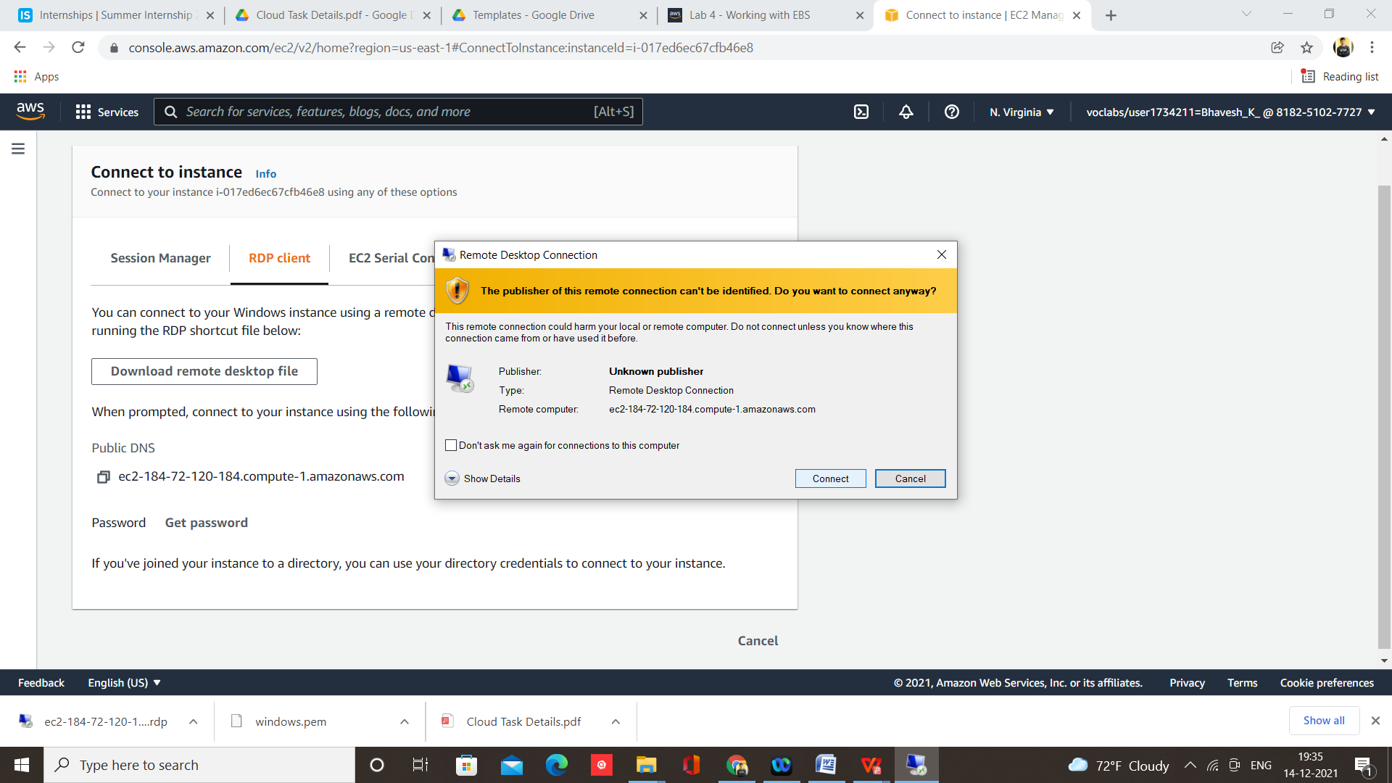

Step 13 – Click on get password

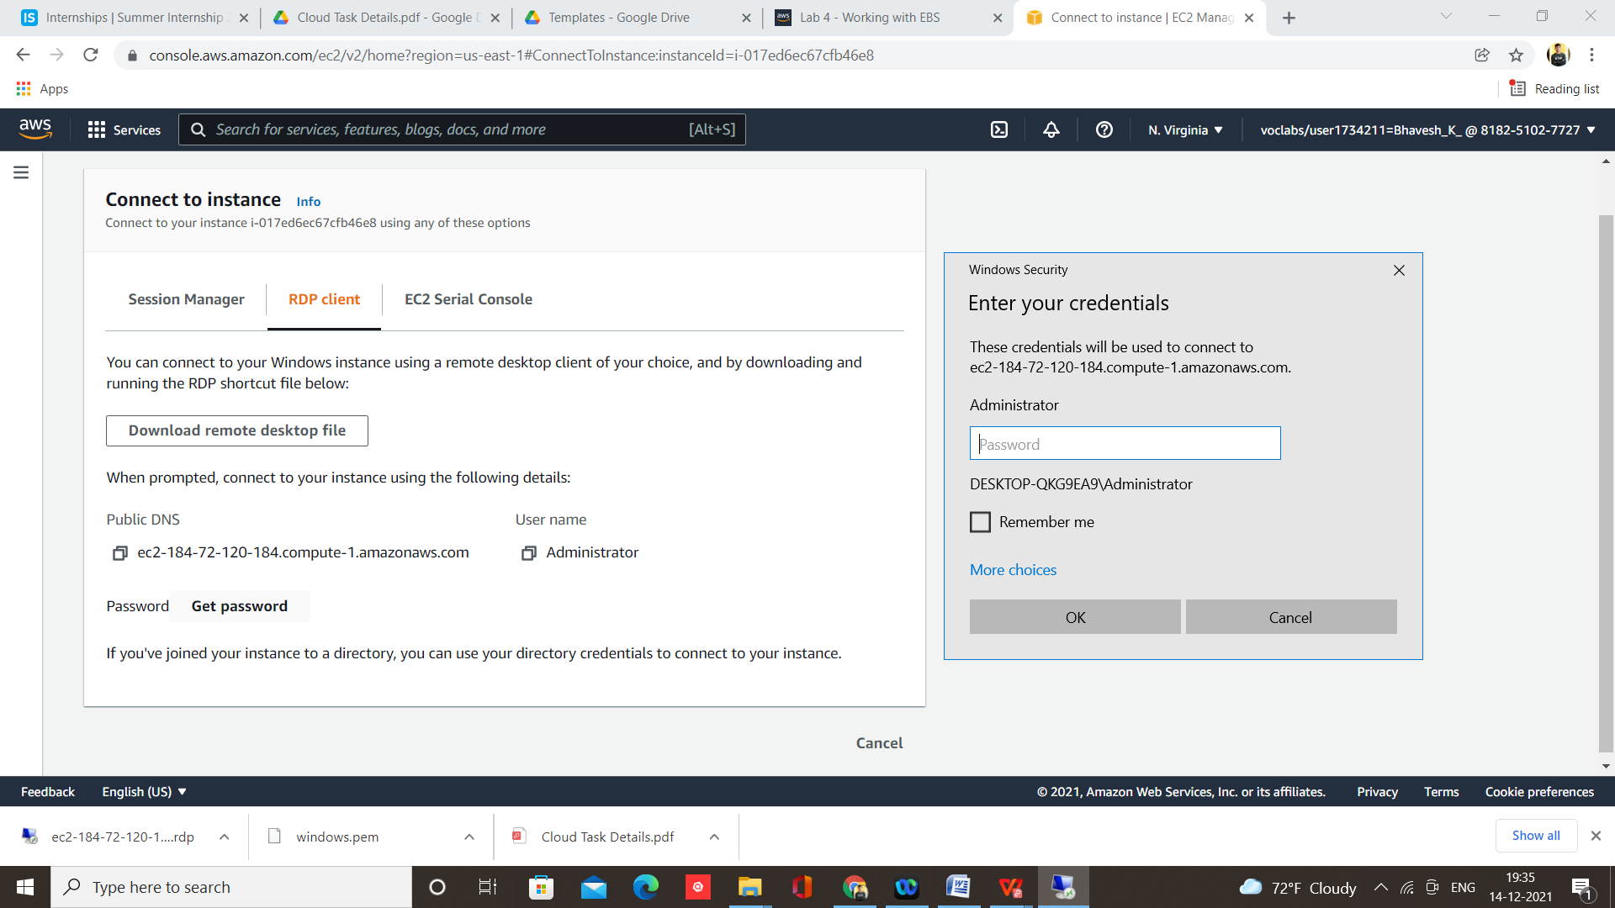

Step 14 – Click on Browse

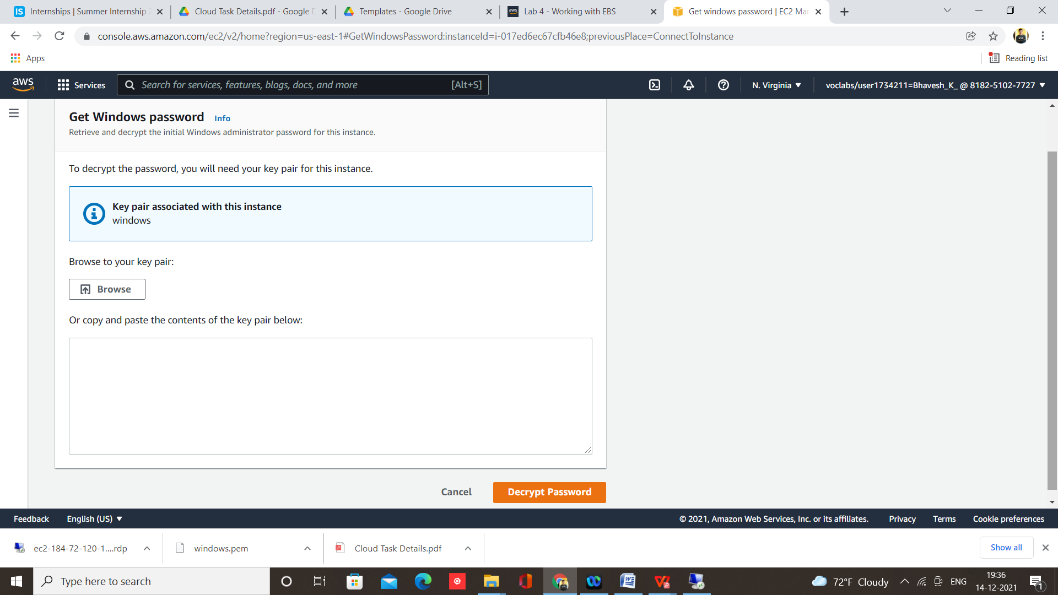

Step 15 – Select .pem file

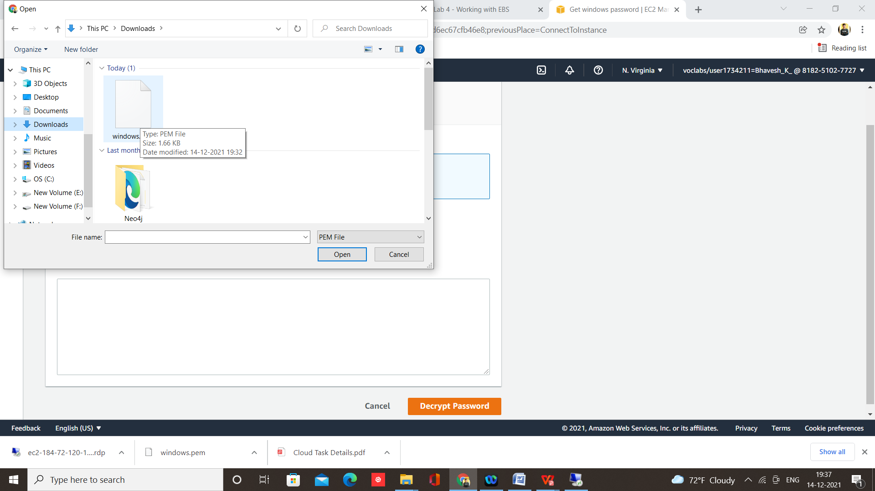

Step 16 – Click on Decrypt Password

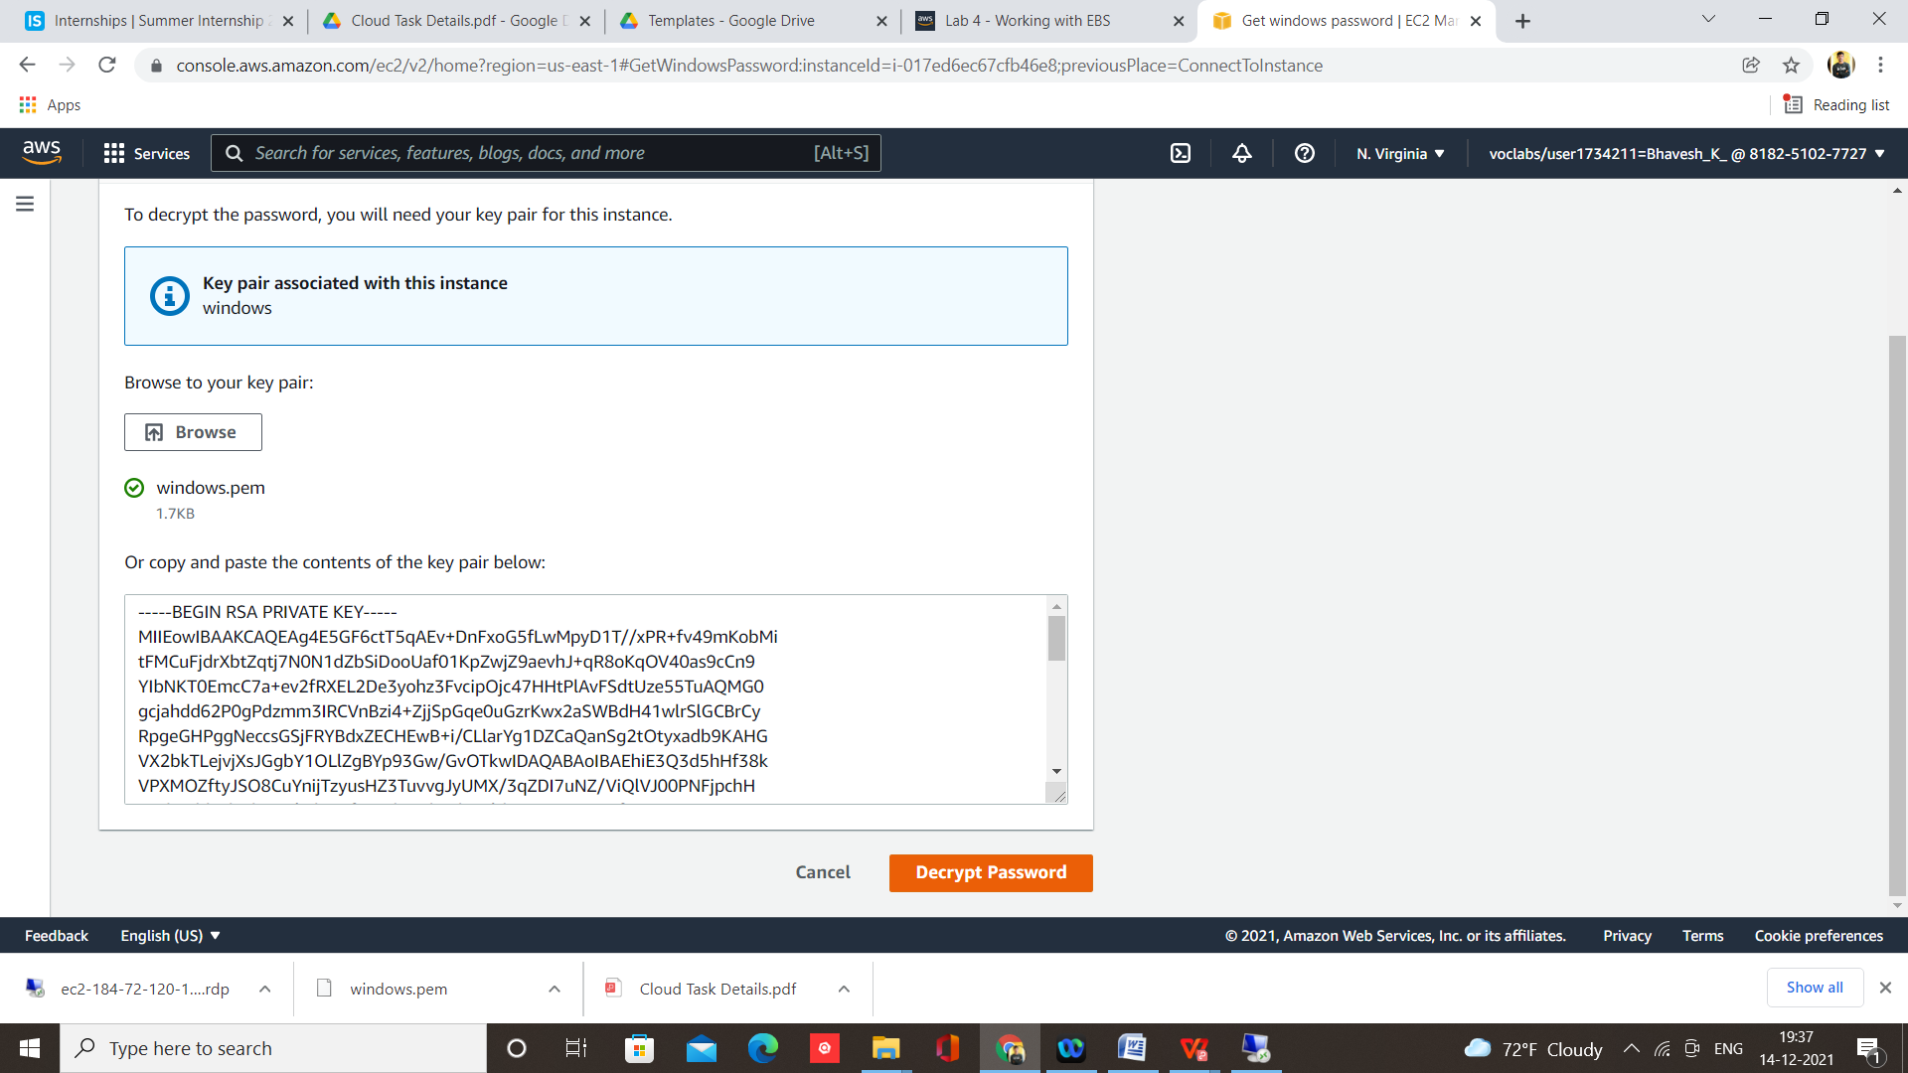

Step 17 – Paste generated password

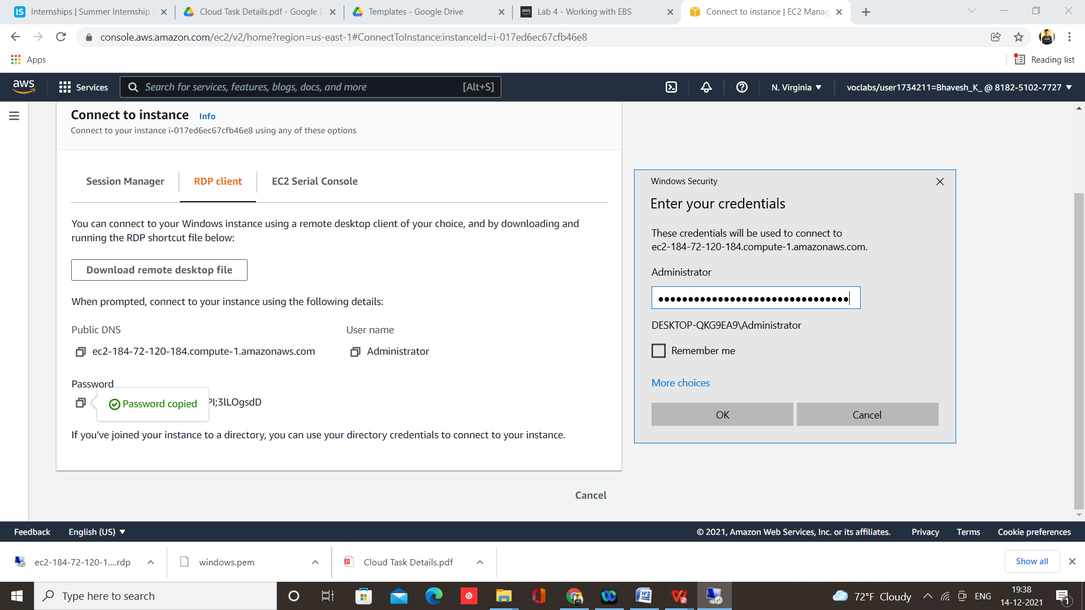

Your Windows instance is now launching

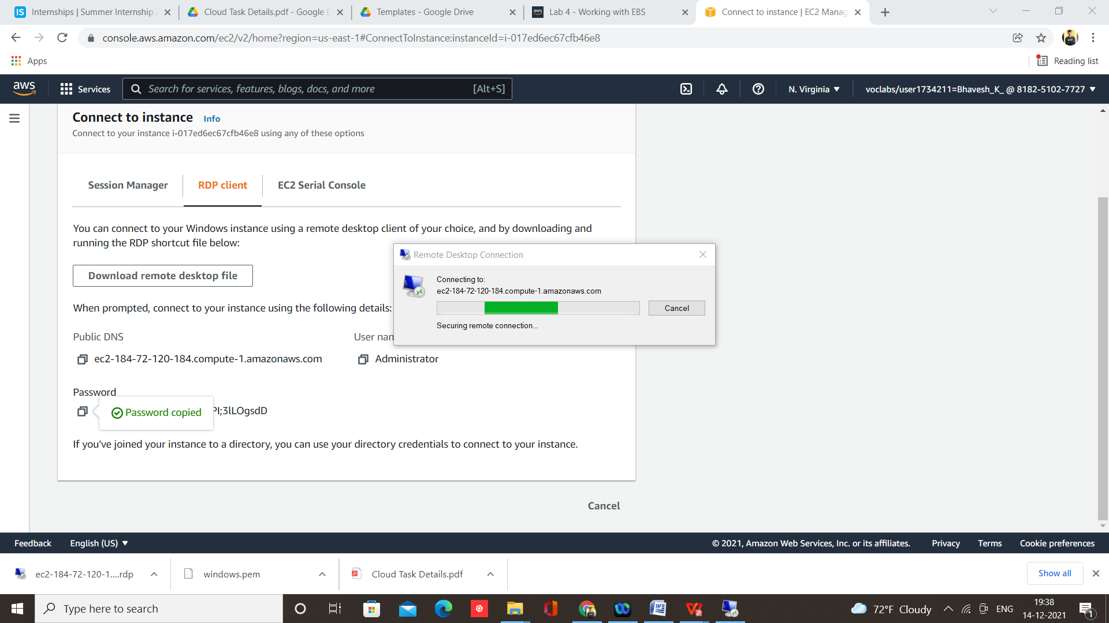

Step 18 – Click on Yes

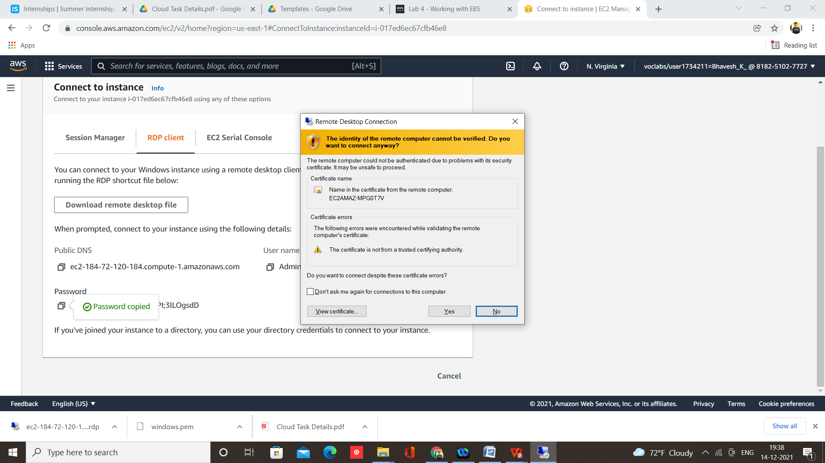

Here is your, Windows Instance

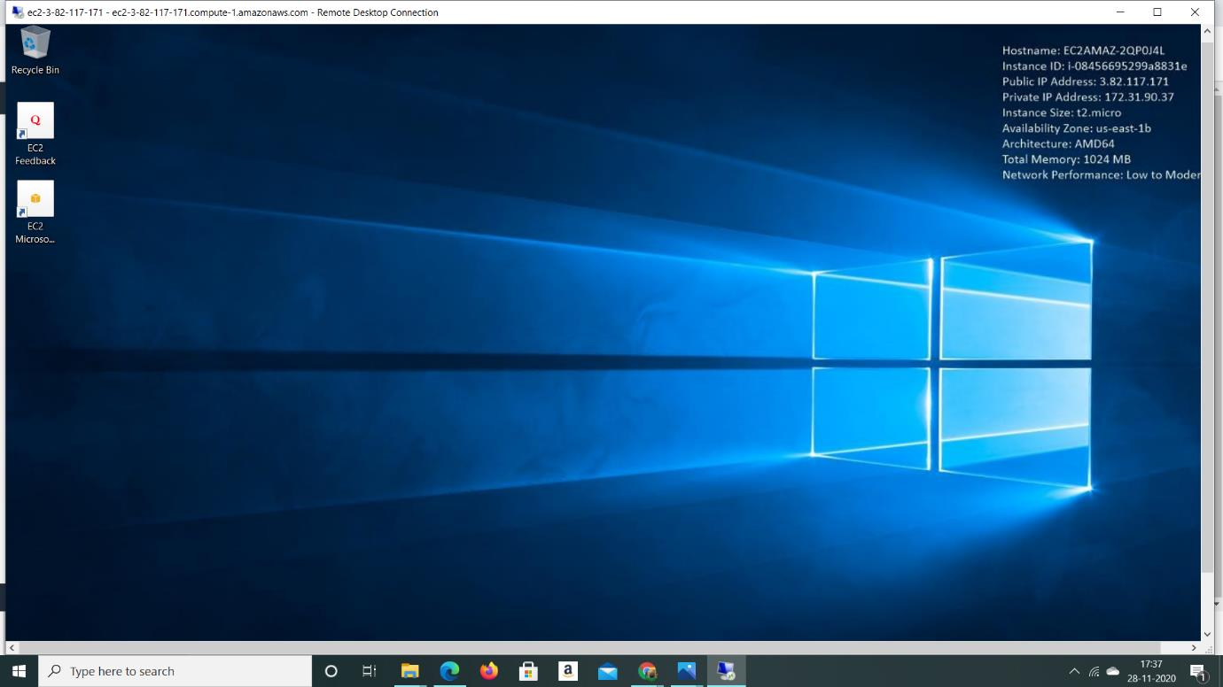

1. **How to install an Apache Web server on AWS EC2 instance**

Step 1 – Login to AWS and select course, I am using Foundation Course



Step 2 – Select Module and Lab

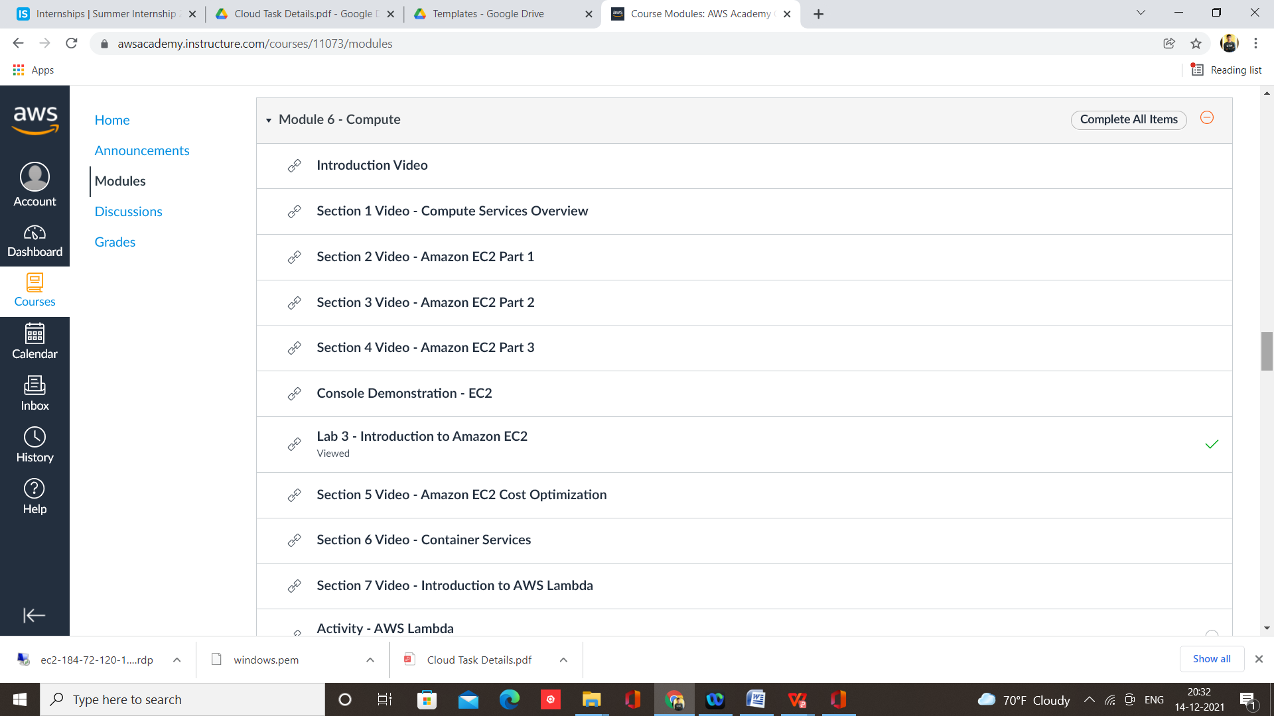

Step 3 – Start Lab and click on AWS to open console

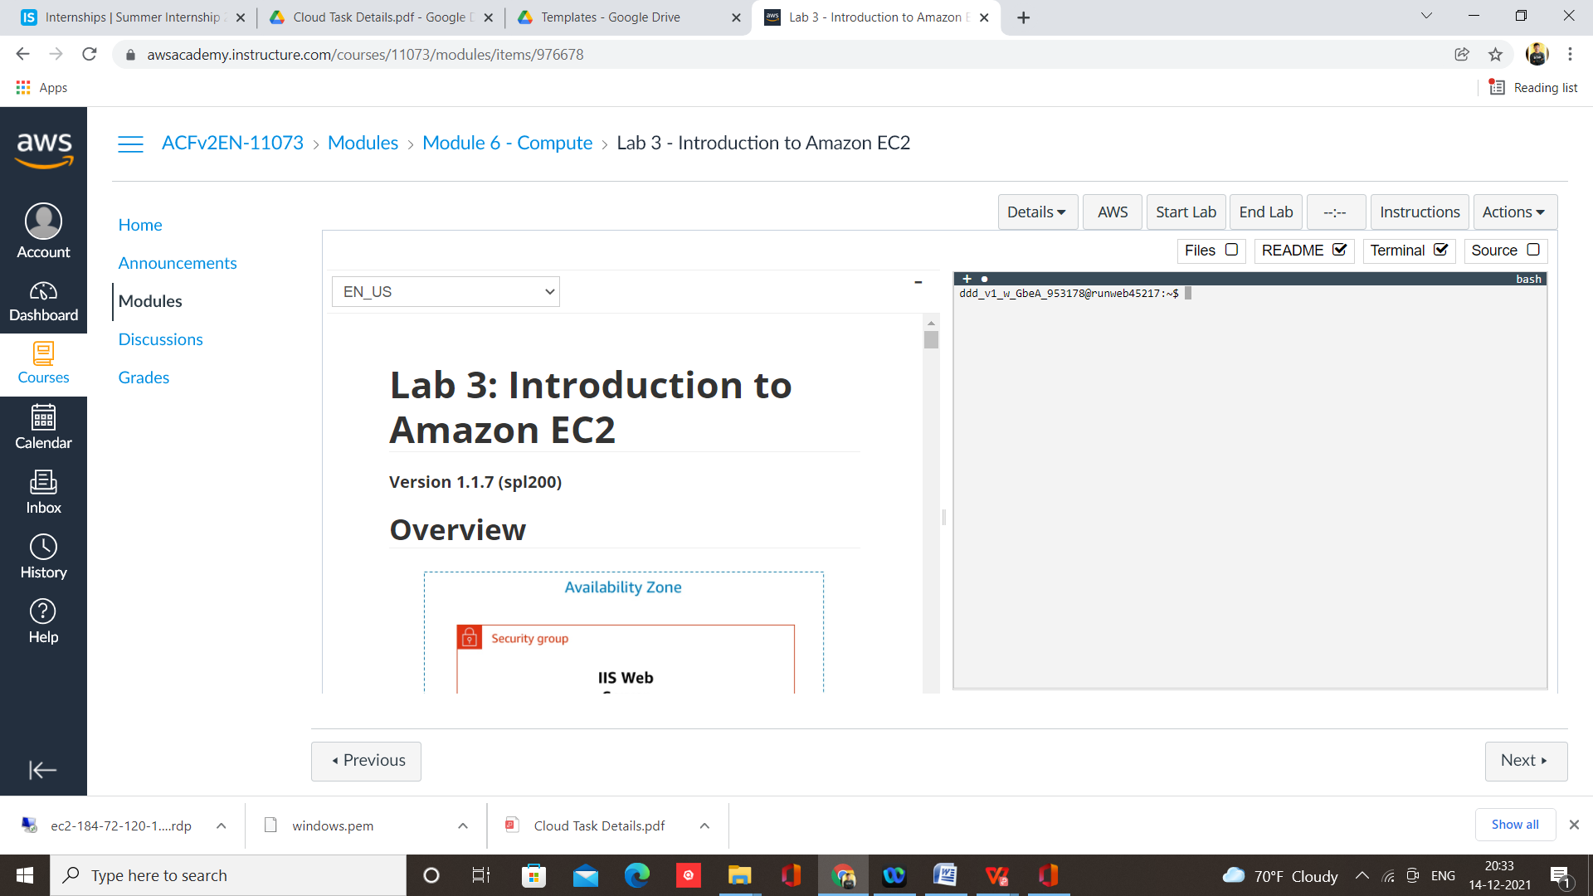

Step 4 - Select EC2 from Services

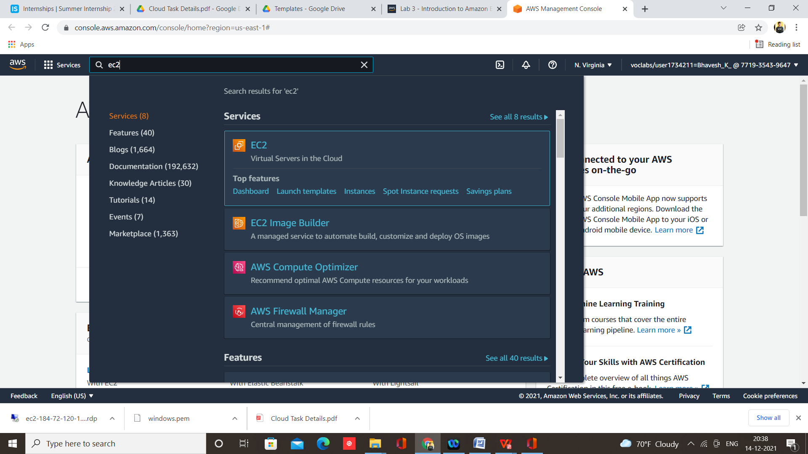

Step 5 – Click on Launch Instances

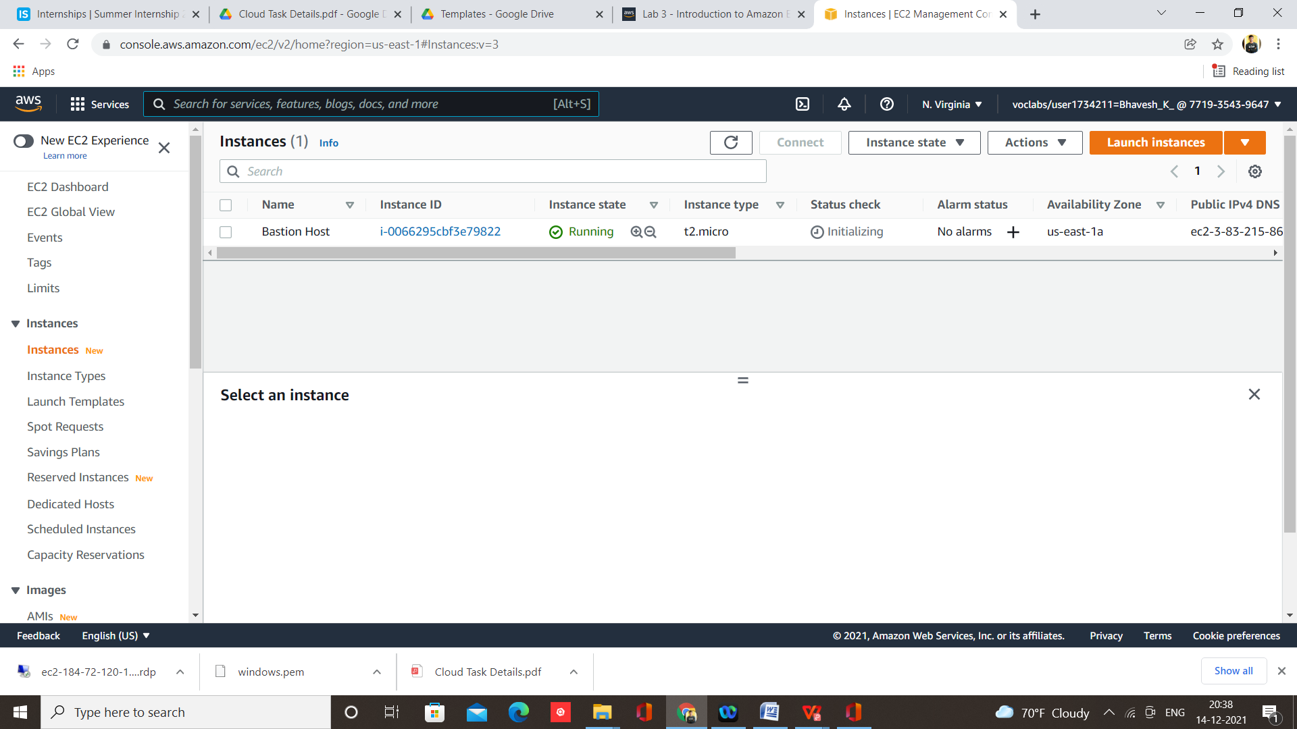

Step 6 –Select AMI Linux

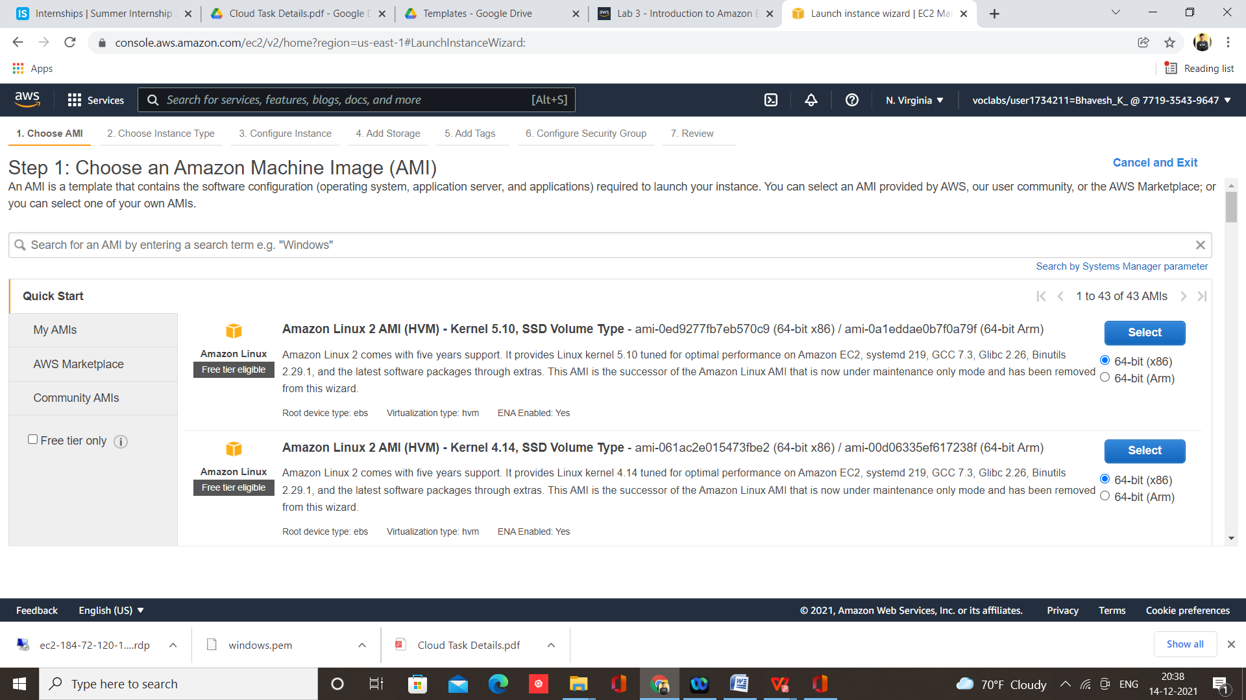

Step 7 – Click on Review and Launch

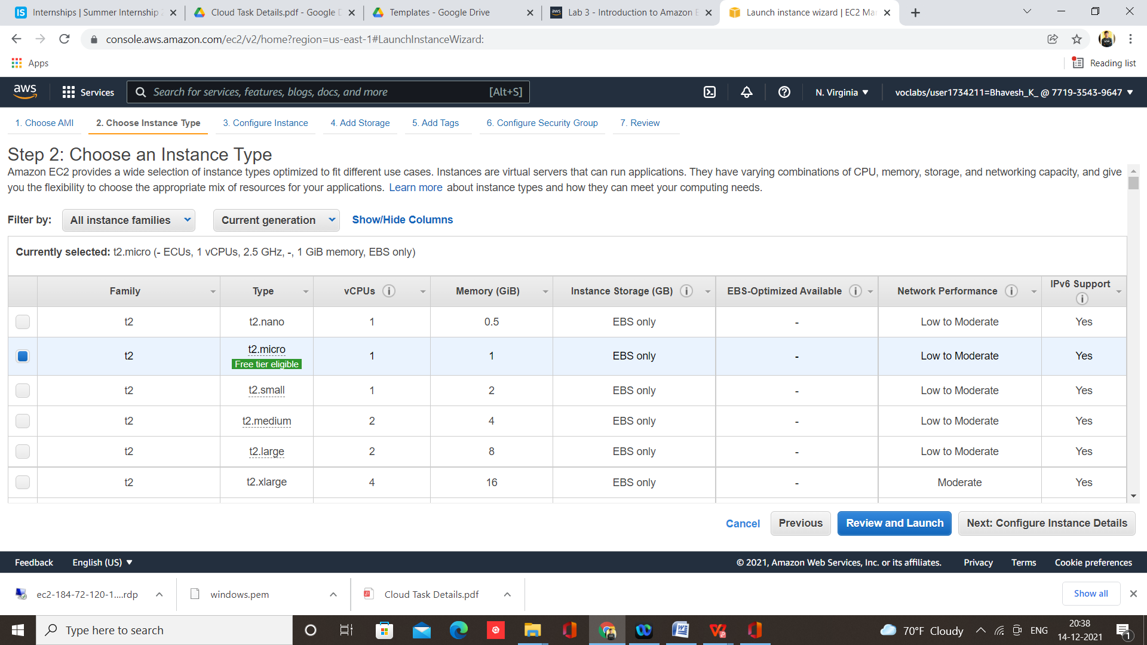

Step 8 – Click on Launch

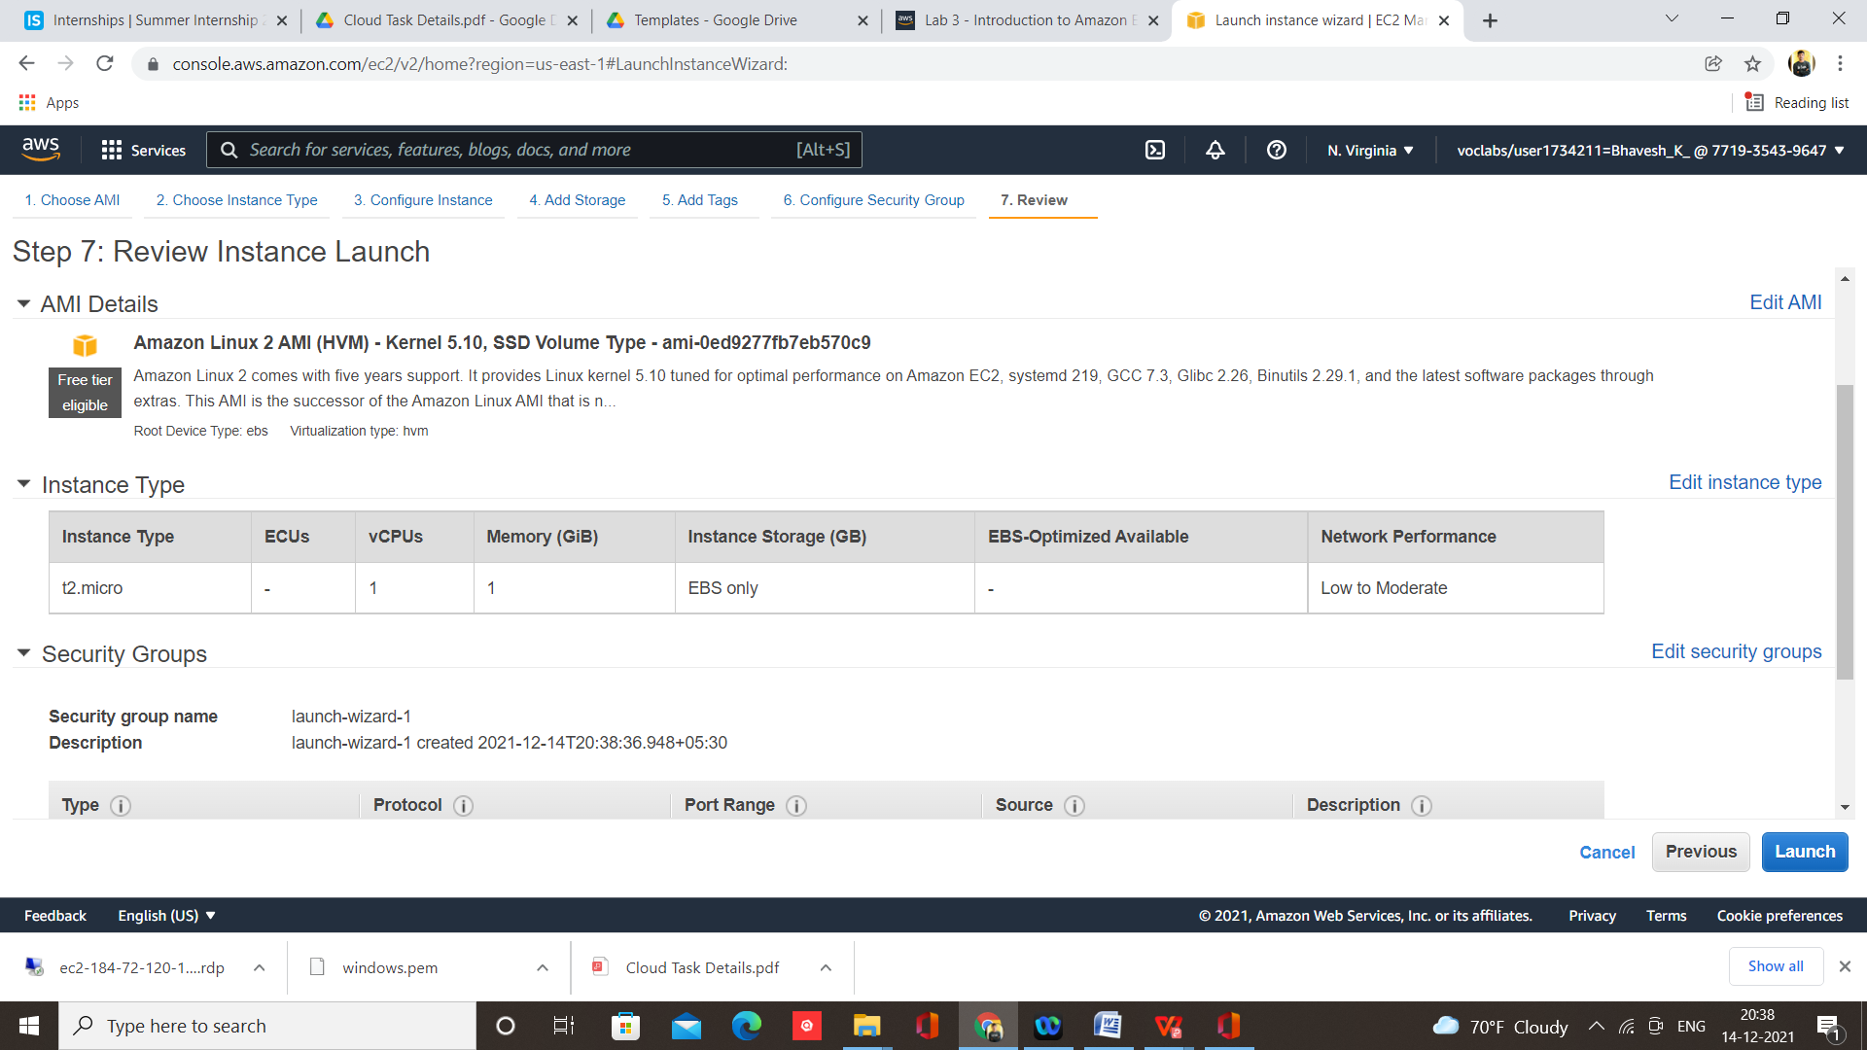

Step 9 – Download key pair and launch instances

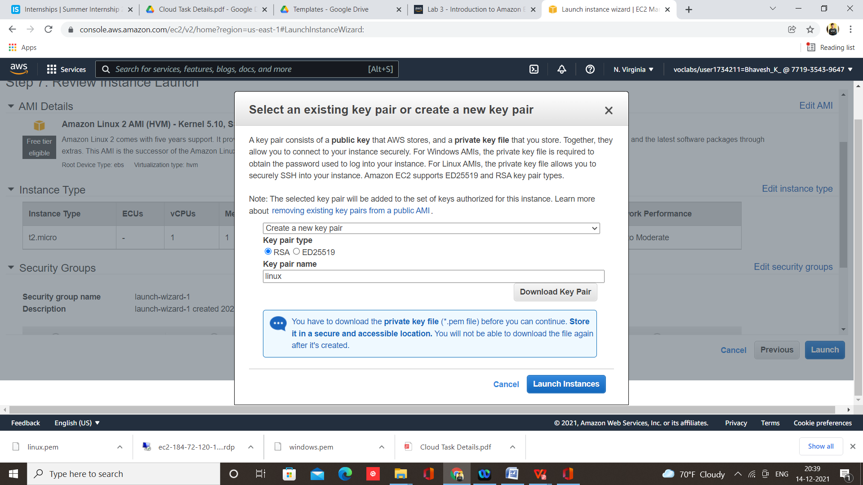

Step 10 – Click on Launch

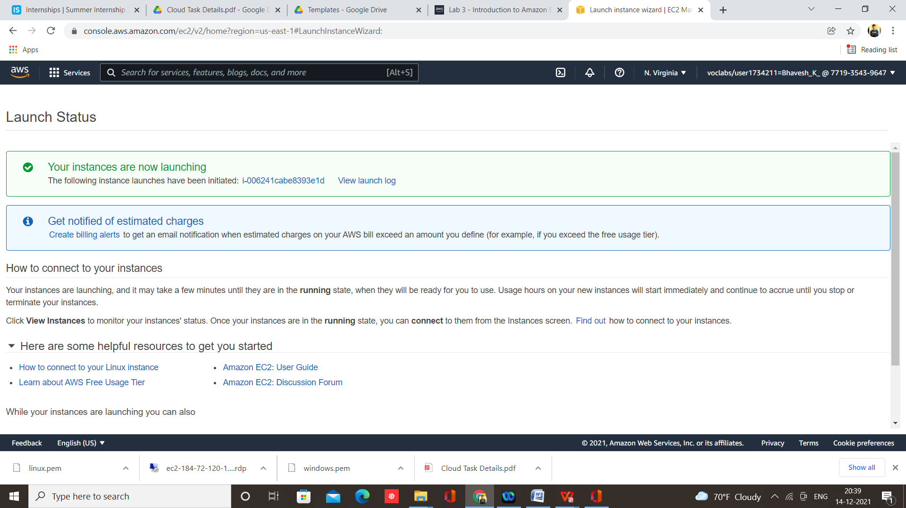

Step 11 – Open putty key generator and load .pem file

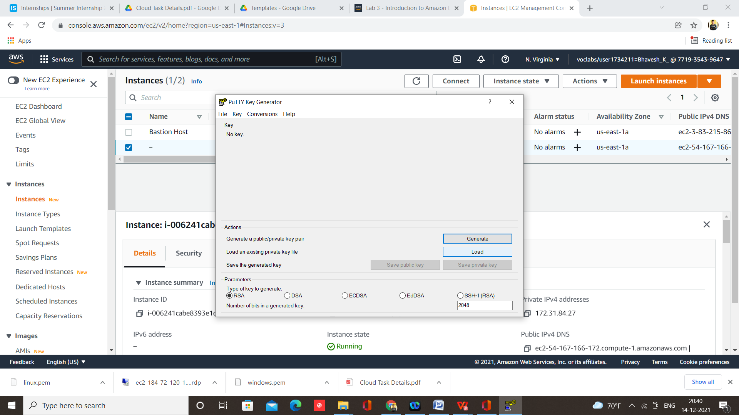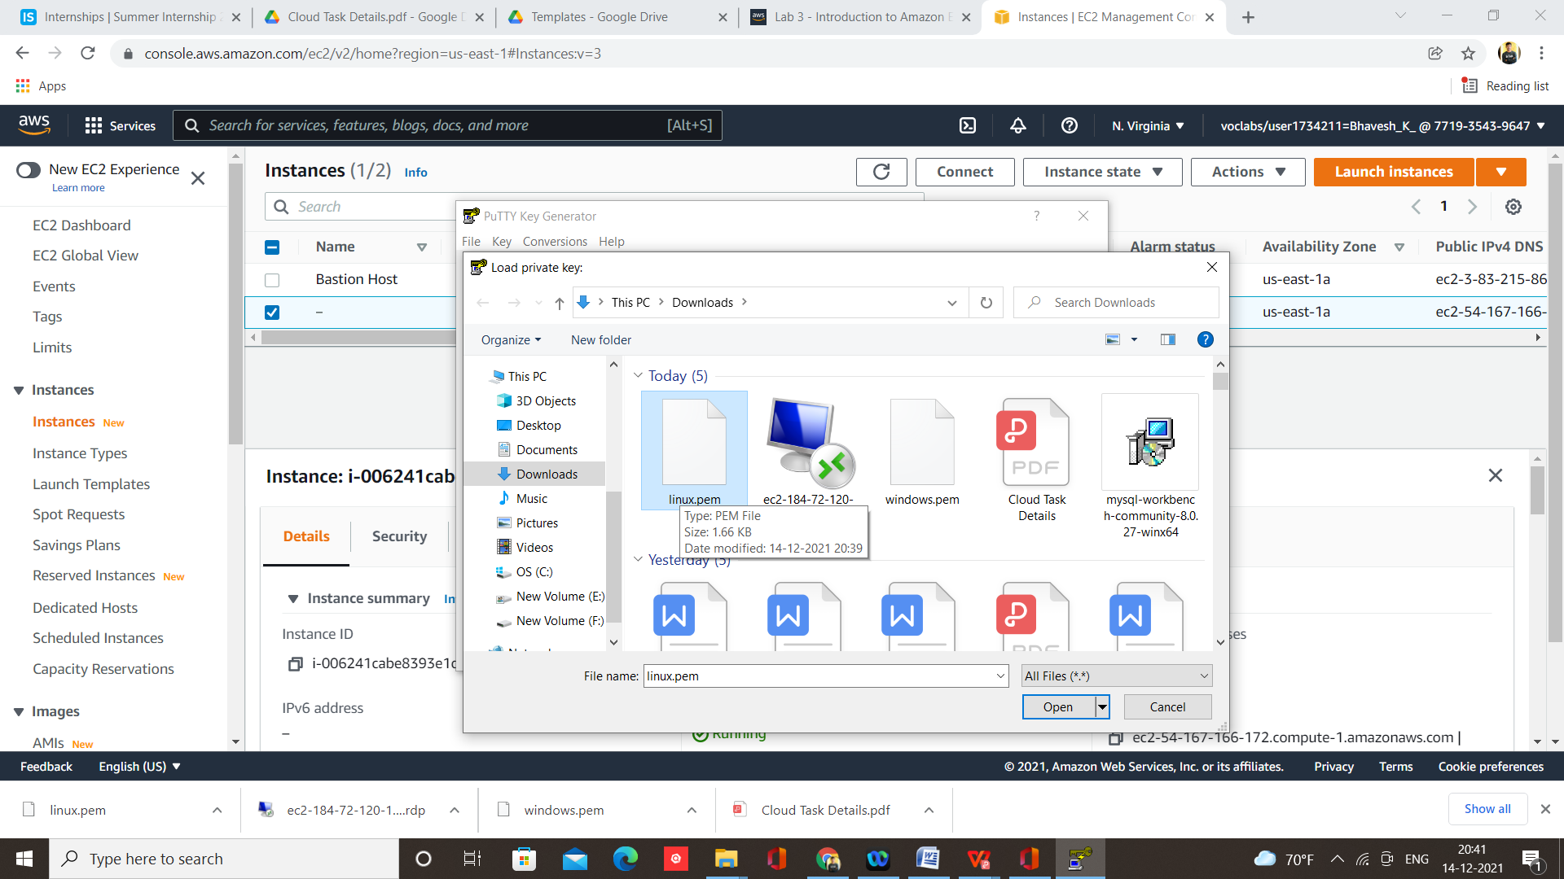

Step 11 – Then click save private key and give name to .ppk file and click on save

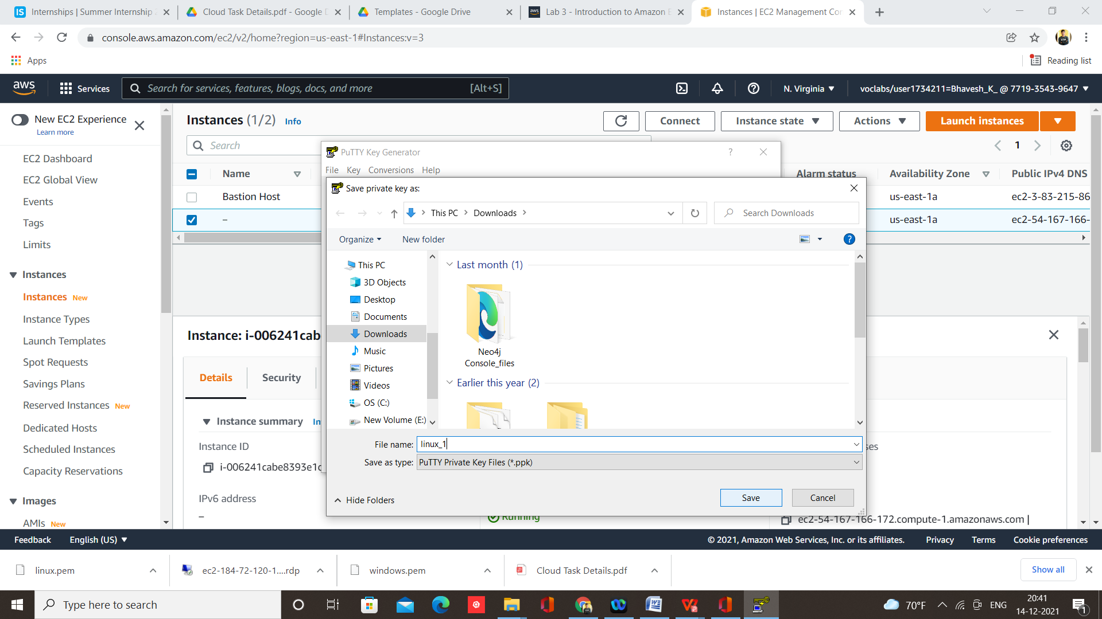

Step 12 – Now open PUTTY Configuration and paste Public IPv4 DNS

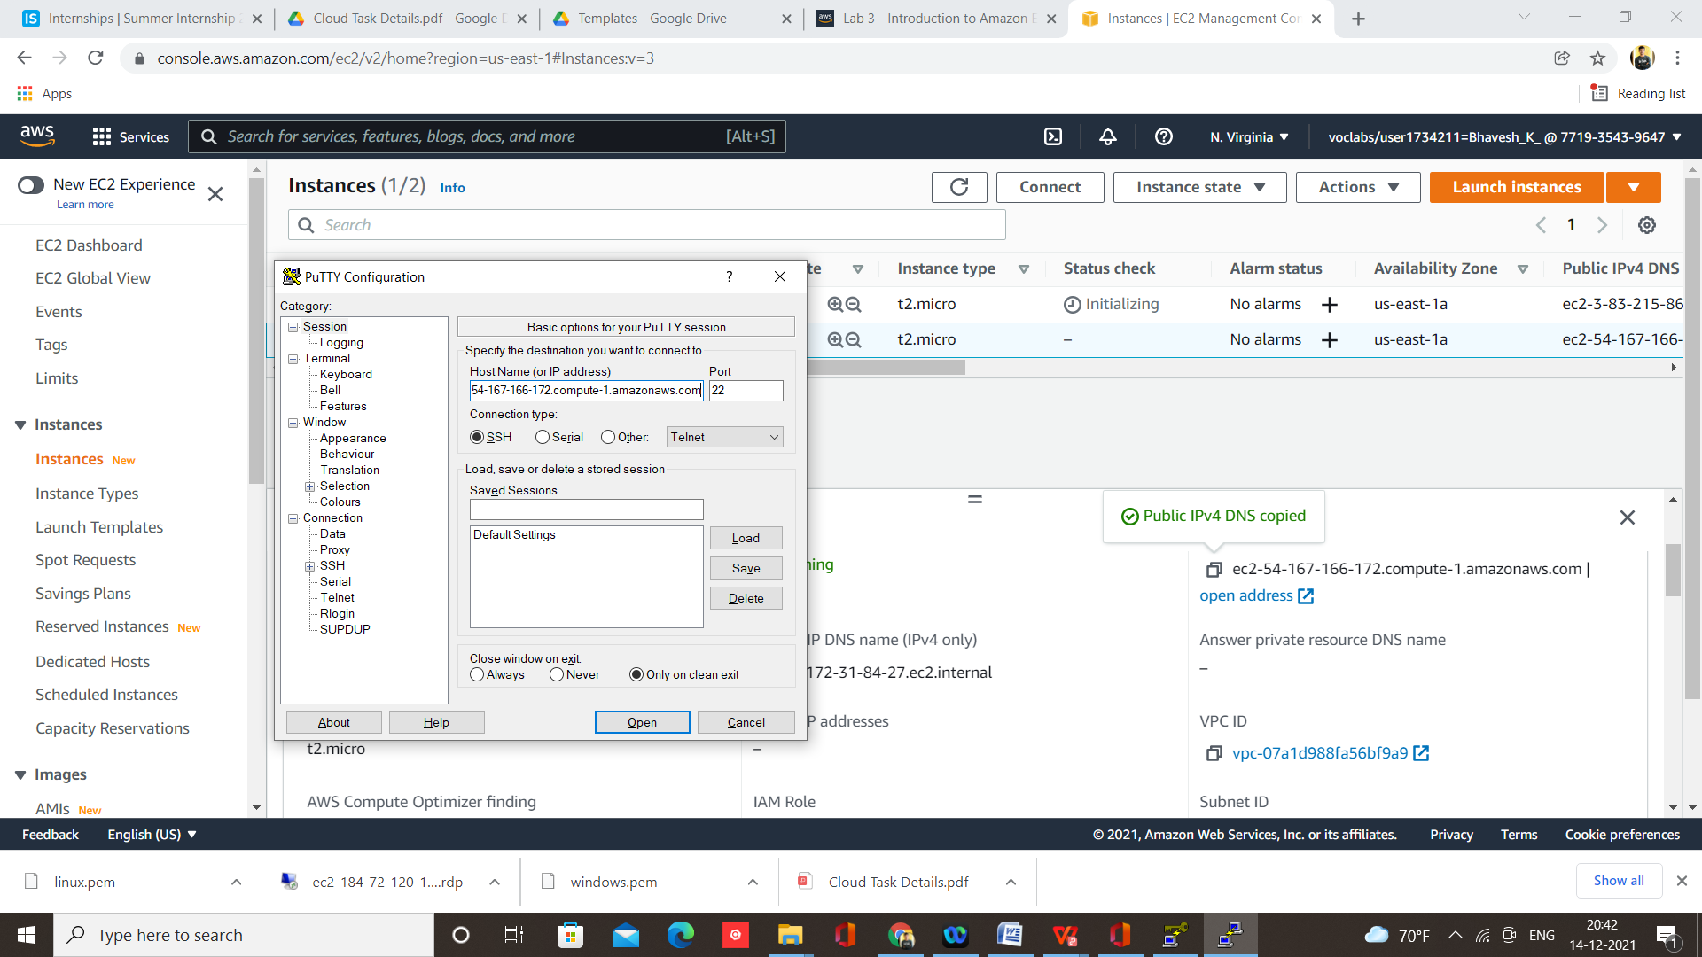

Step 13 – Click on SSH and open Auth and load .ppk file and click on open

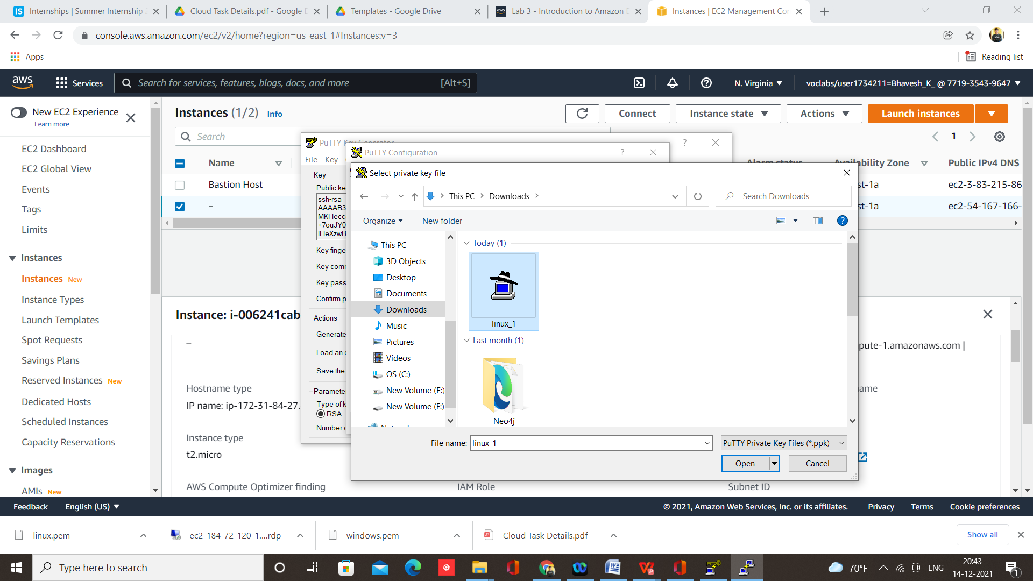

Step 14 – login as ec2-user

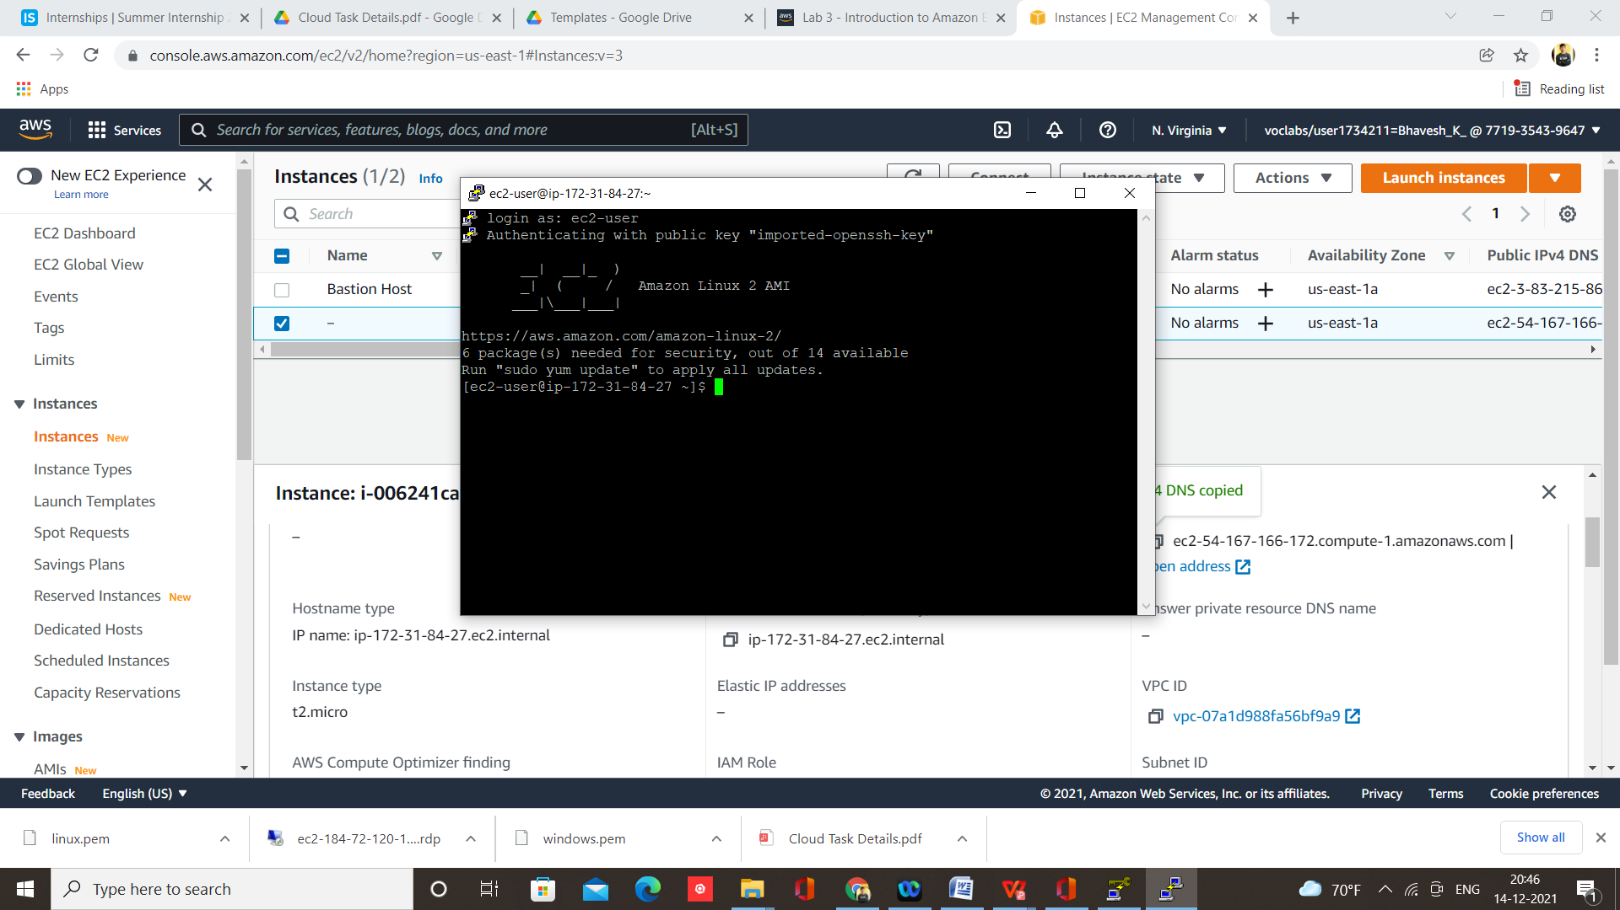

**Use and follow Commands on terminal -**

sudo su

yum update –y

yum install httpd –y

cd /var/www/html

echo “Hello Apache” > index.html

ls

service httpd start

chkconfig httpd on

Step 15 – Go to instance, click on security then open security group

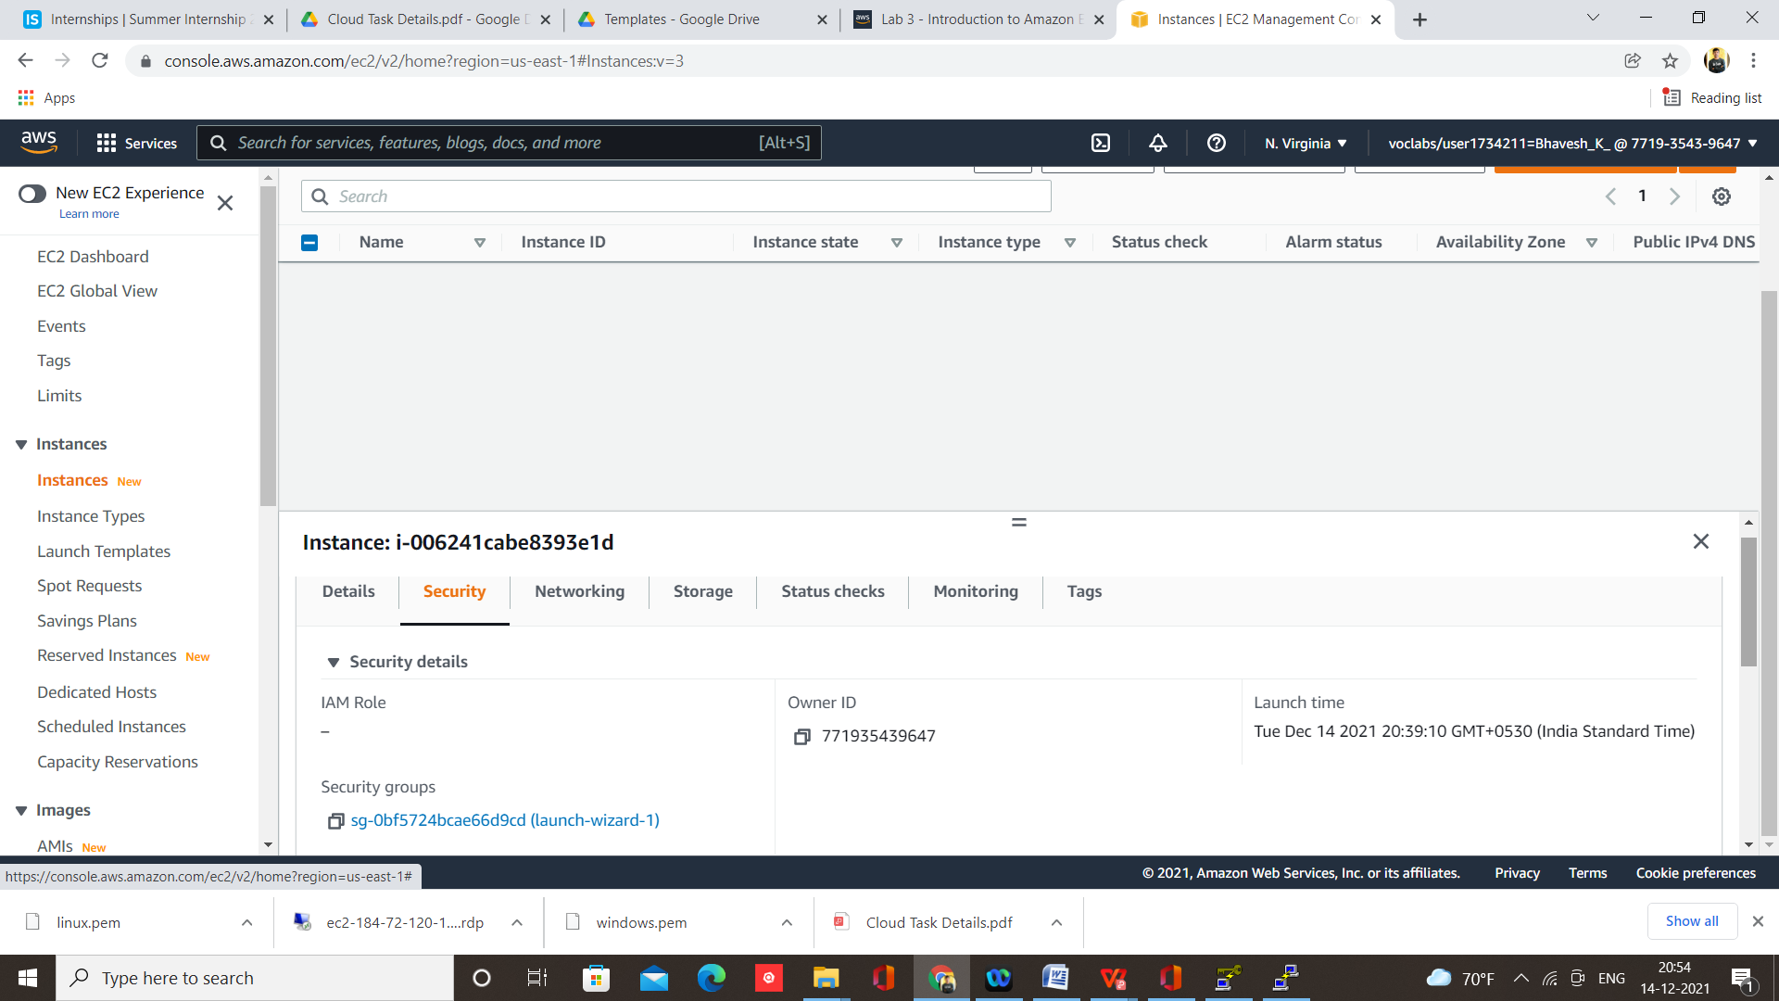

Step 16 – Edit inbound rule

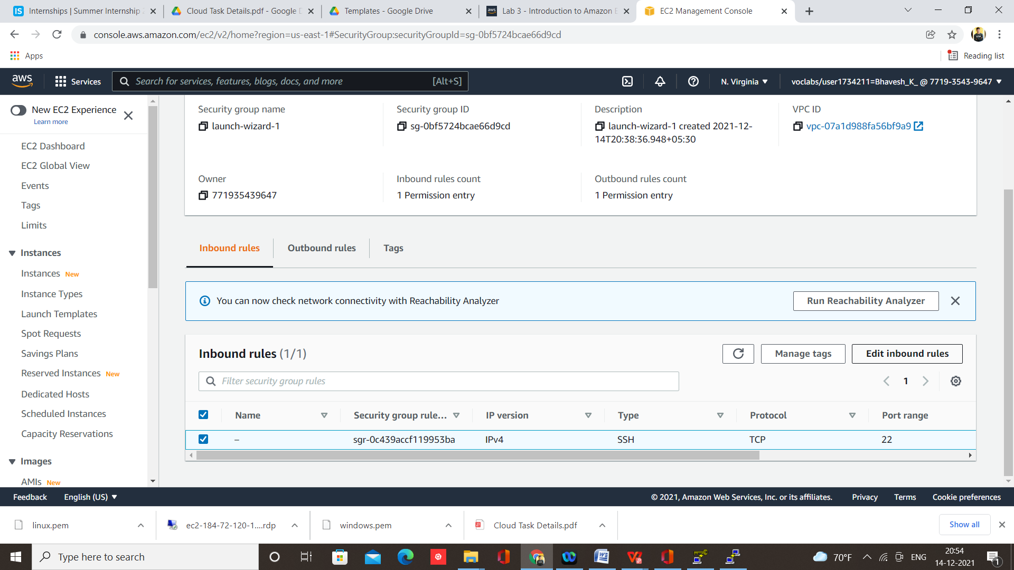

Step 17 – Add rule

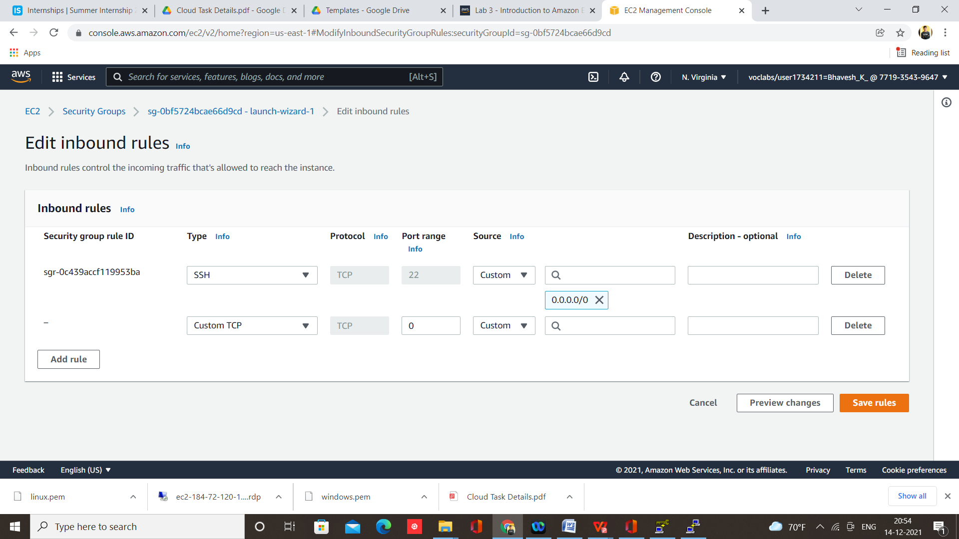

Step 18 – Add rule HTTP and HTTPS

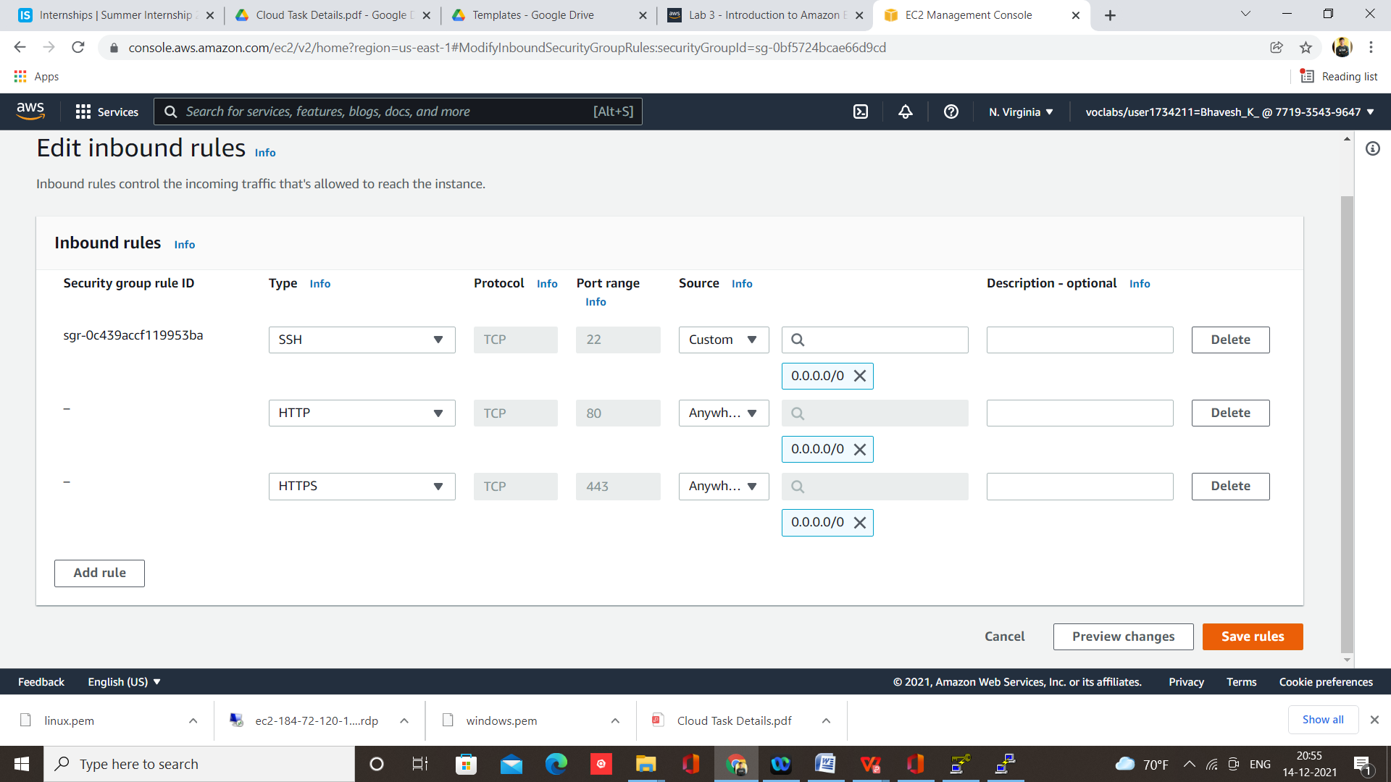

Step 19 – Copy Public IPv4 DNS

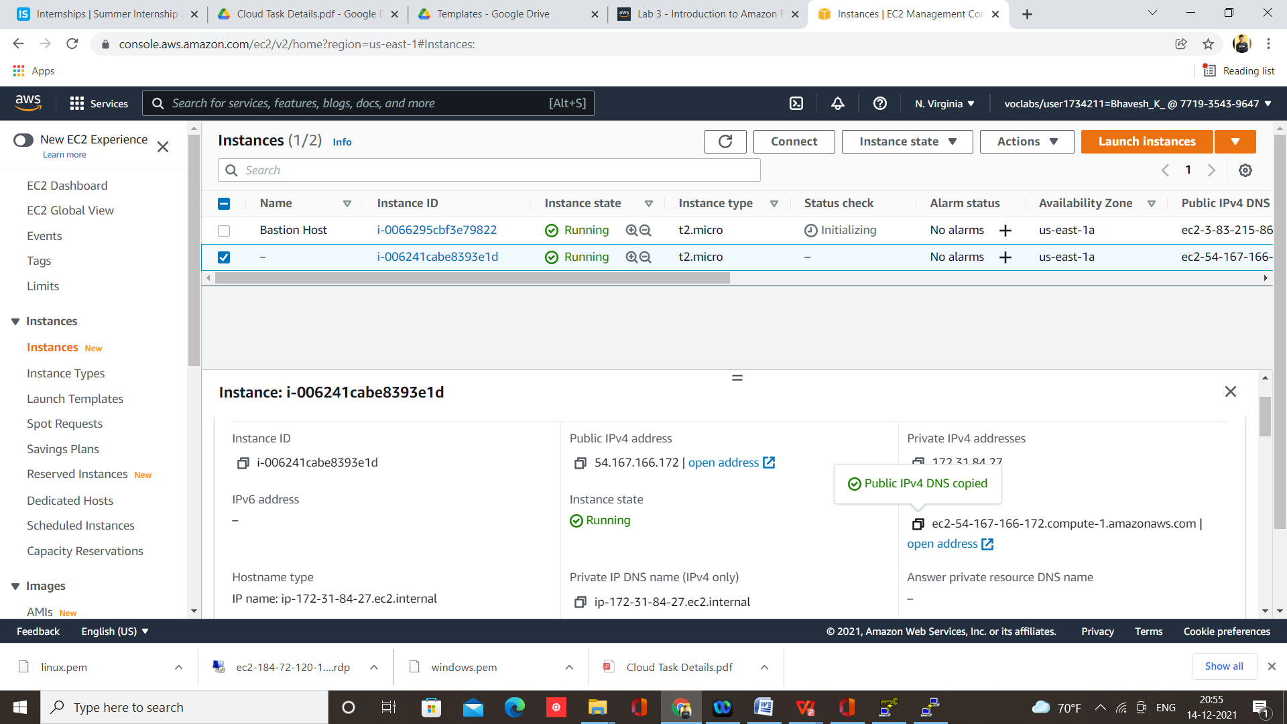

Step 20 – Paste Public IPv4 DNS on browser

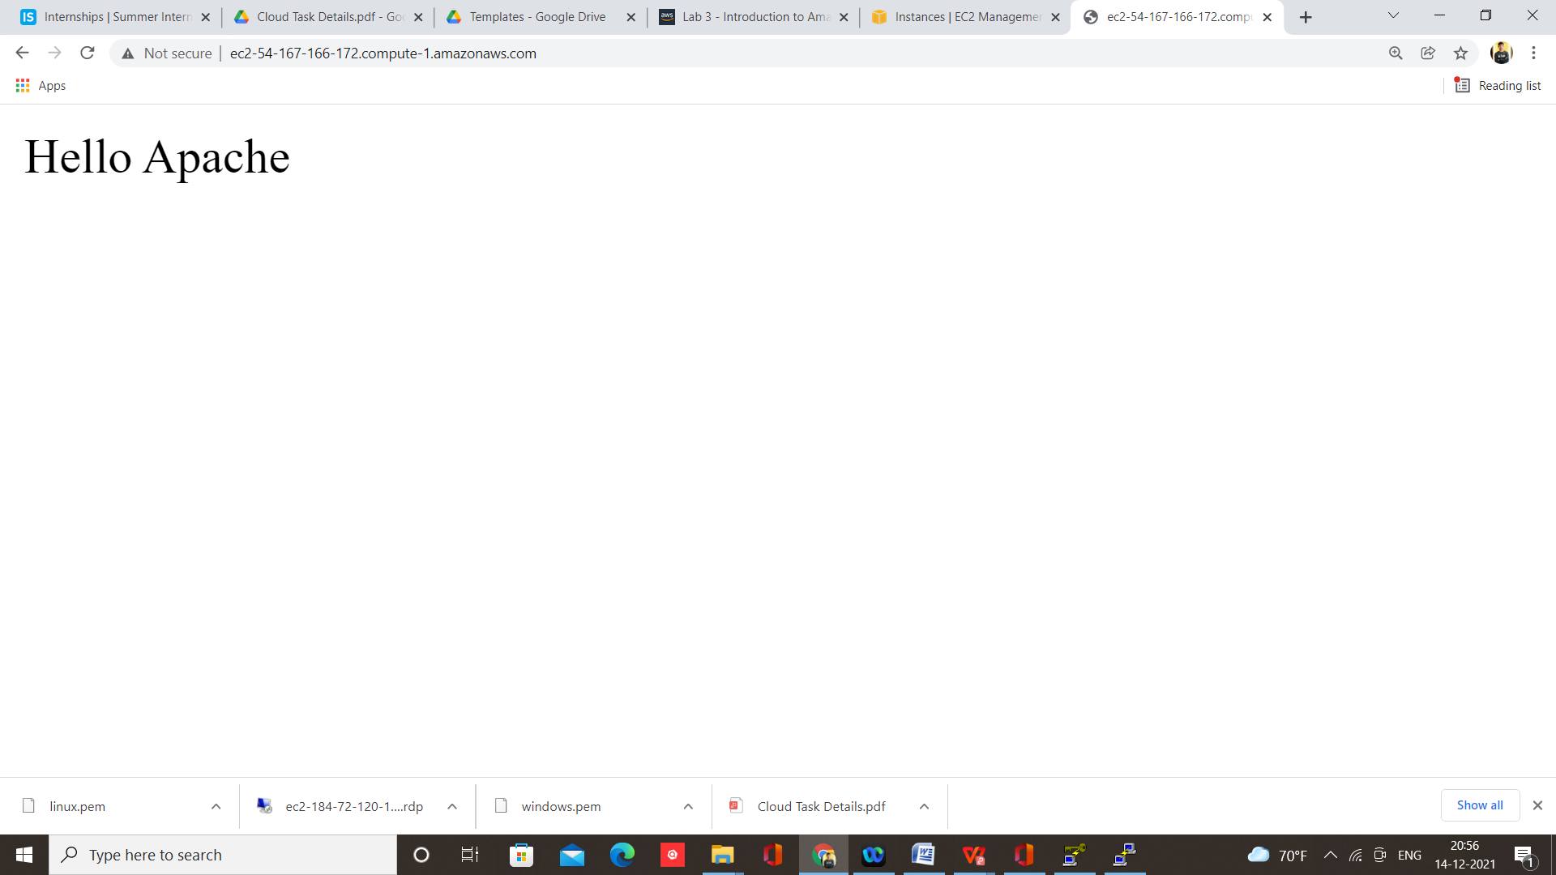

1. **How we can connect an AWS EC2 instance to a MySQL Server Database**

Step 1 – Select Course, I am using Intrduction course



Step 2 – Select Module 10 Lab 10

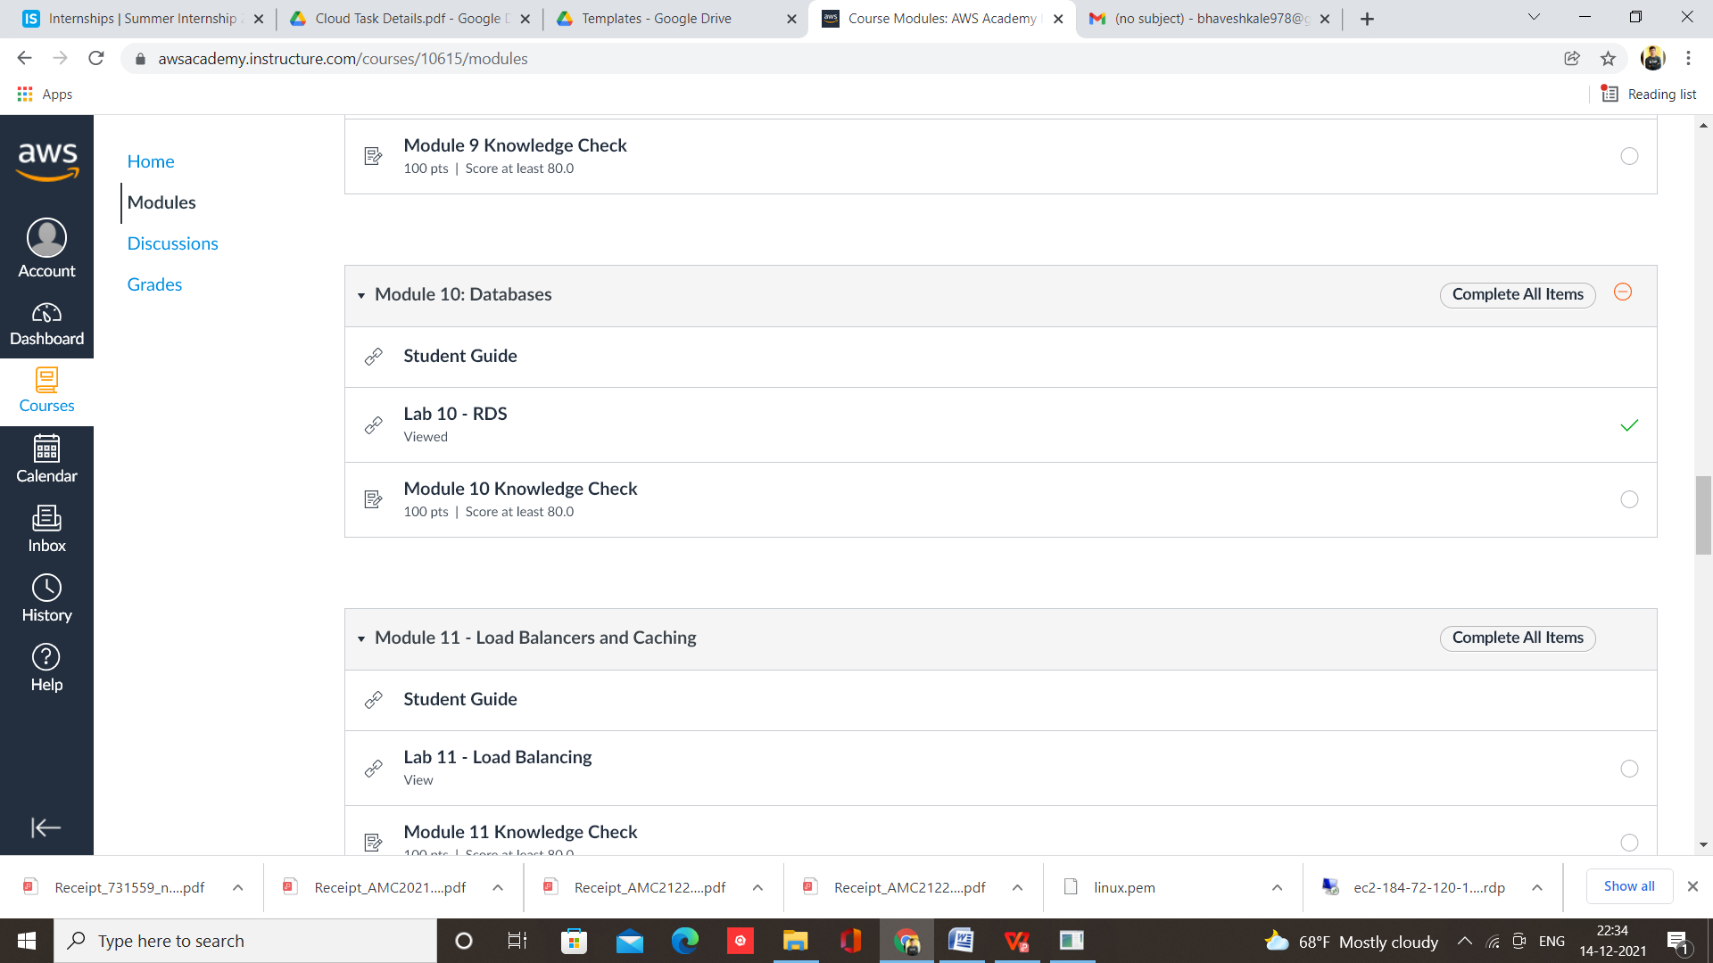

Step 3 – Start Lab and open AWS console

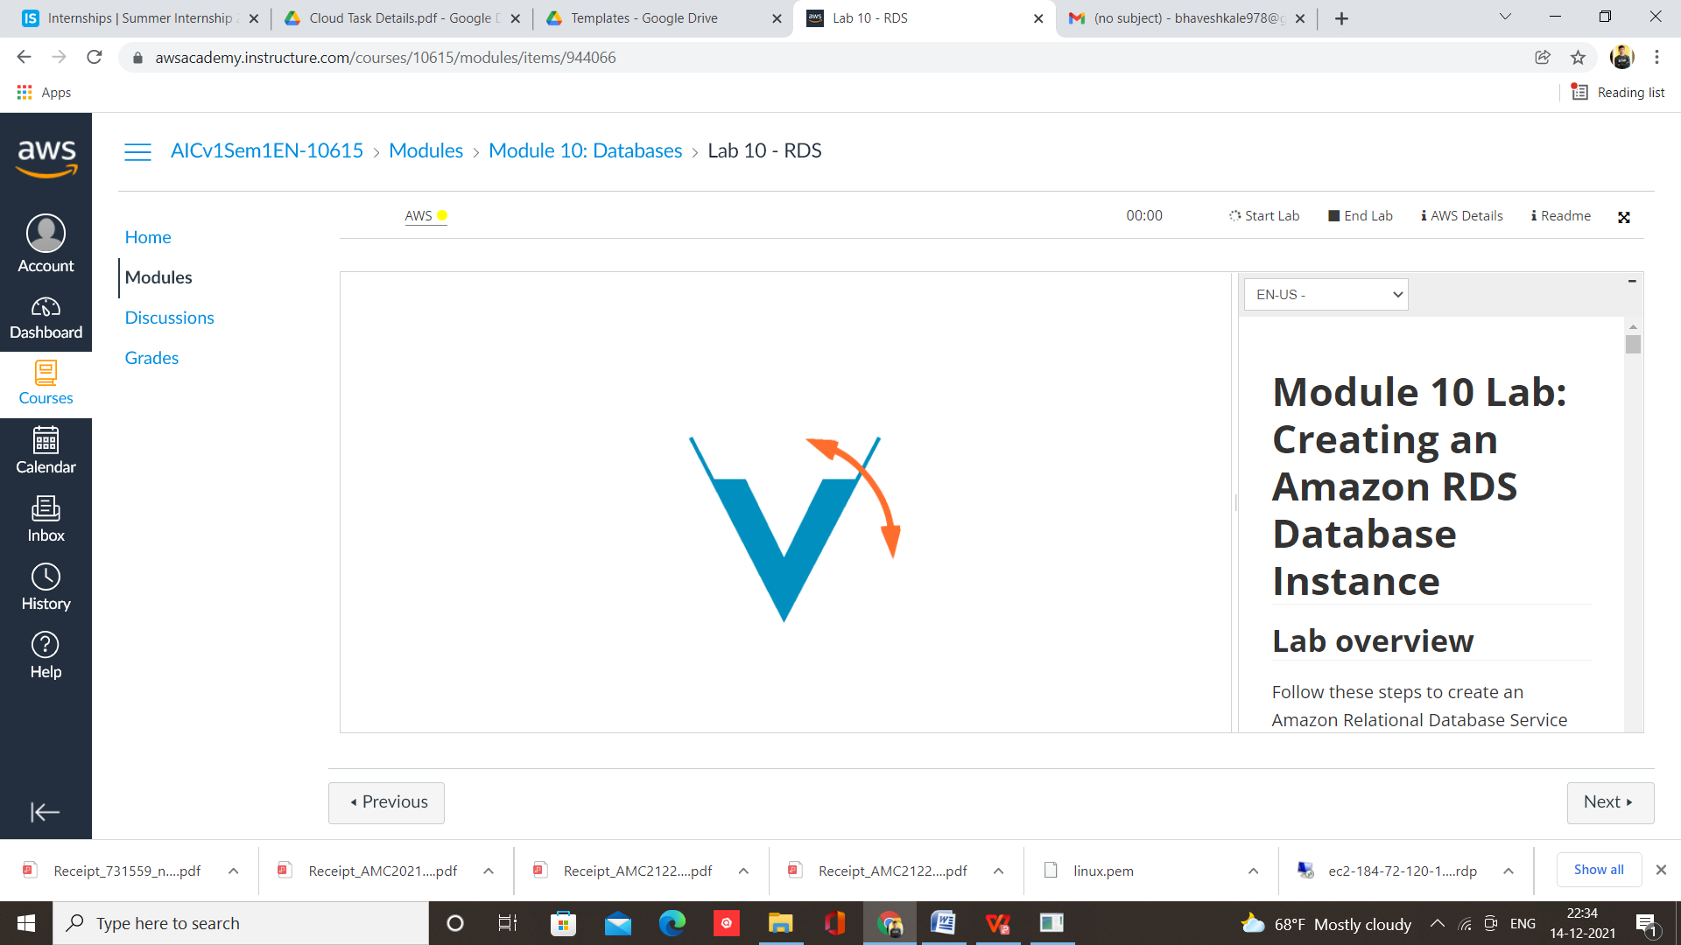

Step 4 – Select RDS from services

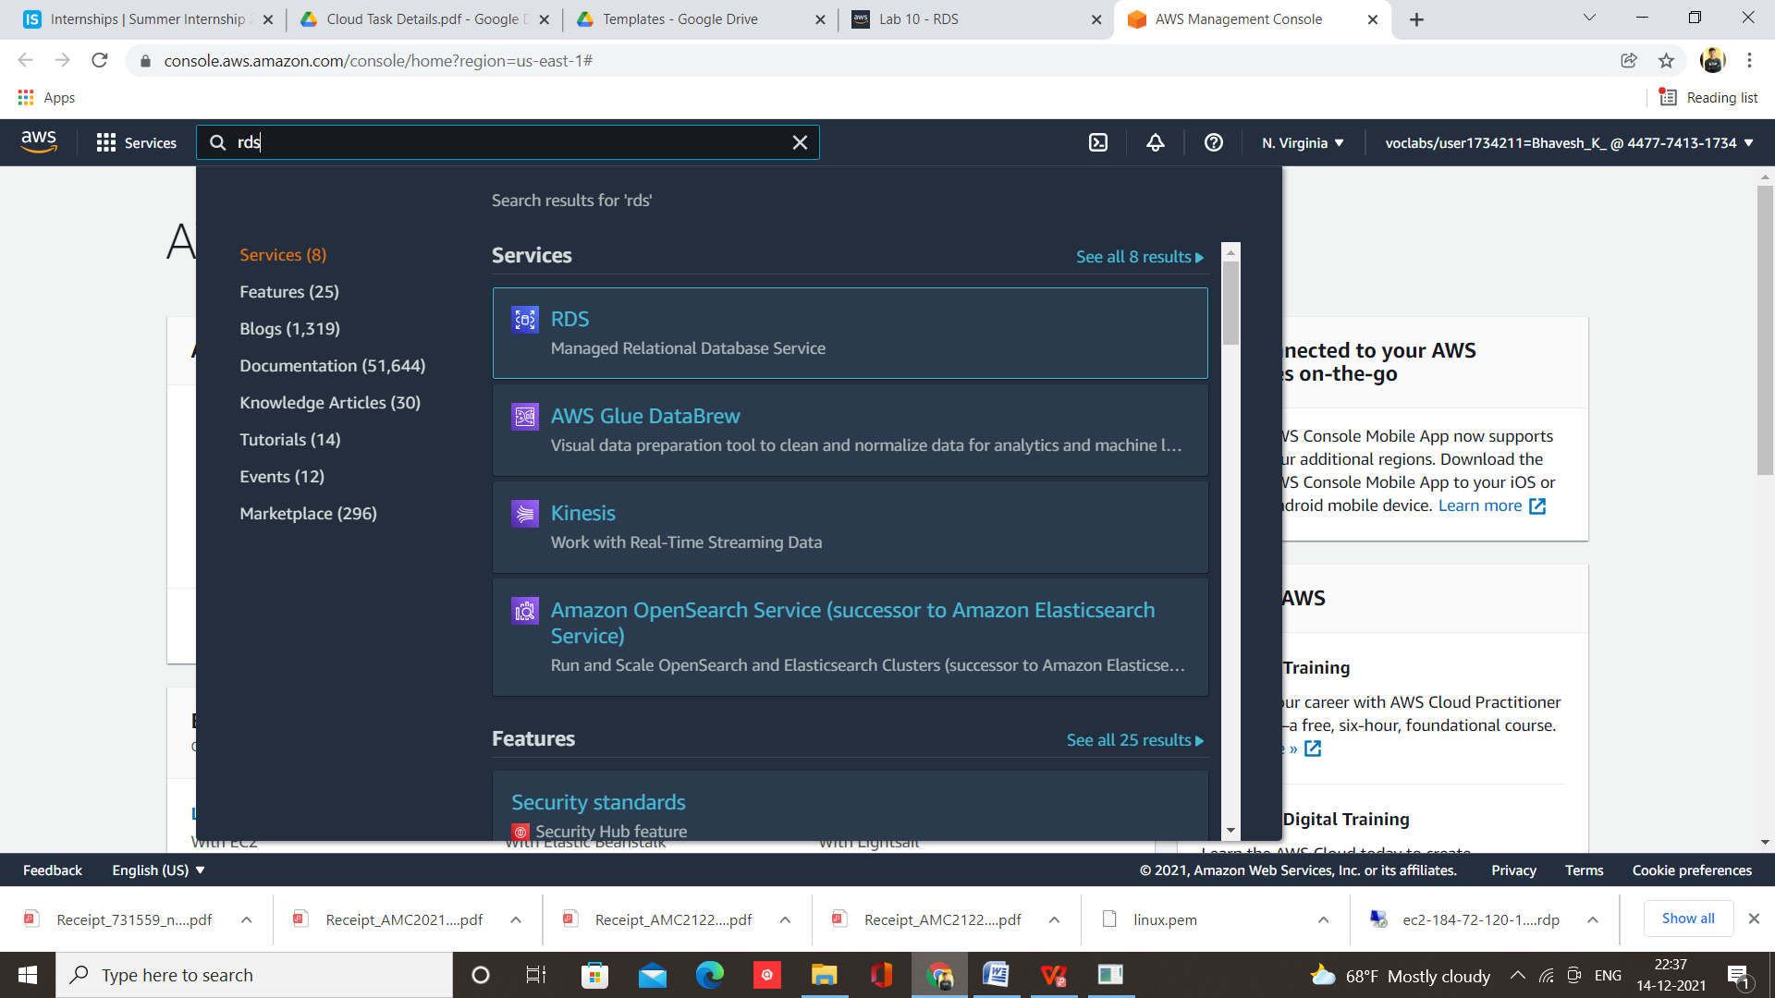

Step 5 – Click on Create Database

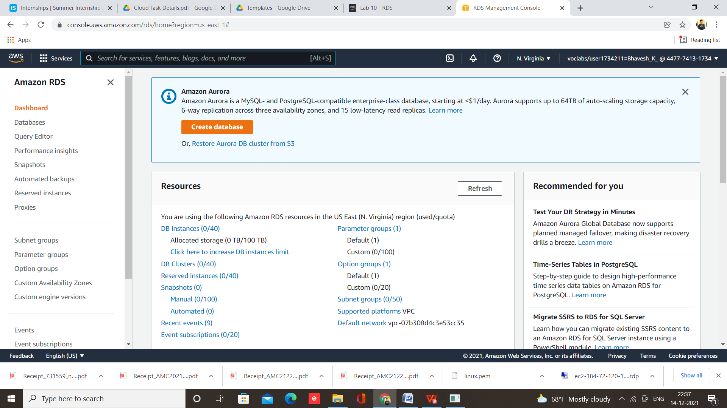

Step 6 – Select Engine MySQL

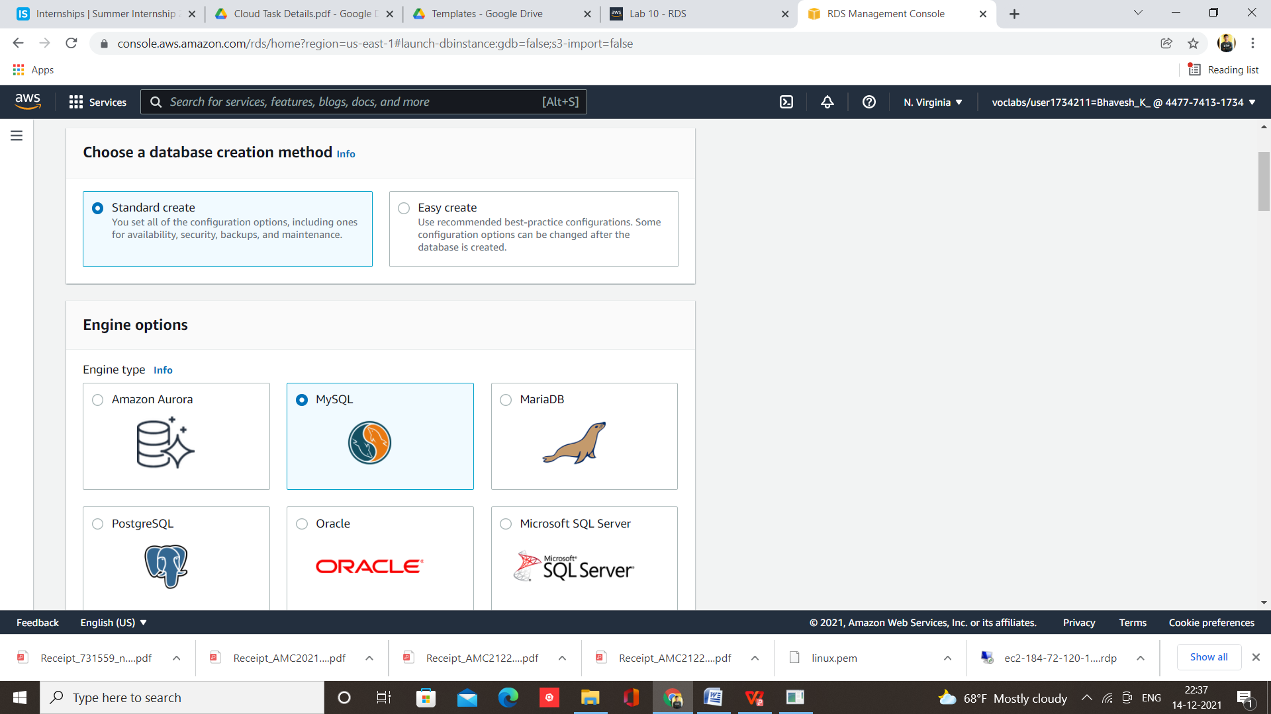

Step 7 – Give name and set password

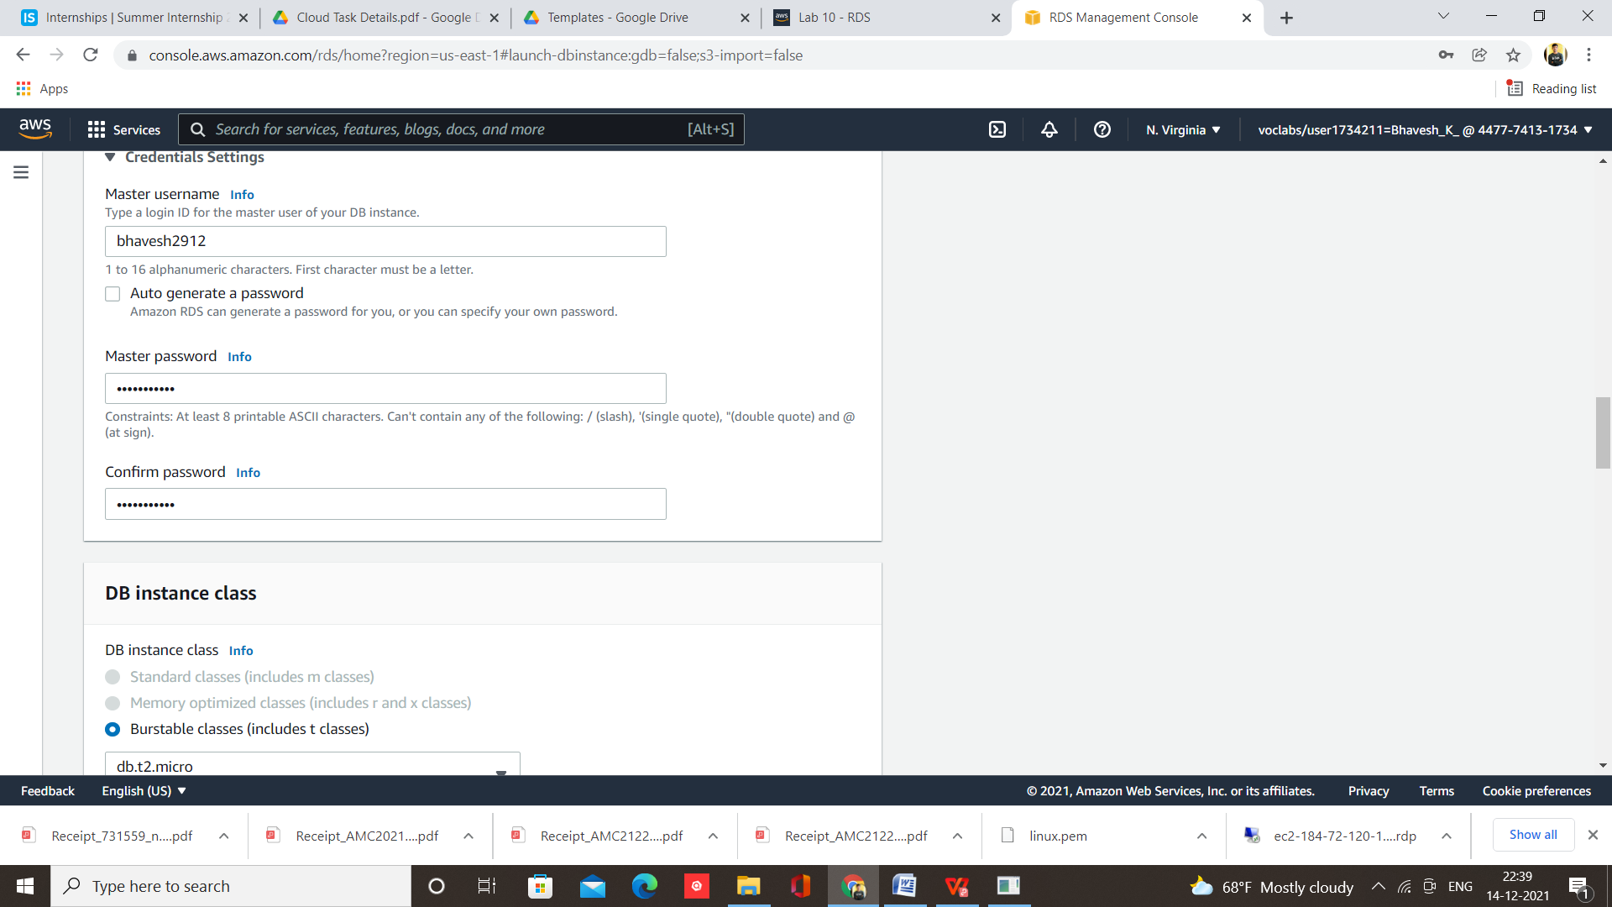

Step 8 – Database Created

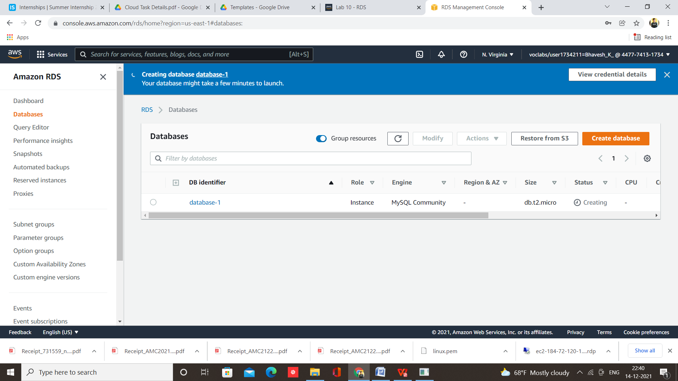

Step 9 – Open MySQL Workbench and click on connect database

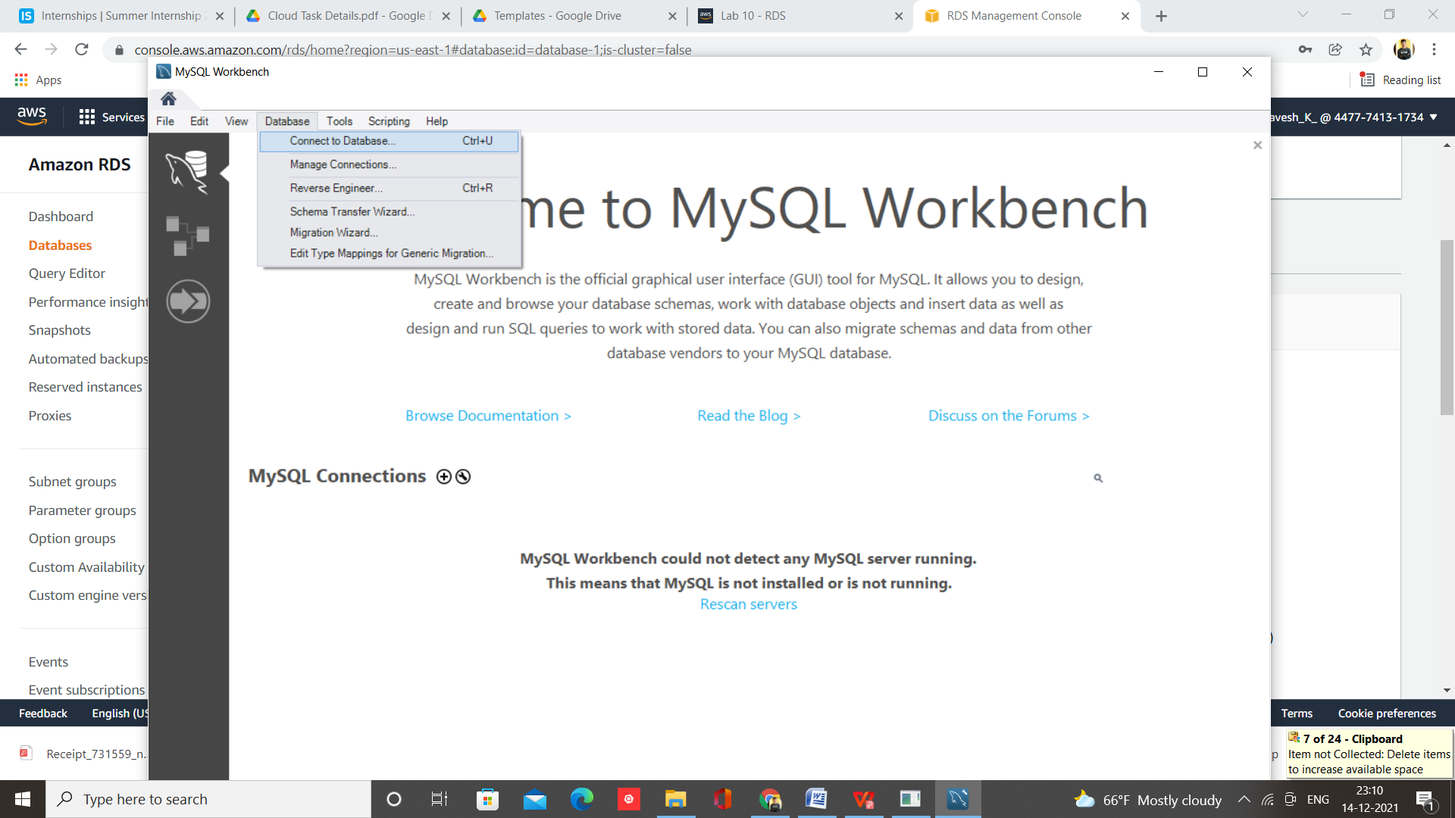

Step 10 – paste endpoint address of db and enter password

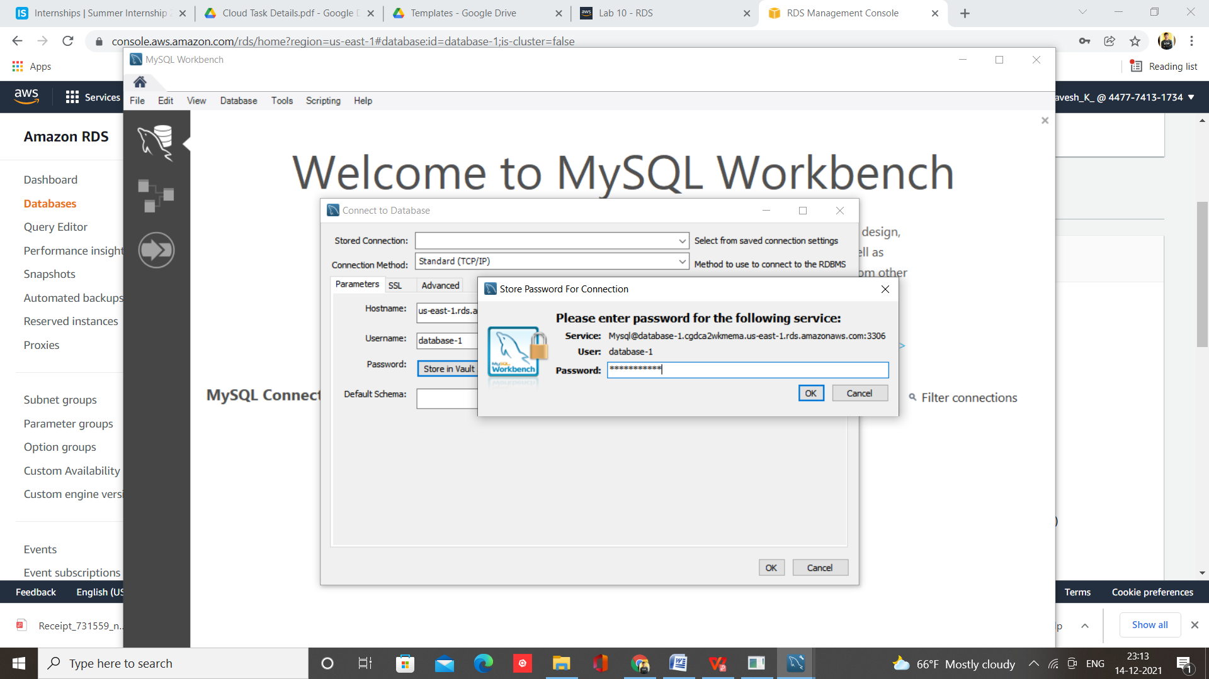

Step 11 – Now Instance is connected with MySQL Server Database

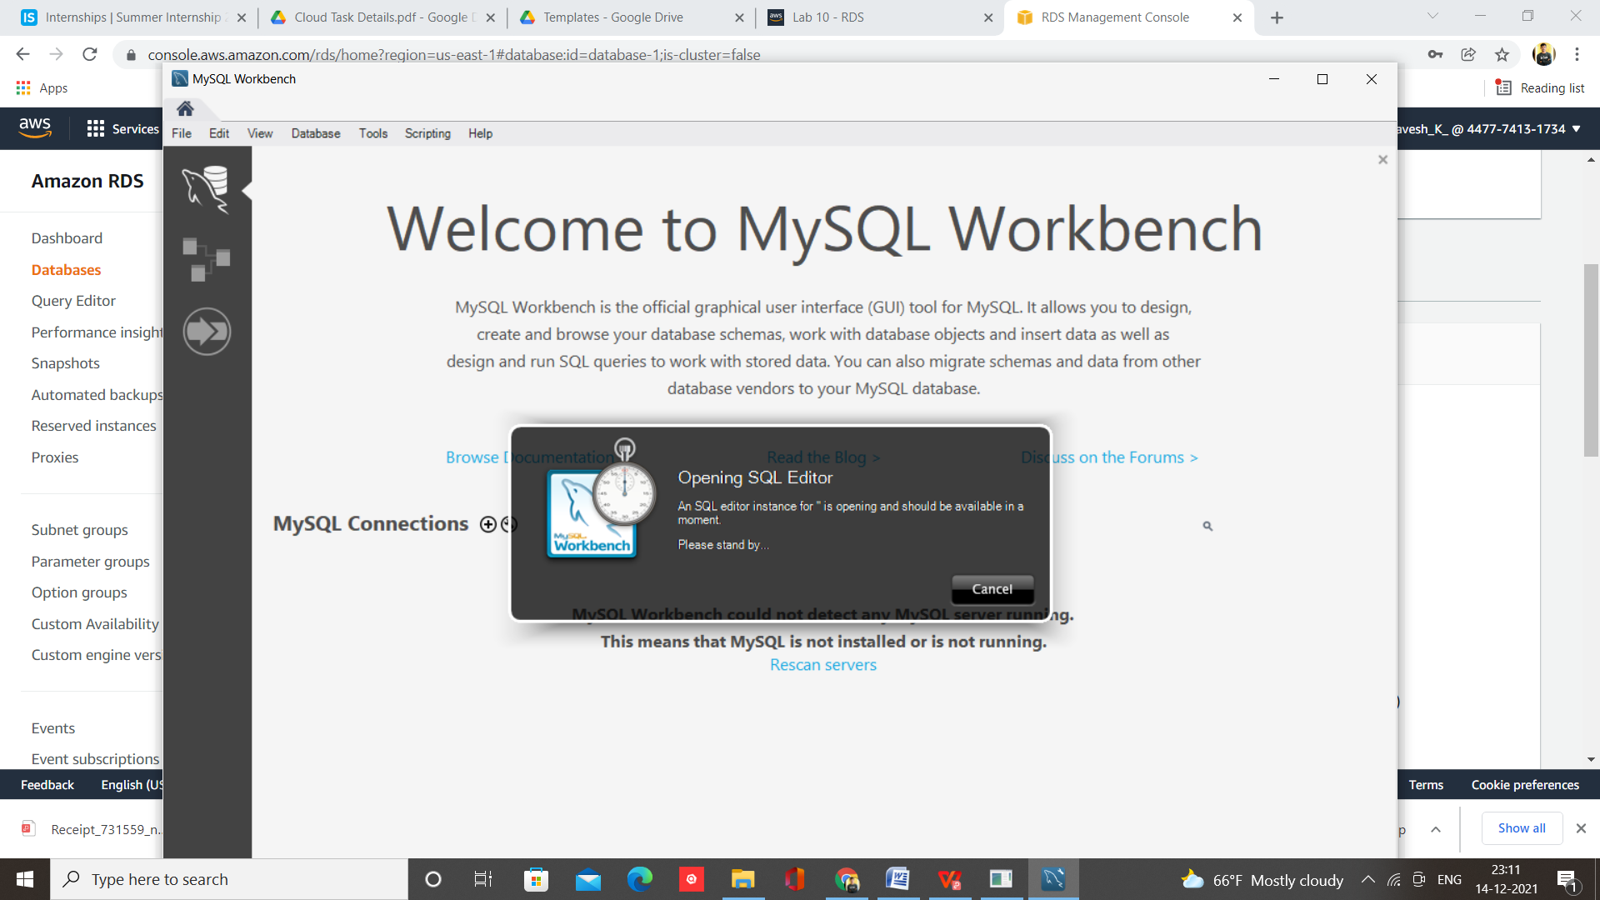

1. **How to connect a domain to your website using Route 53**

[Step 1: Register a custom domain with Route 53](https://docs.aws.amazon.com/AmazonS3/latest/userguide/website-hosting-custom-domain-walkthrough.html" \l "website-hosting-custom-domain-walkthrough-domain-registry)

[Step 2: Create two buckets](https://docs.aws.amazon.com/AmazonS3/latest/userguide/website-hosting-custom-domain-walkthrough.html" \l "root-domain-walkthrough-create-buckets)

[Step 3: Configure your root domain bucket for website hosting](https://docs.aws.amazon.com/AmazonS3/latest/userguide/website-hosting-custom-domain-walkthrough.html" \l "root-domain-walkthrough-configure-bucket-aswebsite)

[Step 4: Configure your subdomain bucket for website redirect](https://docs.aws.amazon.com/AmazonS3/latest/userguide/website-hosting-custom-domain-walkthrough.html" \l "root-domain-walkthrough-configure-redirect)

[Step 5: Configure logging for website traffic](https://docs.aws.amazon.com/AmazonS3/latest/userguide/website-hosting-custom-domain-walkthrough.html" \l "root-domain-walkthrough-configure-logging)

[Step 6: Upload index and website content](https://docs.aws.amazon.com/AmazonS3/latest/userguide/website-hosting-custom-domain-walkthrough.html" \l "upload-website-content)

[Step 7: Upload an error document](https://docs.aws.amazon.com/AmazonS3/latest/userguide/website-hosting-custom-domain-walkthrough.html" \l "configure-error-document-root-domain)

[Step 8: Edit S3 Block Public Access settings](https://docs.aws.amazon.com/AmazonS3/latest/userguide/website-hosting-custom-domain-walkthrough.html" \l "root-domain-walkthrough-configure-bucket-permissions)

[Step 9: Attach a bucket policy](https://docs.aws.amazon.com/AmazonS3/latest/userguide/website-hosting-custom-domain-walkthrough.html" \l "add-bucket-policy-root-domain)

[Step 10: Test your domain endpoint](https://docs.aws.amazon.com/AmazonS3/latest/userguide/website-hosting-custom-domain-walkthrough.html" \l "root-domain-walkthrough-test-website)

[Step 11: Add alias records for your domain and subdomain](https://docs.aws.amazon.com/AmazonS3/latest/userguide/website-hosting-custom-domain-walkthrough.html" \l "root-domain-walkthrough-add-record-to-hostedzone)

[Step 12: Test the website](https://docs.aws.amazon.com/AmazonS3/latest/userguide/website-hosting-custom-domain-walkthrough.html" \l "root-domain-testing)

1. **Demonstrate the hosted website**

Step 1 – Login and select course

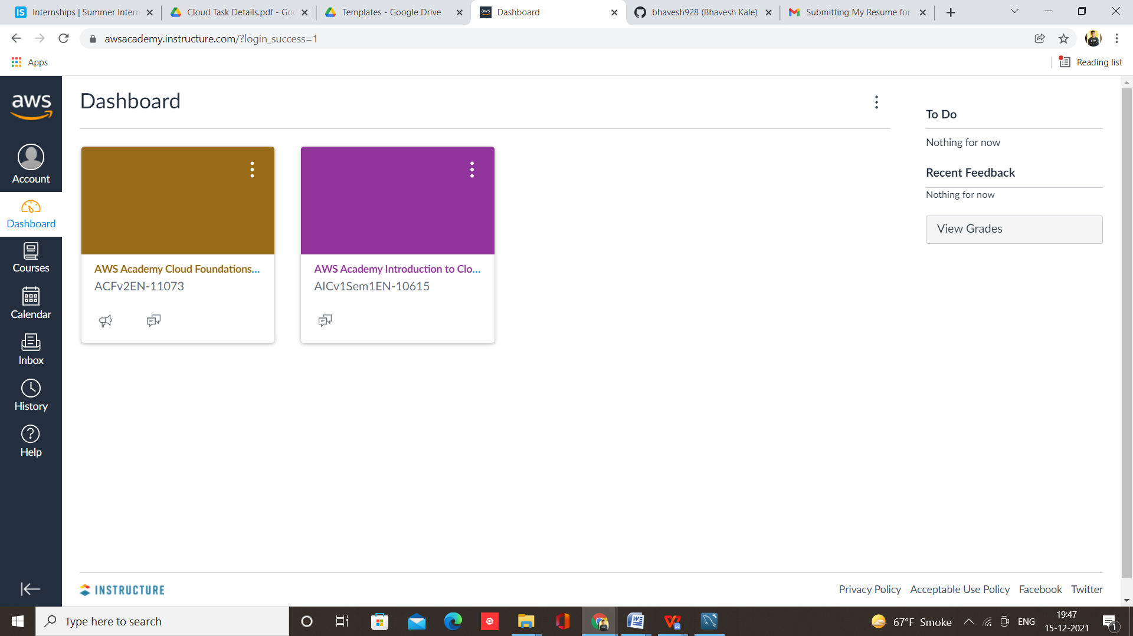

Step 2 – Select Module & Lab, I am selecting Module 4 Lab 4.2

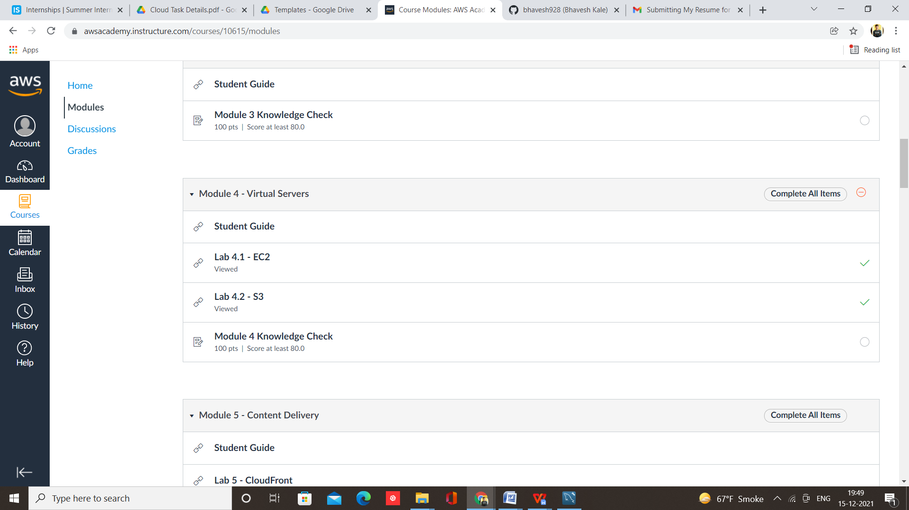

Step 3 – Start Lab and Launch AWS console

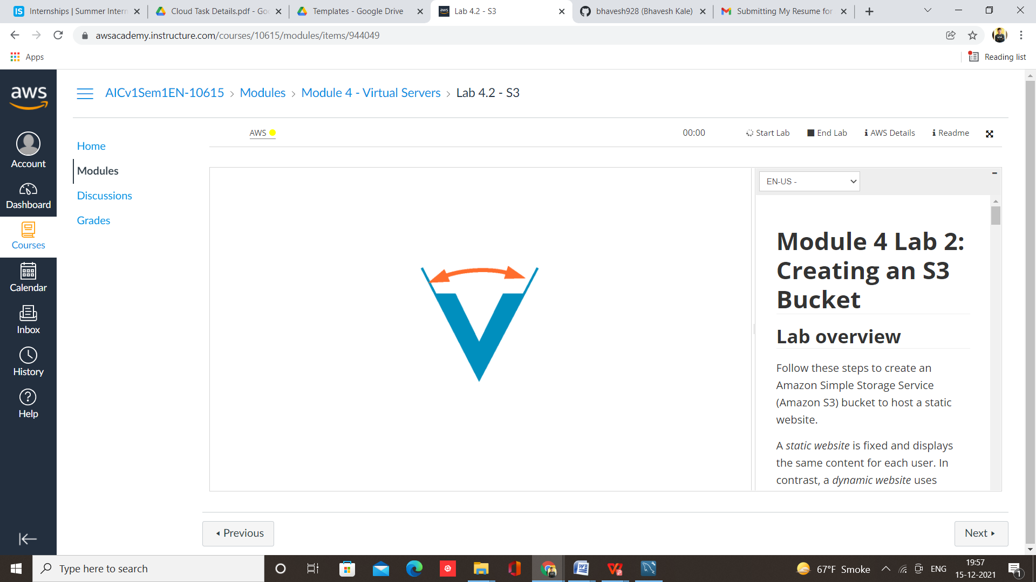

Step 4 – Select S3 from services

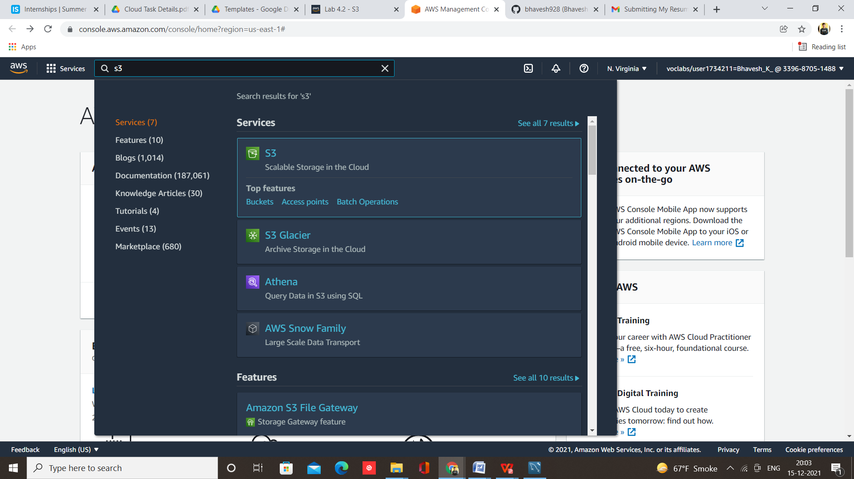

Step 5 – Click on create bucket

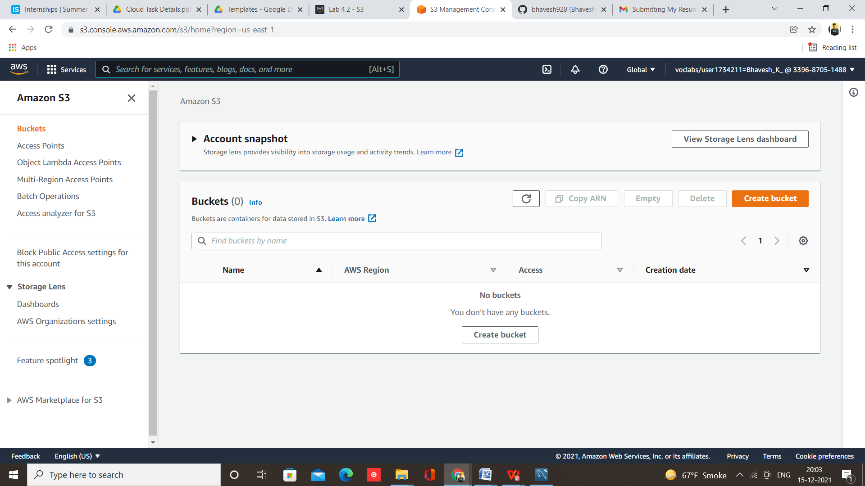

Step 6 – Give name to bucket

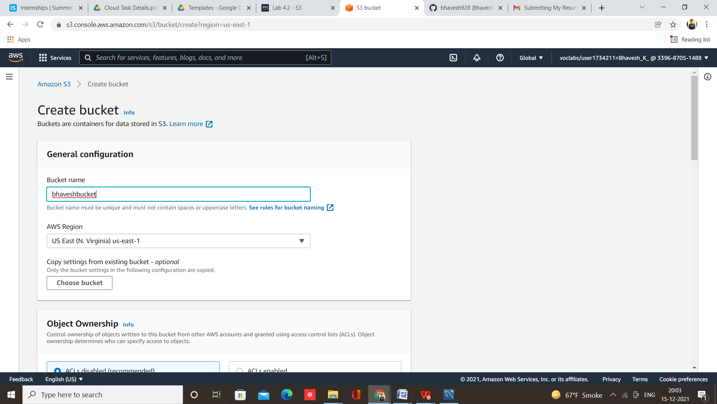

Step 7 –Click on ACLs enabled and allow public access

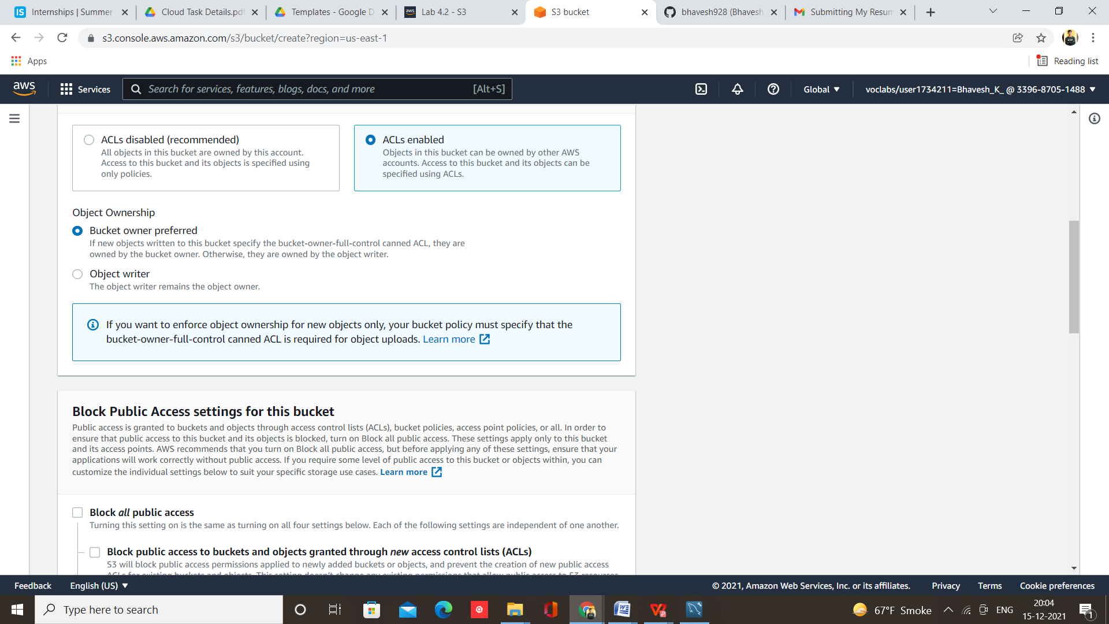

Step 8 – Click on create bucket

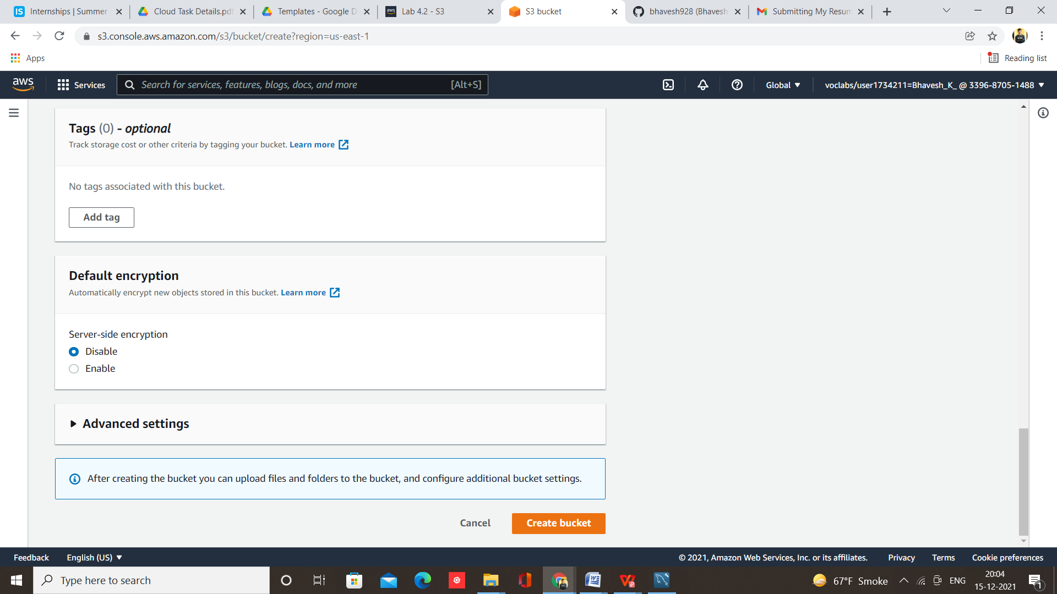

Step 9 – Bucket created successfully, Now click on bucket

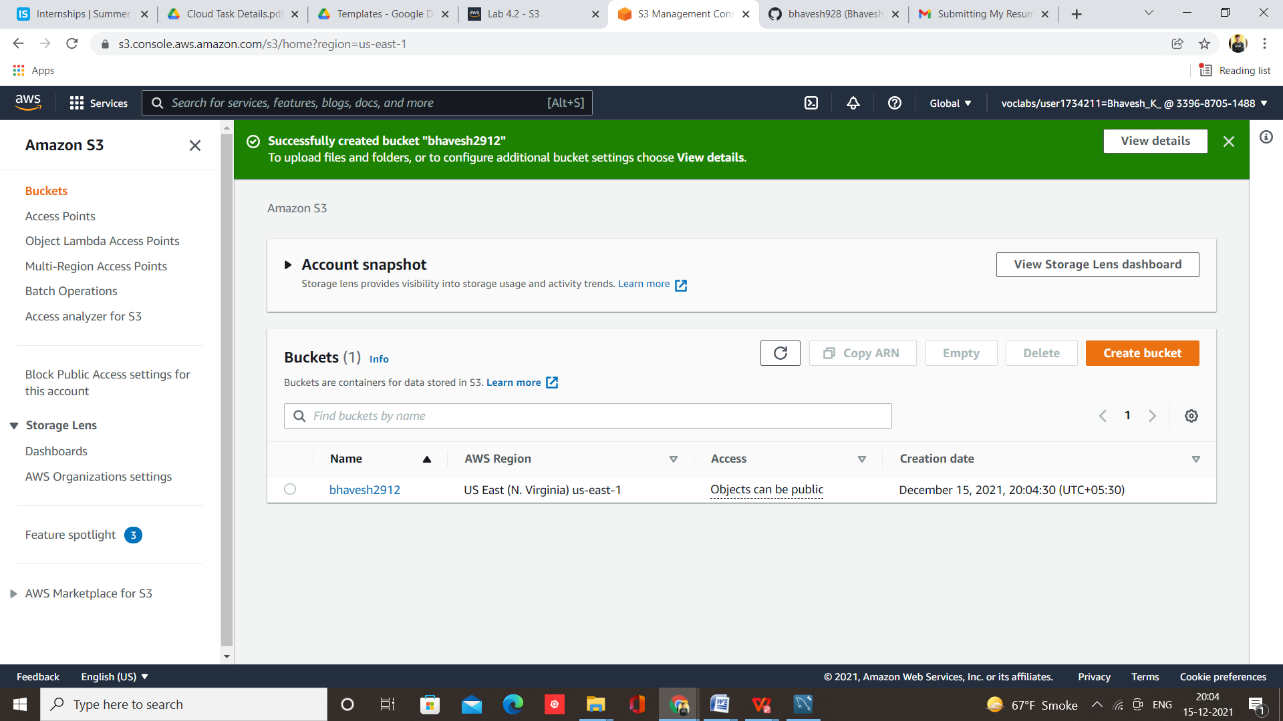

Step 10 – Now click on upload

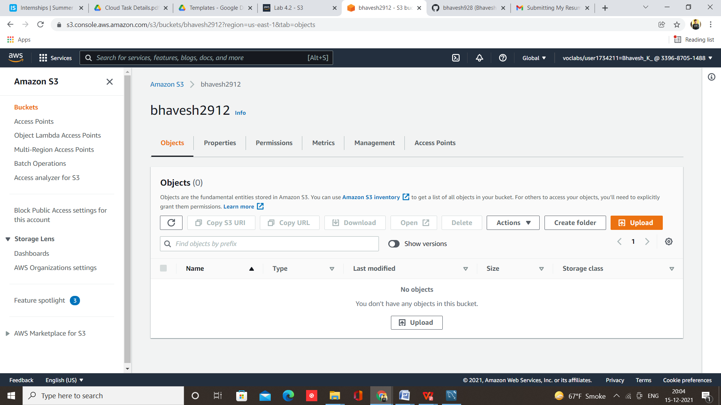

Step 11 – Add files

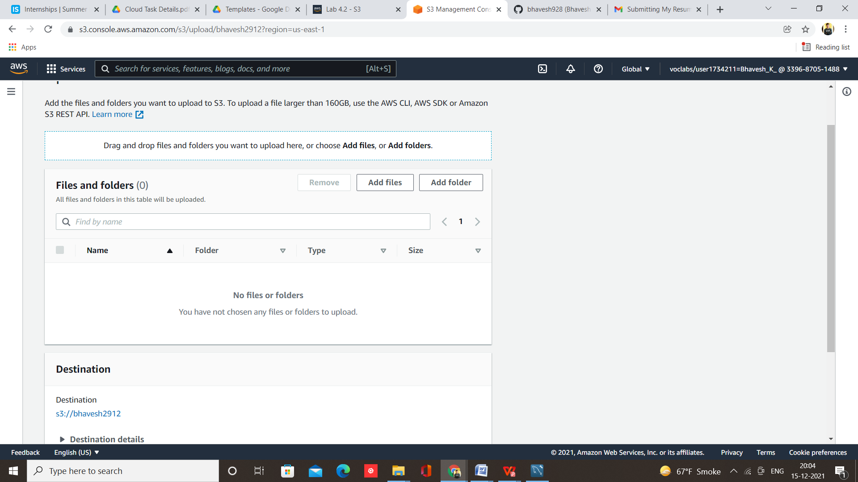

Step 12 – Select your website code

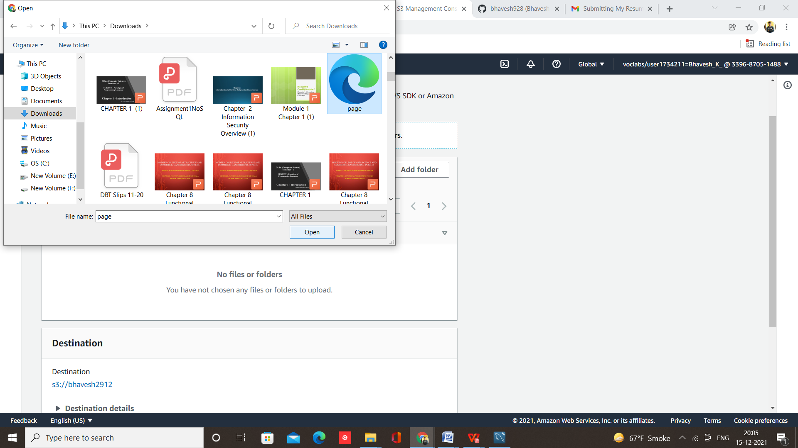

Step 13 – Now click on upload

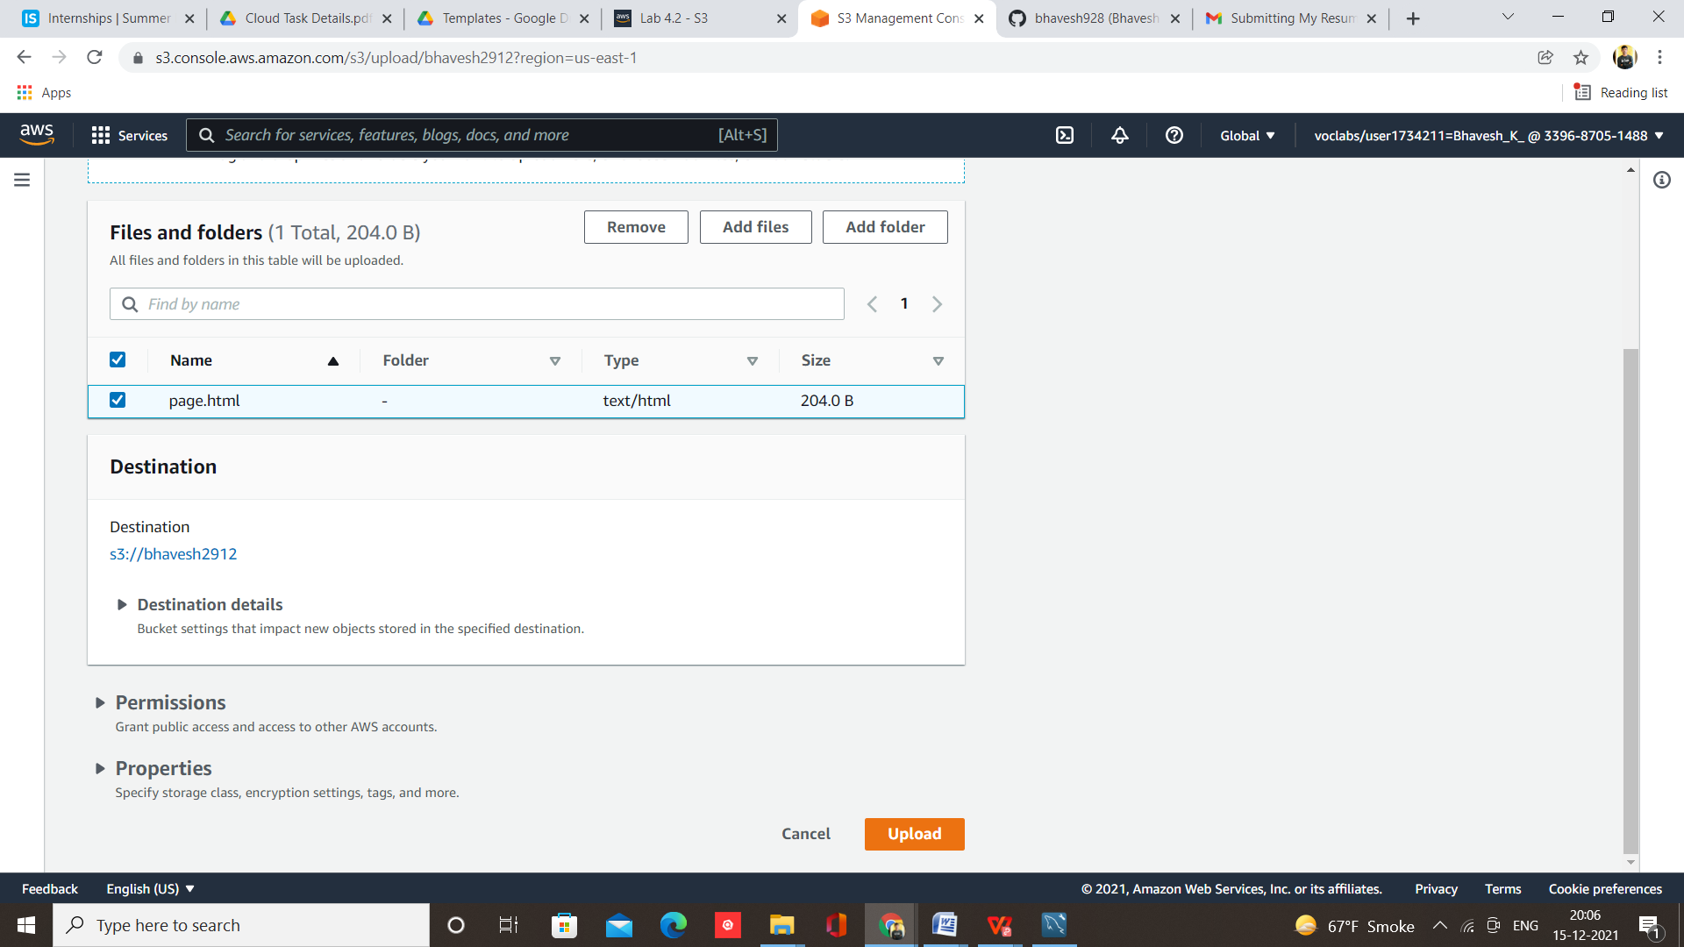

File uploaded successfully

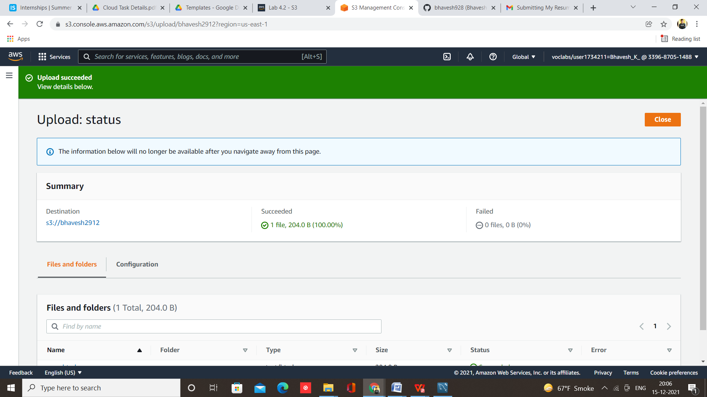

Step 14 – Open Permissions

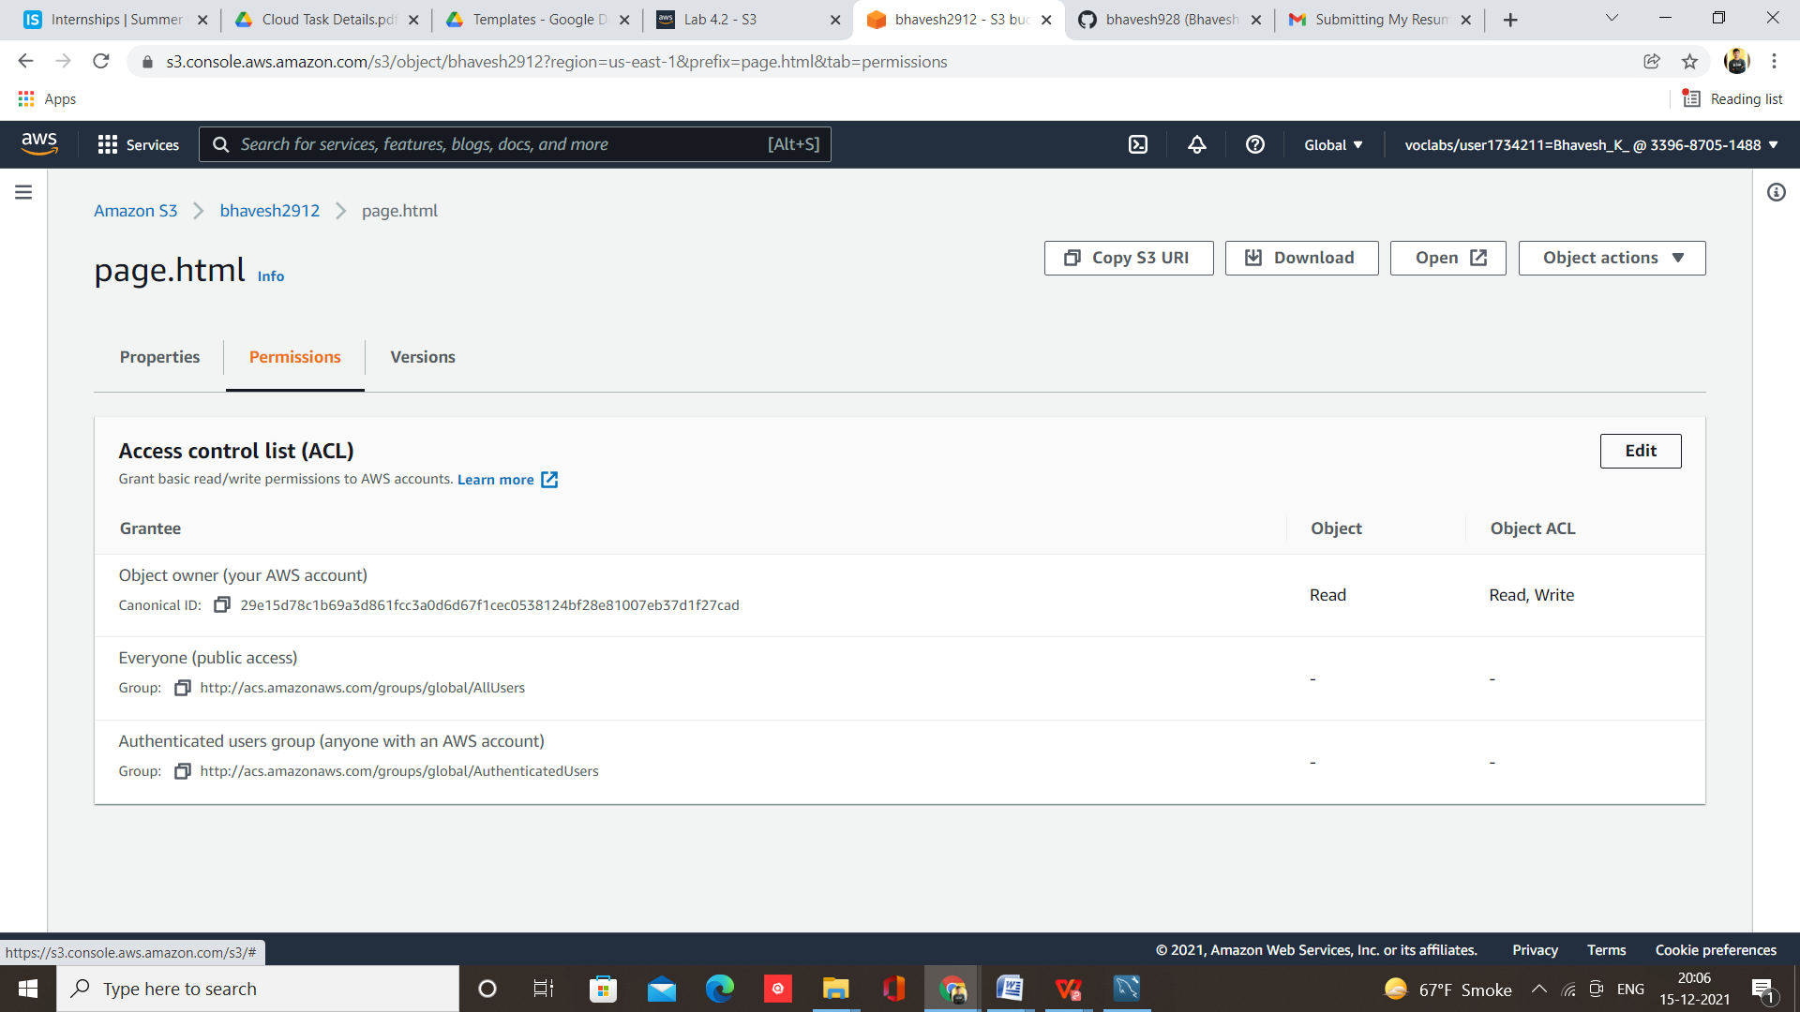

Step 15 – Make it public readable because this is public website

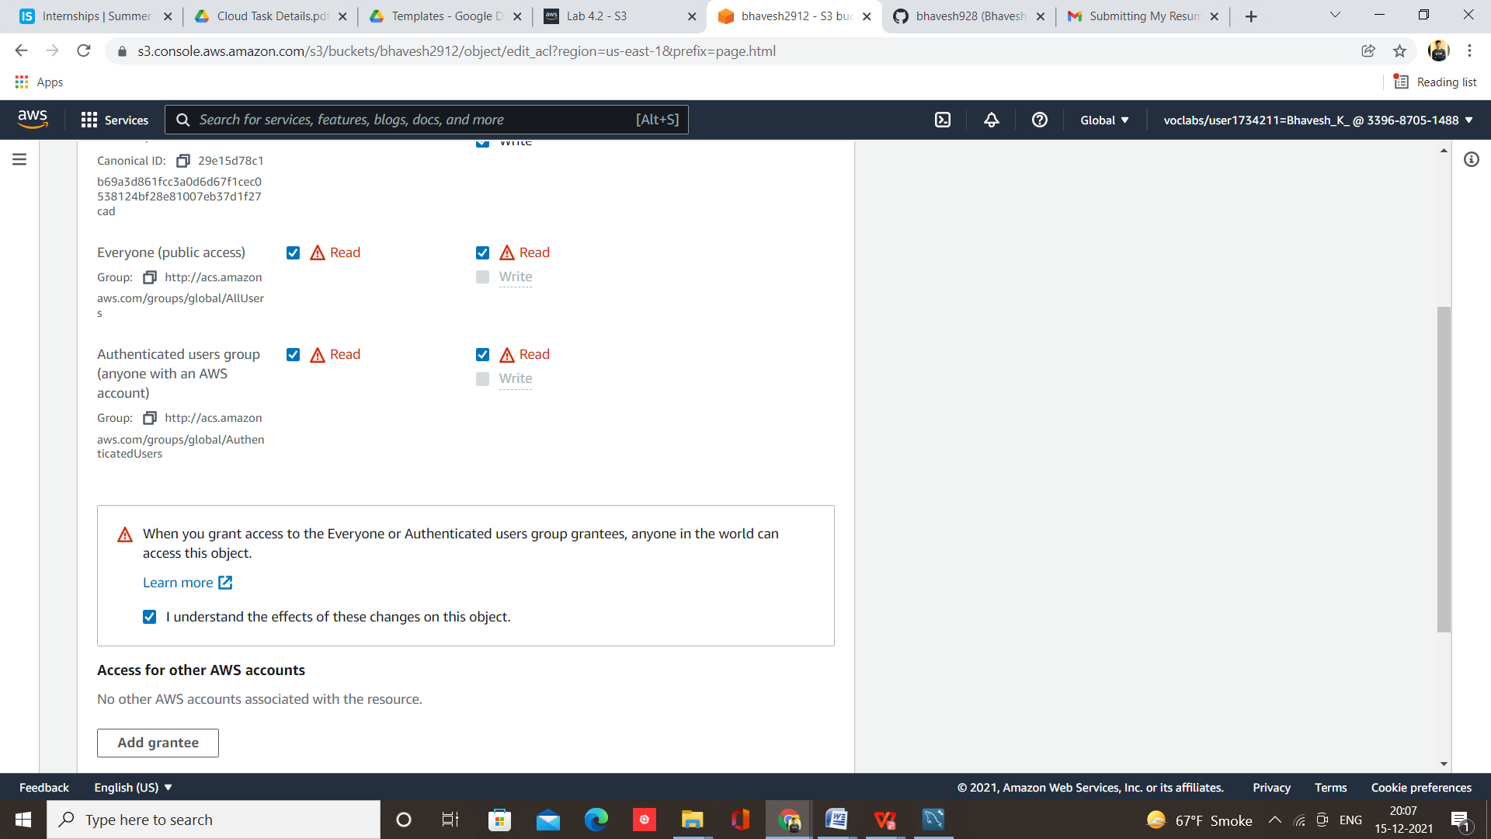

Step 16 – Now Copy Object URL

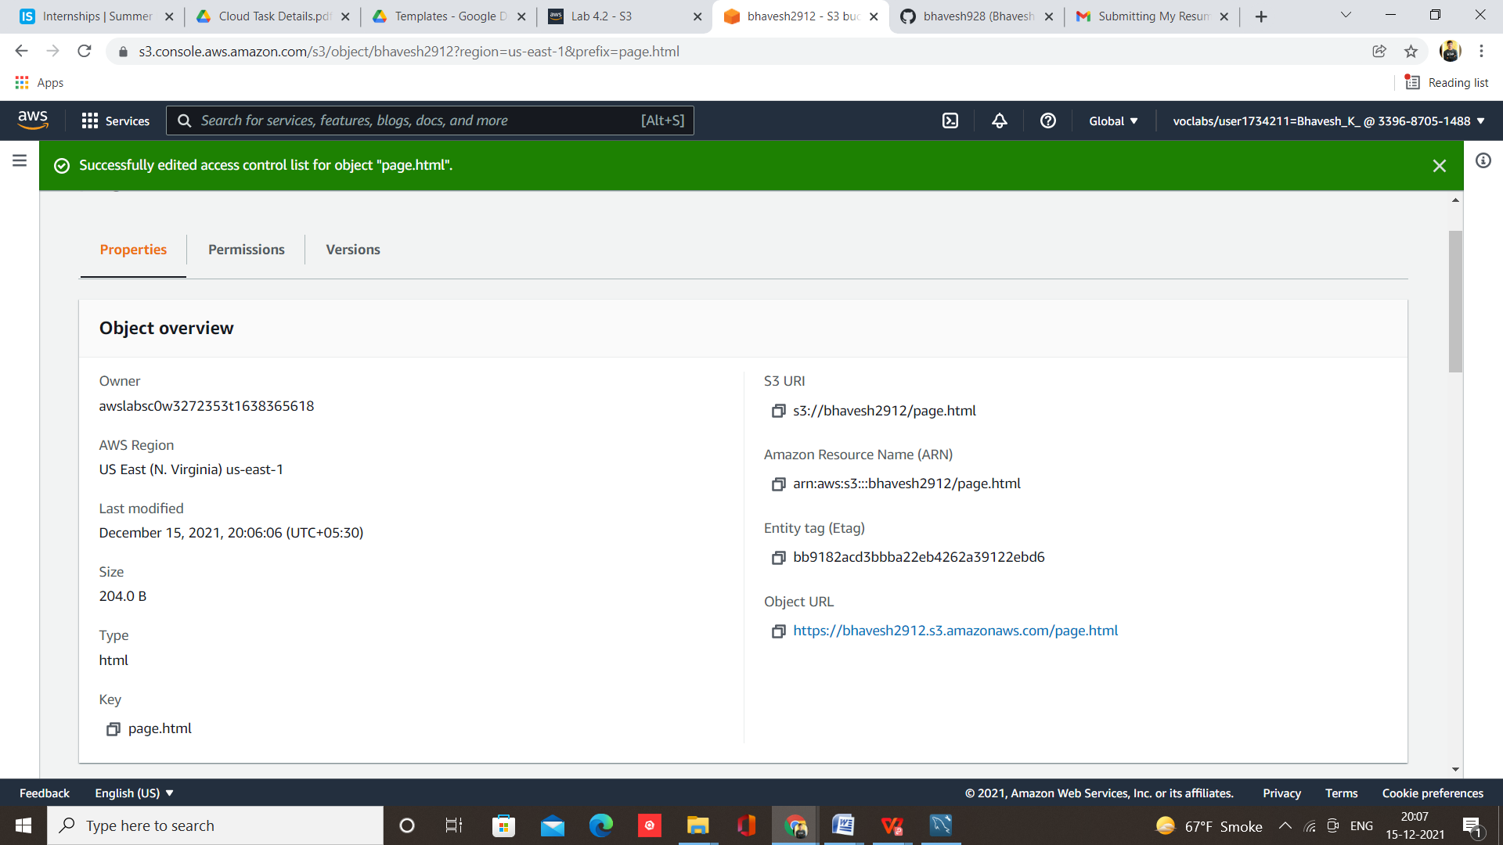

Step 17 – Paste it into your browser

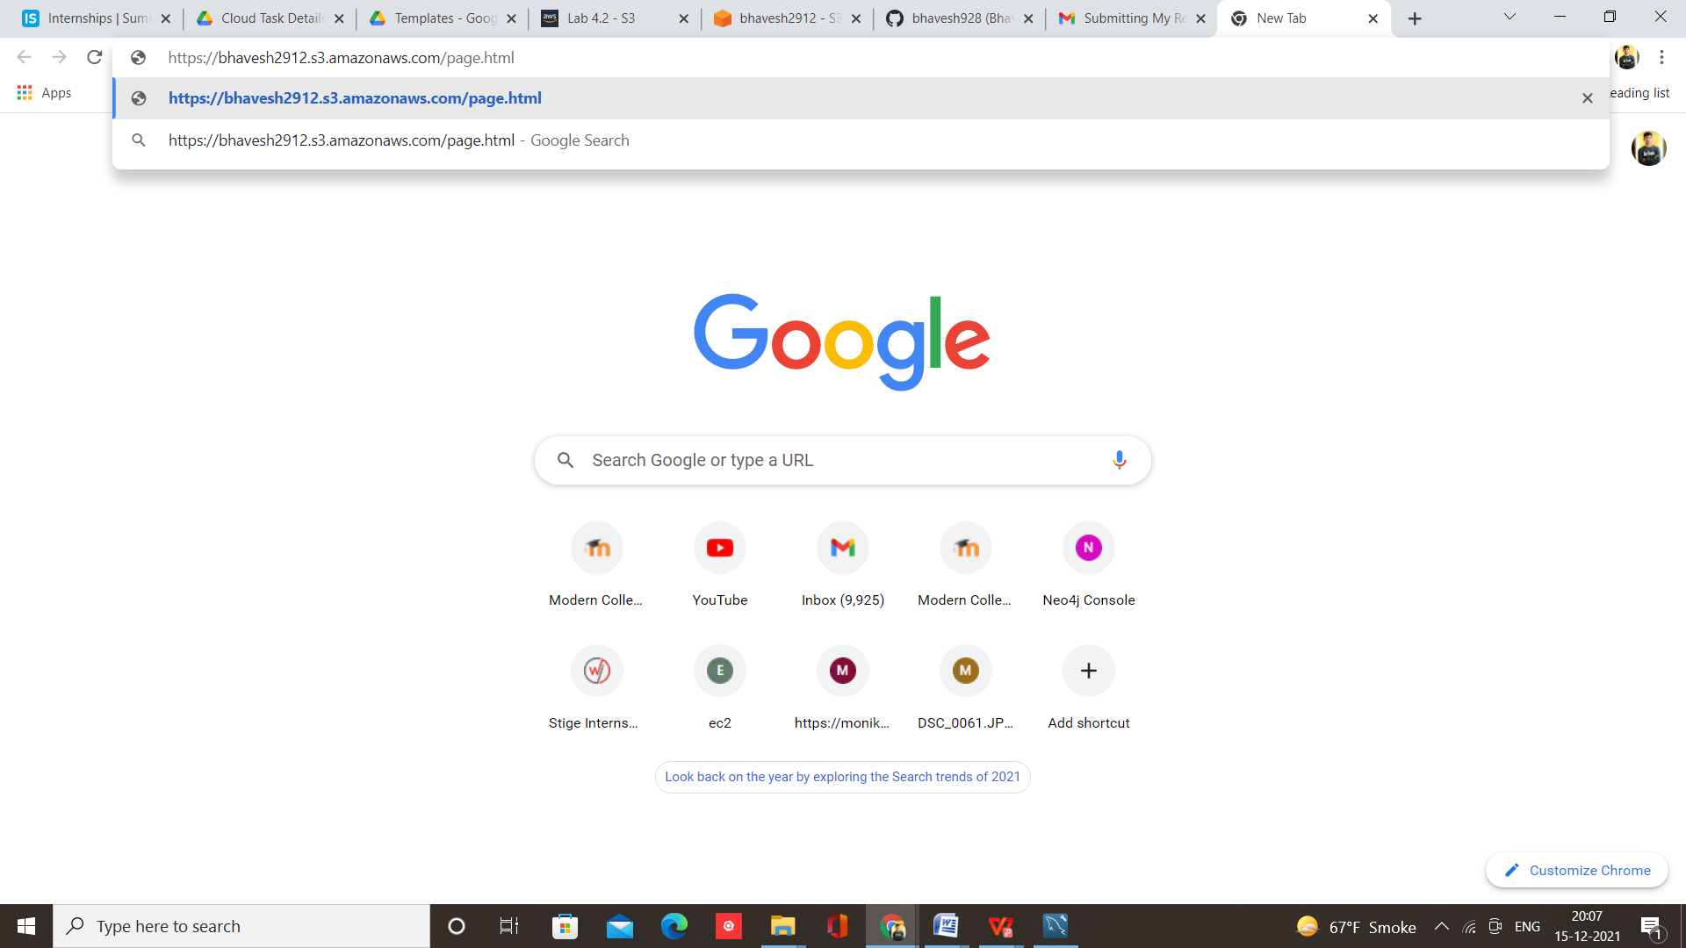

Your Website Hosted Successfully

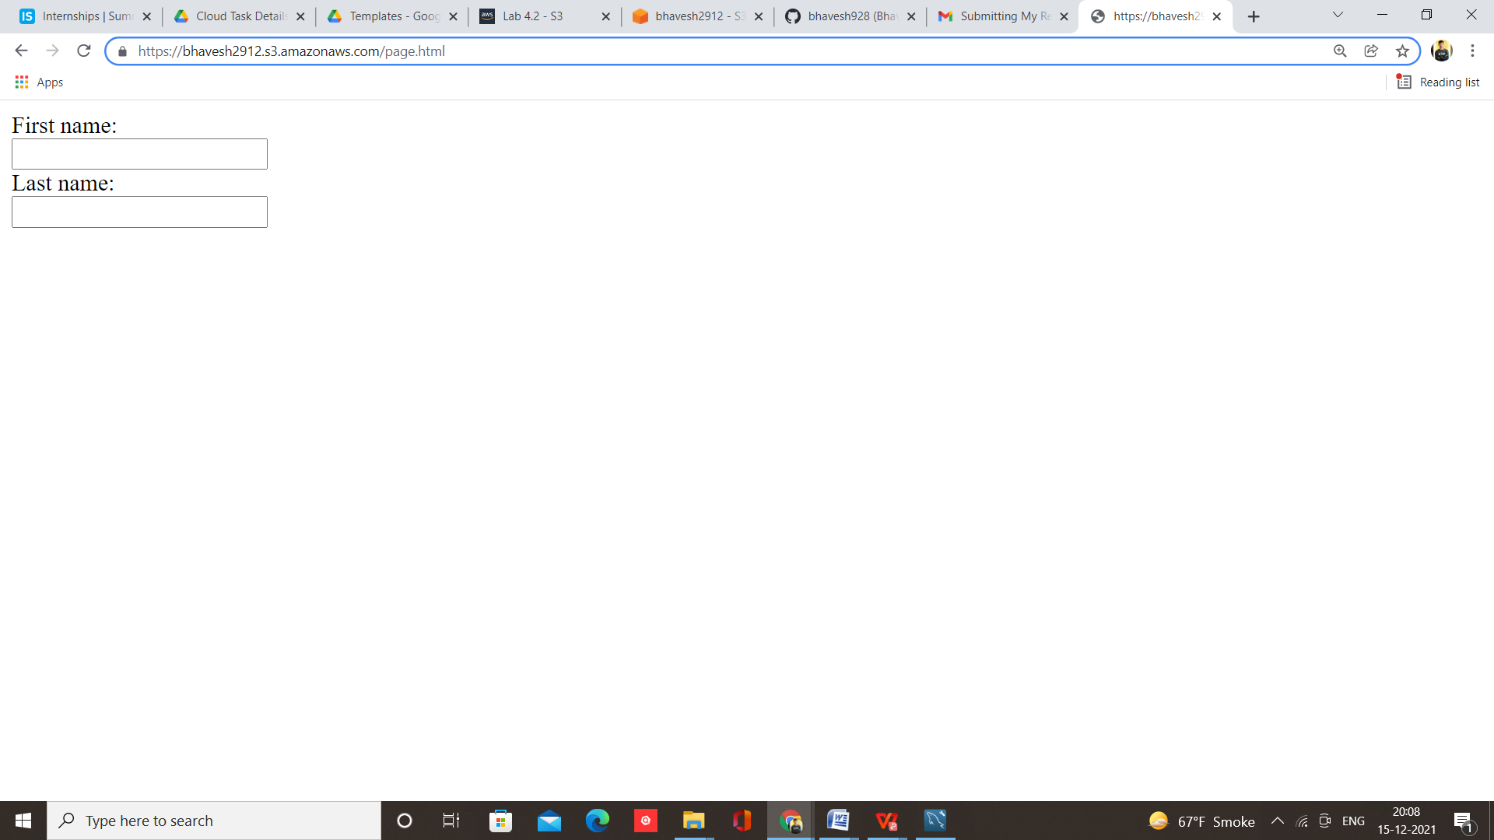

1. **What are the key factors to keep in mind during the process?**

### Safeguard your passwords and access keys

1. The two main types of credentials used for accessing your account are passwords and access keys.
2. Set up a multi-factor authentication (MFA) device to protect access keys that have only API access.
3. Limit root user access to your resources

### Audit IAM users and their policies frequently

### Monitor your account and its resources

### Clean up the project environment and avoid future costs

### Your Lab has a time limit it is based on your plan

### Complete your task within this time to avoid extra charges

### Do not remain lab ON after work

### Pause the Lab if not in use for few time

### After completing project always clean up the project environment

### Remove all endpoint addresses

### Empty and delete all buckets if in use

### Remove all public IP address

### At the end close the console

### And STOP the Lab